Mobile App User Guide for iOS

Webster, Texas 77598 Published: June 2019  www.goclockwise.com | Clockwise by GHG Corporation  960 Clear Lake City Blvd Document By: Joe Driscoll
Version 1.0

Table of Contents
Introduction 3
Requirements 3
Login Process 4
Timesheet 9
In/Out Punches 10
Adding Punches 10
Editing Punches 12
Removing Punches 14
Hours Worked 16
Adding Hours Worked 16
Editing Hours Worked 22
Removing Hours Worked 23
Timesheet Submission 25
Submitting Timesheets 25
Unsubmitting Timesheets 27
Timesheet Comments 29
Adding Comments 29
Editing Comments 30
Removing Comments 32
Documents 33
Adding Documents 33
Removing Documents 35
Photos 37
Adding Photos 37
Removing Photos 38
Schedule Tab 41
Leave Tab 43
Settings Tab 48
FAQ 54

Introduction
Clockwise strives to provide the easiest to use time and attendance system for both management and employees. This user guide will explore our mobile app on Apple products. This new app will allow employees to use many of the features of the Clockwise website, from the convenience of their iPhone. You will be able to clock in, clock out, add hours, and submit their timesheet. You will also be able to request leave, and view their schedule.

Requirements
The following is required to use the Clockwise iOS app:
- Requires iOS 11.0 or later
- Site version 7.5.3.12 or higher
- Device ID assigned to the user
- Internet Access
- Must allow outside access (for self-hosted only)
- 10.6 MB Size

Login Process
When you first open the app, the first thing you will see is the login screen. | 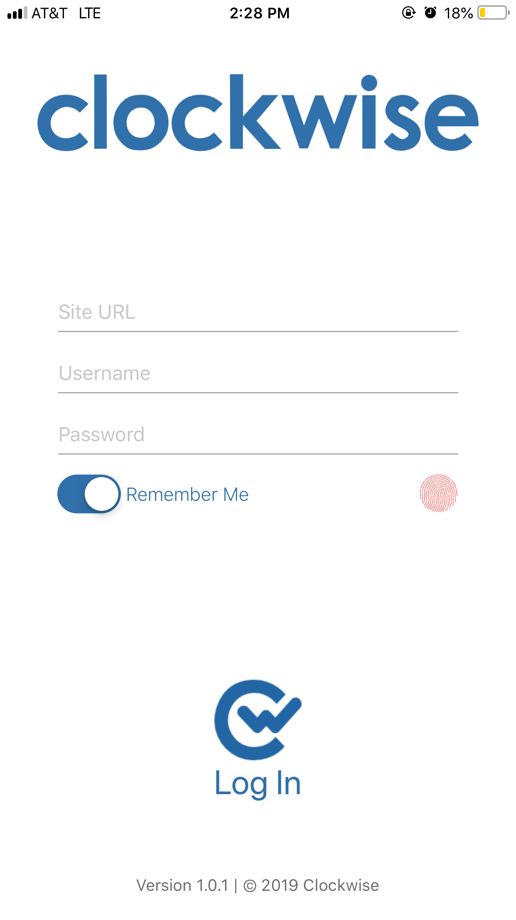
The first item to type in will be the URL for your company’s Clockwise site. | 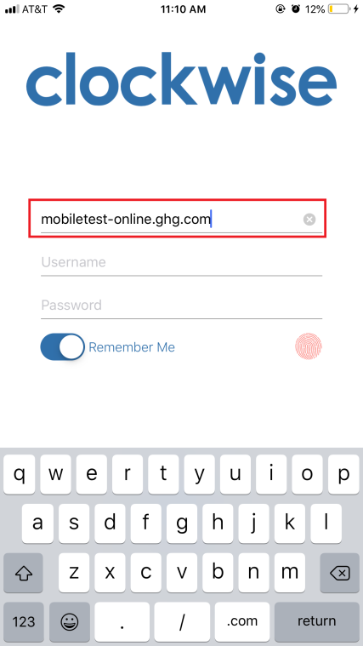
Once you’ve typed in the URL, you will need to enter your username. | 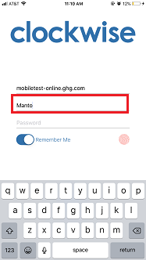
Once your username is entered, type your password. | 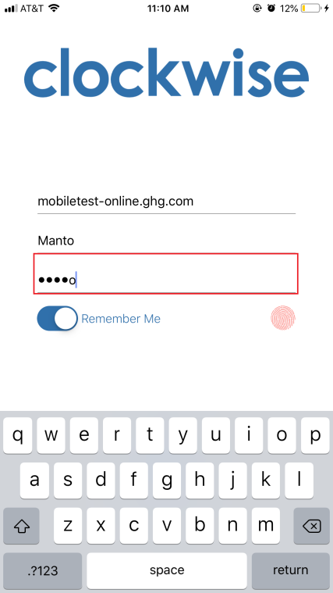
Alternately, instead of typing your password, if your iPhone has Touch ID, you can login with your finger print. You will still need to type your password the first time you use the app. | 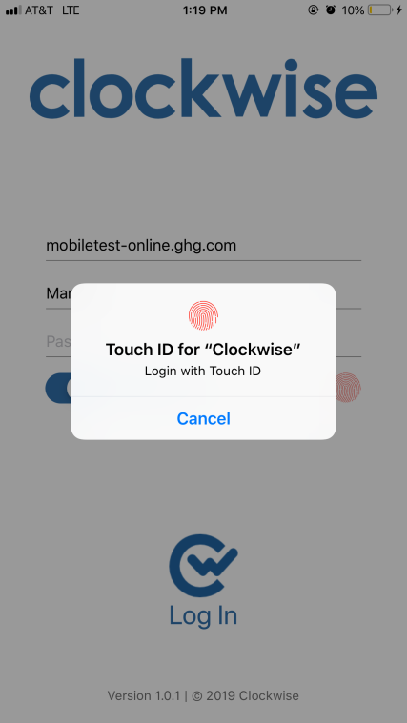
If the you are not automatically prompted to use the Touch ID, you can tap the thumb print next to “Remember Me.”  NOTE: This feature is only available on iPhone 5S and later. | 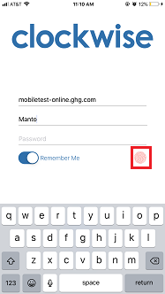
Selecting “Remember Me” will save the URL and the username. You will still need to enter their password or use their touch ID every time you log into the app. | 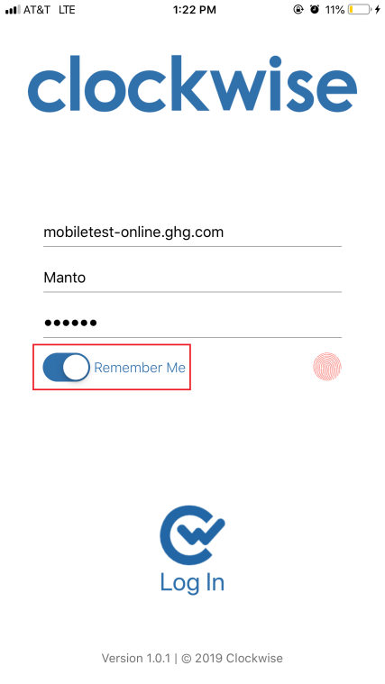
Once all of the information is entered, select the Clockwise Logo at the bottom to log in. | 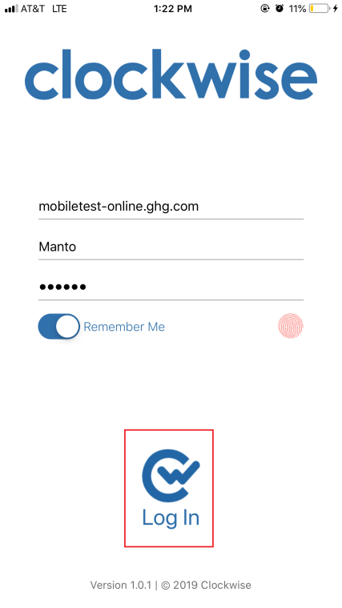
Once logged into the app, you will see the home screen. It will show their name, as well as their most recent punch. From here, you can tap ‘Clock In’ or ‘Clock Out’ to record an in or out punch respectively. You can also sign out from the top right corner. | 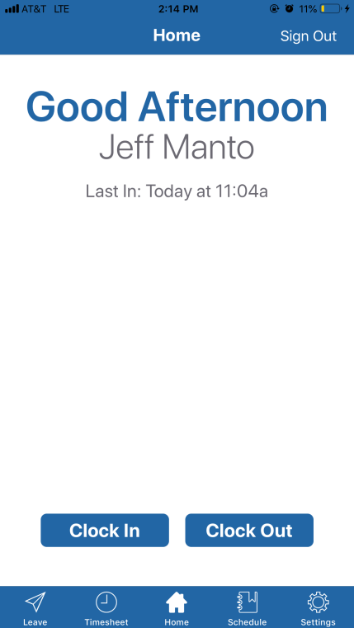
Process Complete

Timesheet
When you first open the Timesheet page, you will see the current timesheet. You can use the arrows to the left and right of where it says Timesheet End Date to scroll through past or future timesheets. It also shows the In/Out Totals and Hours Worked for each day during that timesheet. Tapping on that date will bring you to a more detailed breakdown of the selected day. | 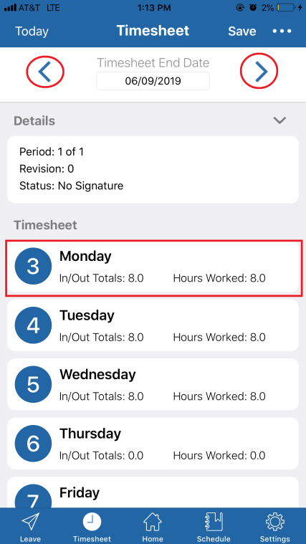
Once you tap the day, you can see the specific details for that day. This includes all In and Out punches, and which groups, pay types, charge codes, and tasks have been assigned.  This page also shows the In/Out and Hours Worked Totals. Tapping the Plus Sign (+) in the top left corner will allow the employee to Add In/Out punches, or hours worked. | 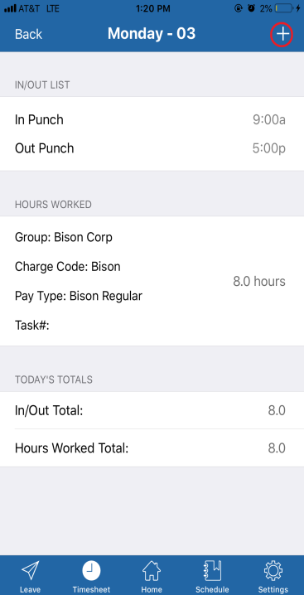

In/Out Punches

Adding Punches
To manually add an In or Out punch, tap the plus sign in the top right corner of the screen, then tap Add In/Out. | 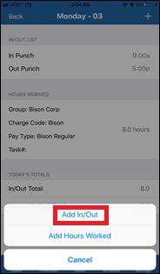
Once you tap the Add In/Out option, it will bring you to the page that will allow you to manually enter punches. Once you tap the In Punch or Out Punch field, use the time picker to enter the time, and select Done when finished. | 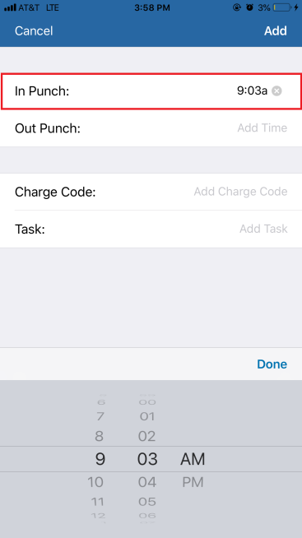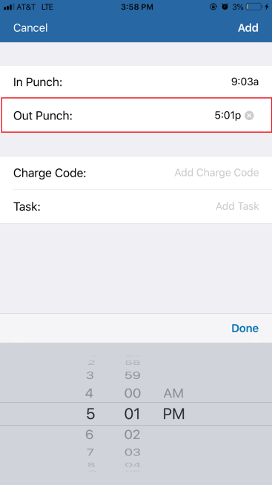
Once the time for the punches have been entered, the employee will also have the option to add a Charge Code and/or Task to this specific set of punches. | 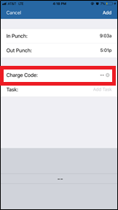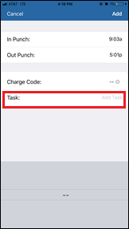
Once finished entering your punches, tap Add in the top right corner. | 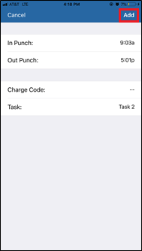
After adding the punches, you will be brought back to the details for that day. If you need to edit the punches after adding them, tap on the IN/OUT LIST box. | 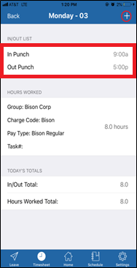
Process Complete

Editing Punches
In order to edit punches, you have made, first, tap the set of punches from the detail page for that day. | 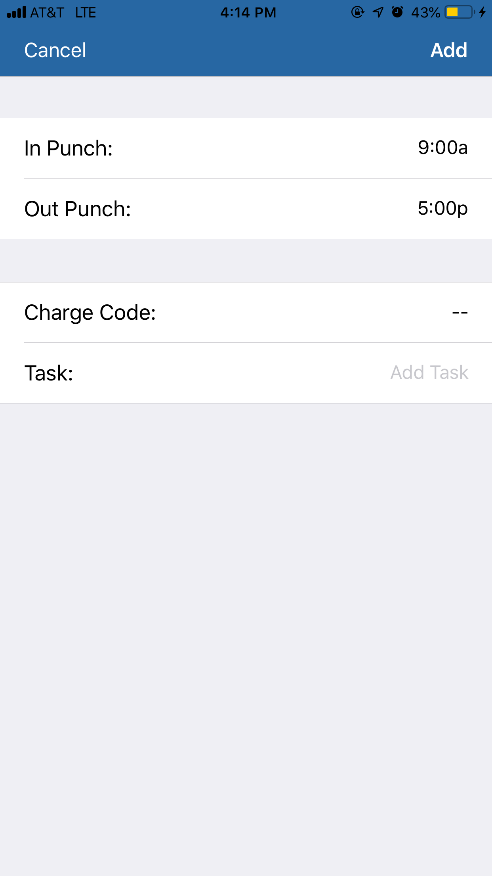
Once you tap the set of punches you would like to edit, tap the specific punch you need to change. | 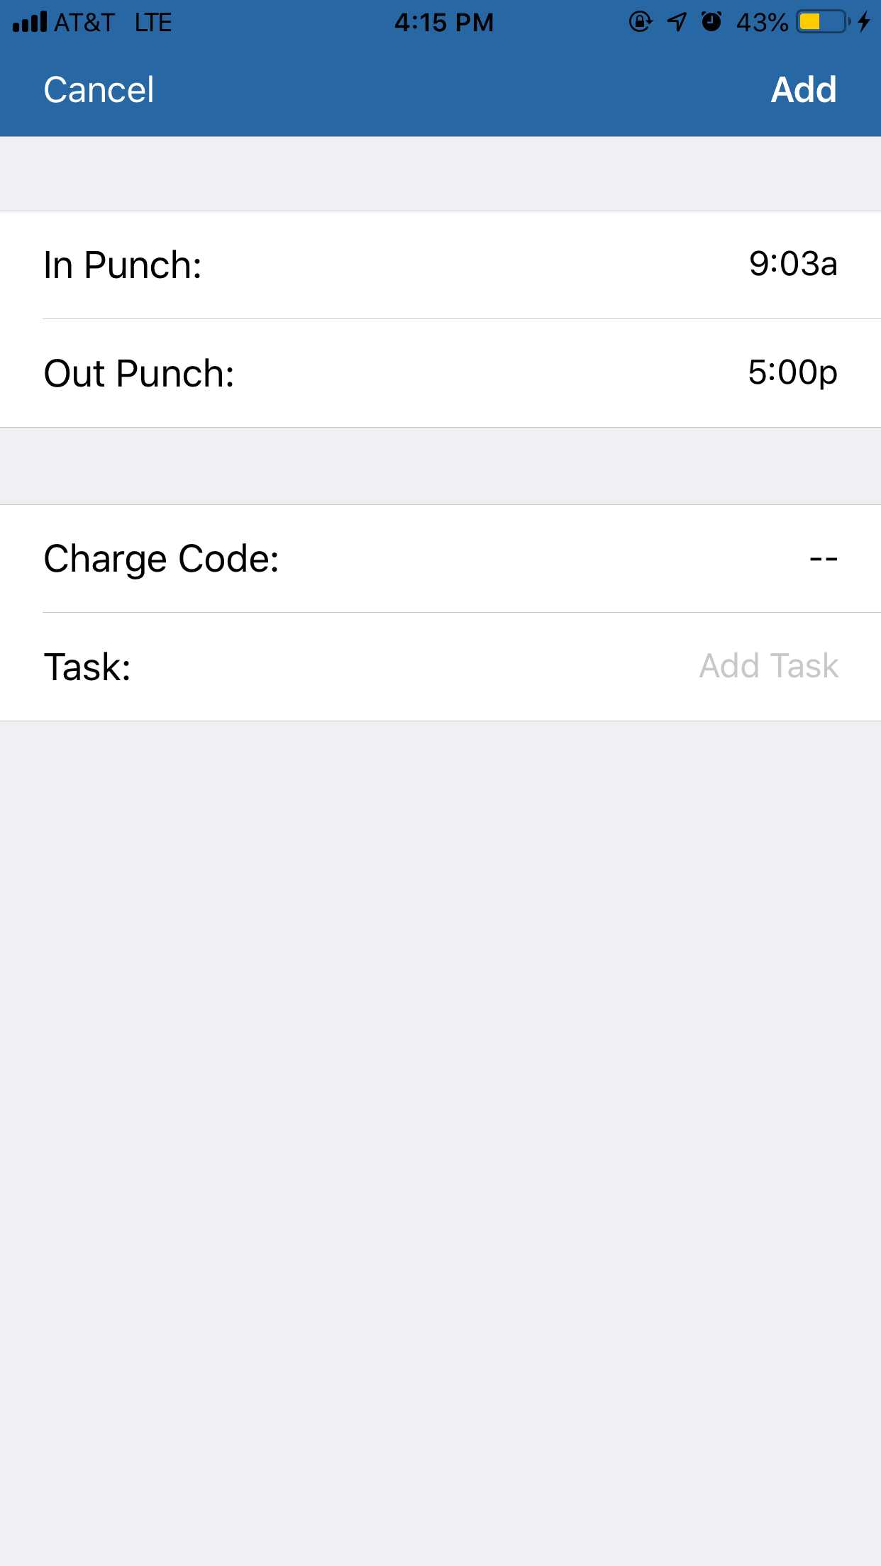
Use the picker to change it to the correct time. Tap Done above the picker, and then Add in the top right corner of the screen. | 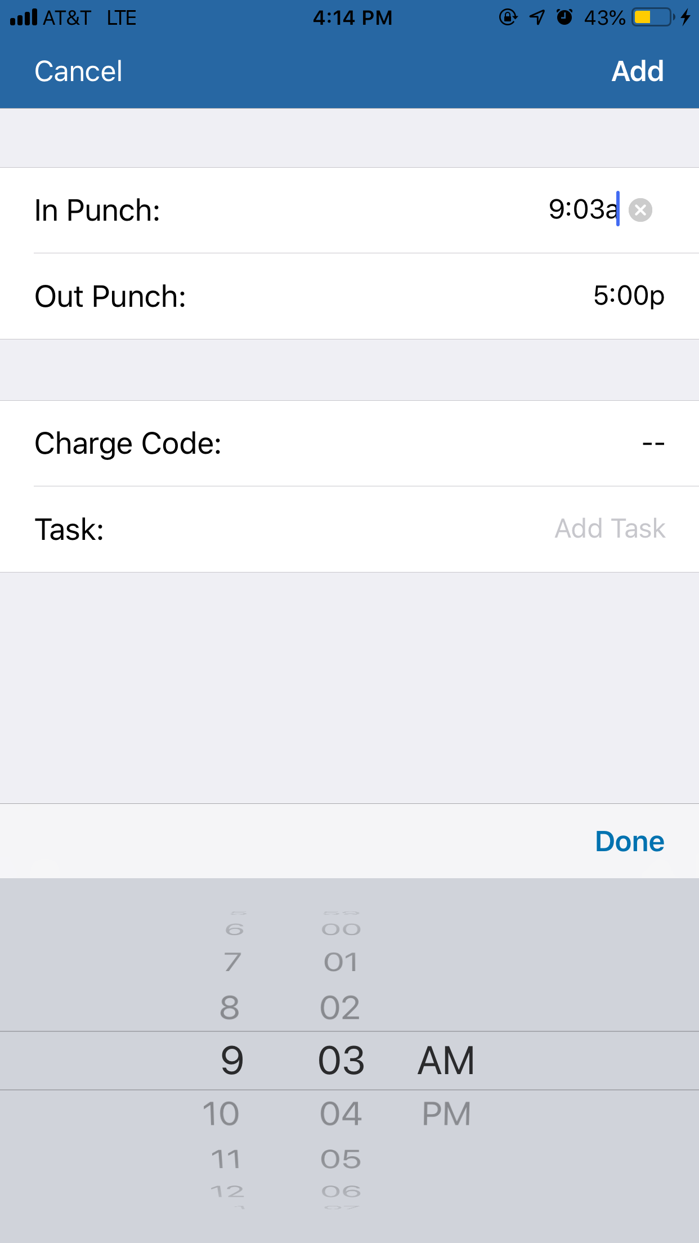
After you have made the changes, you will be brought out to the details for the day that you made changes for, with the corrected information showing. Be sure to tap Back and then Save on the Timesheet page to ensure the changes are saved. | 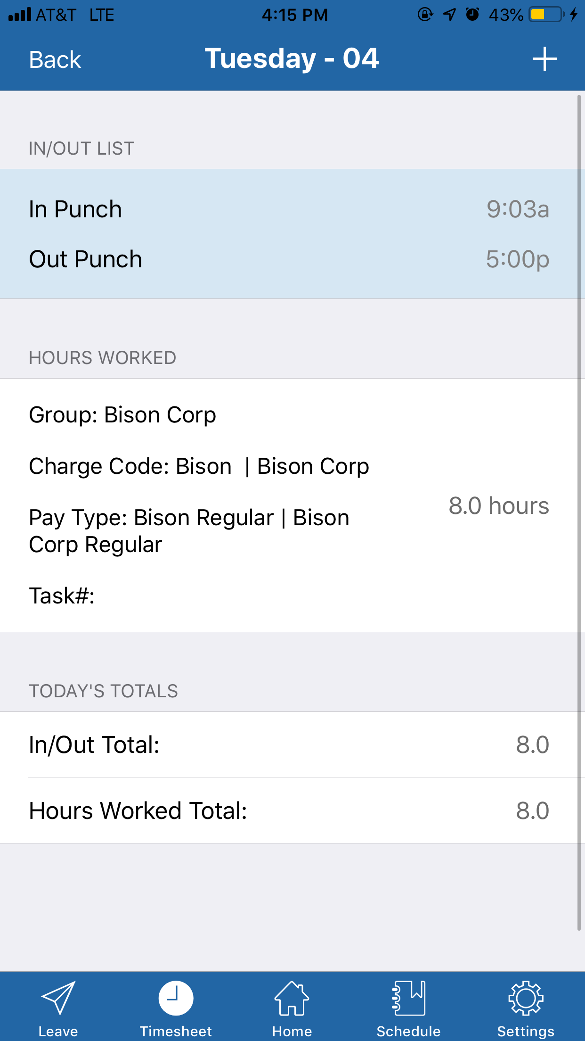
Process Complete

Removing Punches
In order to delete a set of punches, swipe the in/out set you wish to delete. | 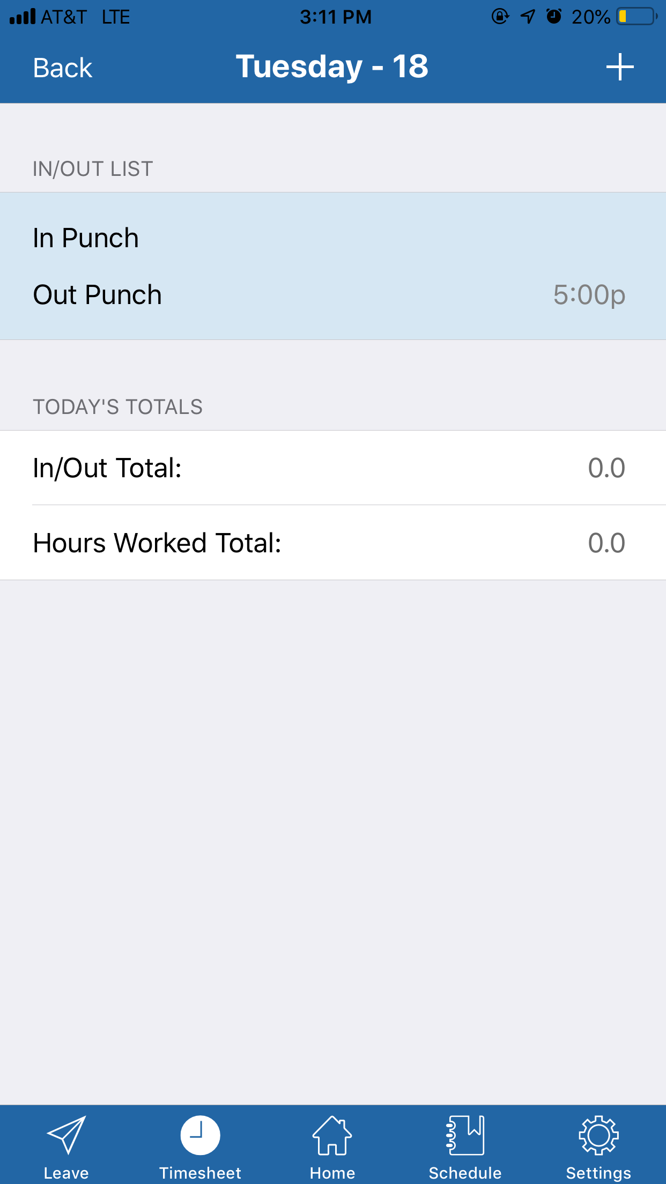
After you have swiped the punches, Tap the delete button that appears. | 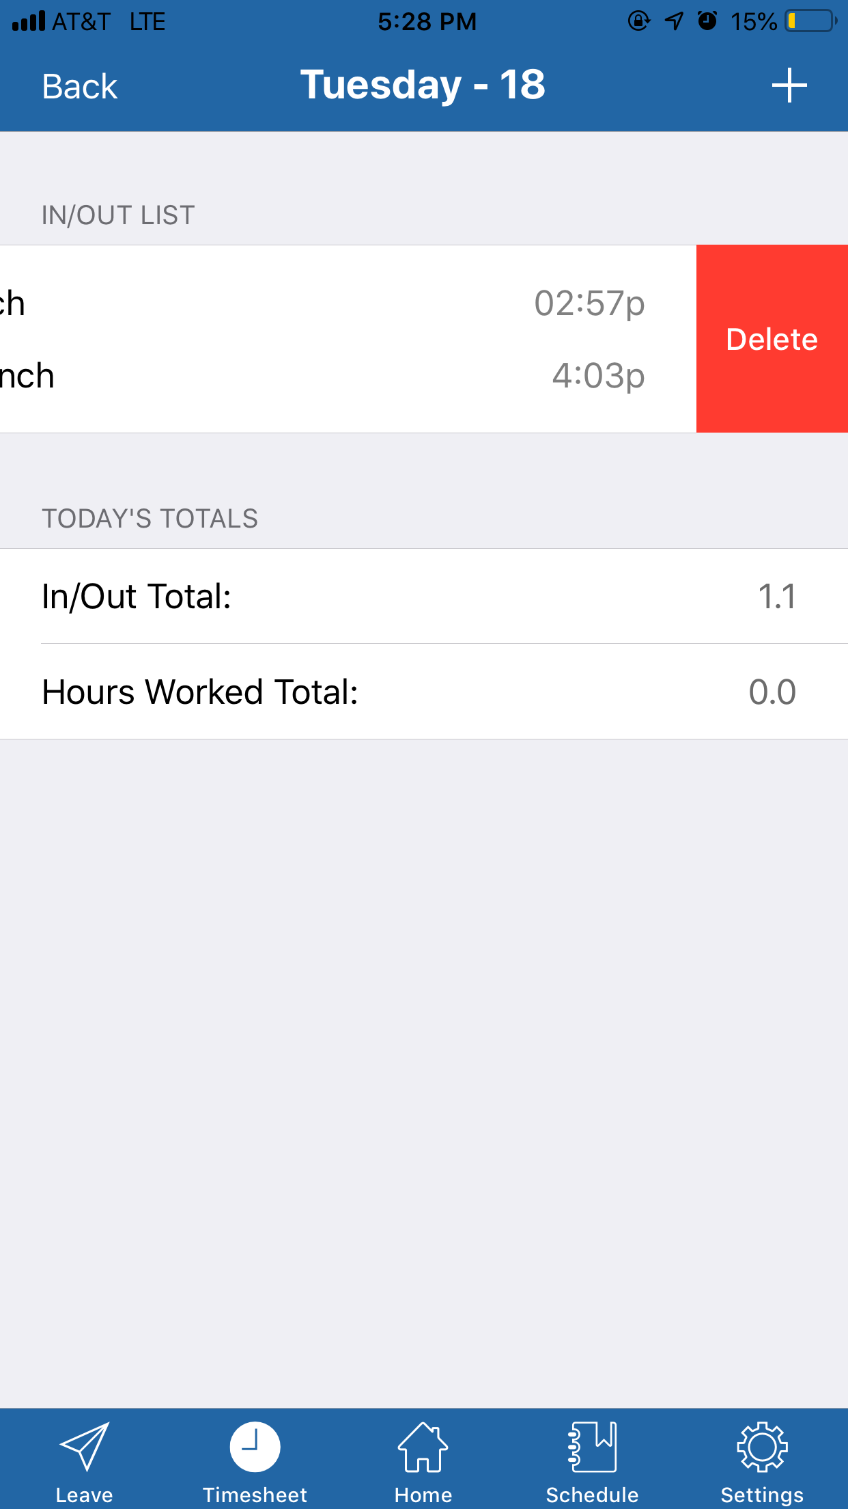
Once you have deleted the punches, you will disappear from the screen. | 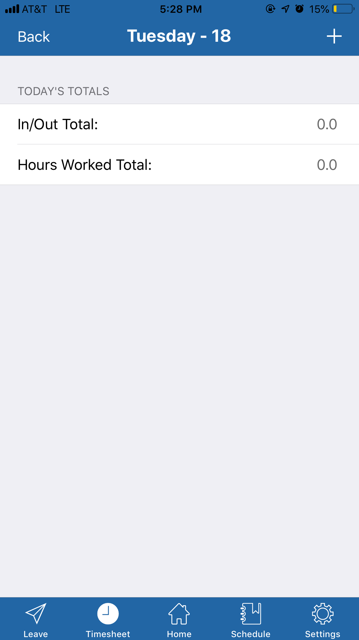
Process Complete

Hours Worked

Adding Hours Worked
To add Hours Worked, tap the plus sign in the top right corner of the screen, then tap Add Hours Worked. | 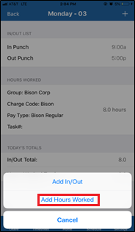
After tapping Add Hours Worked, the app will take you to the Add Hours Worked Page. | 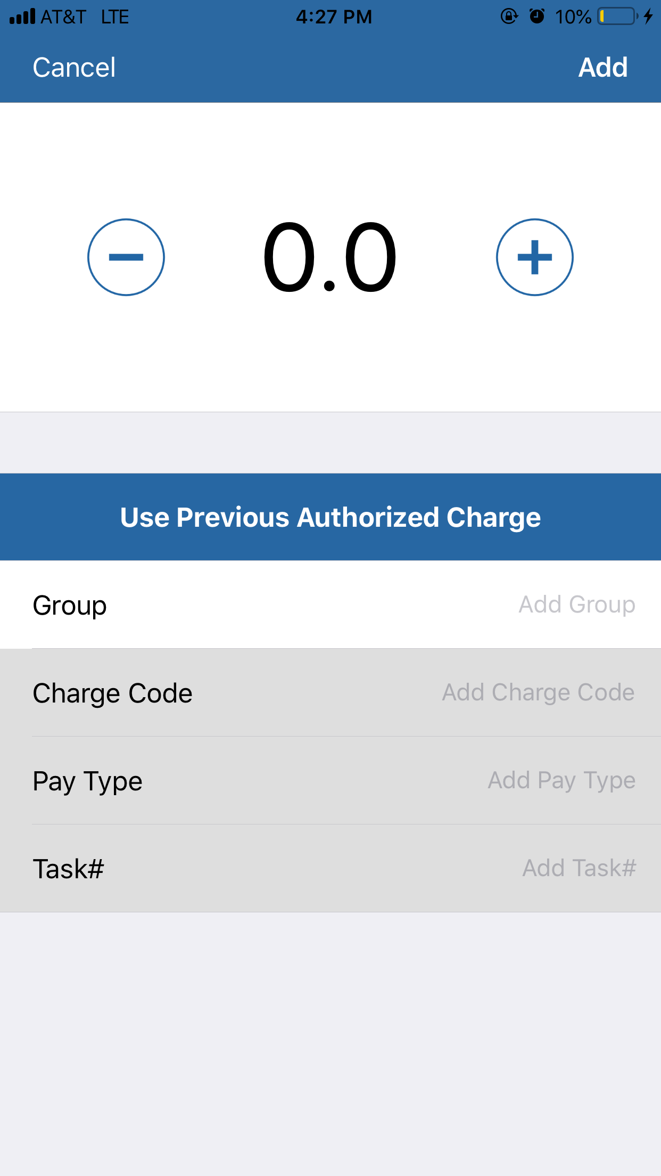
You can use the Plus (+) and Minus (-) buttons to add or subtract in one-hour increments. | 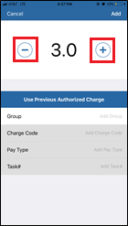
If you tap the number, you can type a specific number in tenths of an hour. | 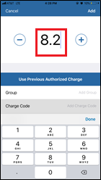
Once the hours are entered, tap the Group box to enter the Group associated with these hours. | 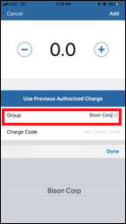
Once the Group is entered, tap the Charge Code box to enter the Charge Code associated with these hours. | 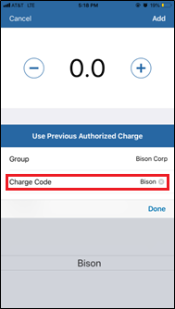
After choosing a Charge code, tap the Pay Type box and select the pay type needed. | 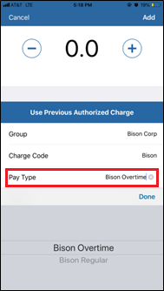
Another option is the Use Previous Authorized Charge button, which allows you to enter previously used charge codes. | 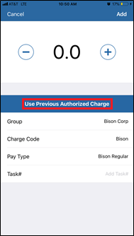
Finally, tap the Task # box, and select the appropriate task. | 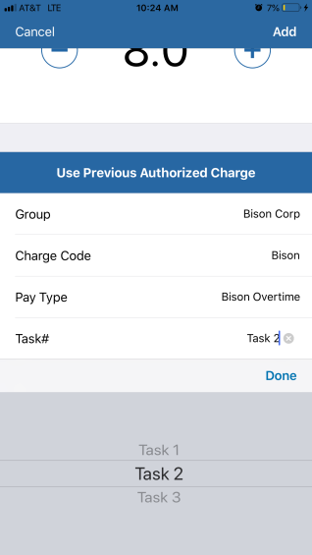
Once you tap Use Previous Charge Code, it will bring up a list of the most recent charge codes you have used. Select the charge code you wish to use. After, it will automatically fill in the Group, Charge Code, Pay Type, Organization, and Task #. | 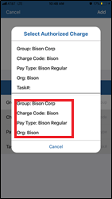
Once you have entered their hours worked, tap Back to bring you to the details for the day. Confirm the information is correct, and tap Back again, to bring you to the timesheet for the current period. | 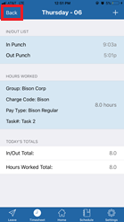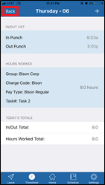
Once on the timesheet, tap Save in the top right-hand corner of the page. This will save any changes made to your timesheet during this session. | 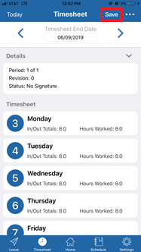
Process Complete

Editing Hours Worked
In order to edit hours worked, first tap the hours from the detail page for that day. | 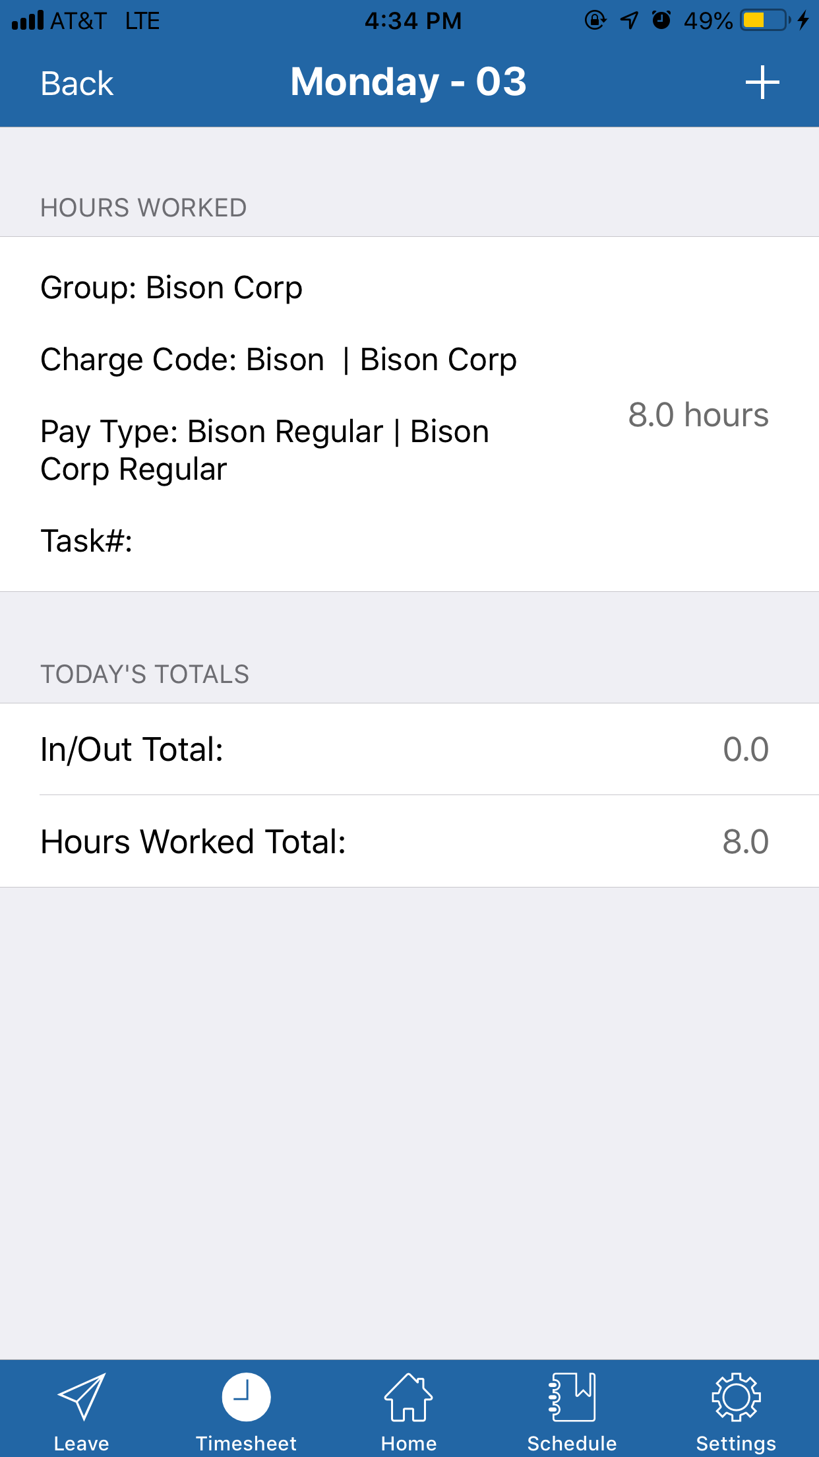
After you have tapped the hours you would like to edit, tap the specific information you need to change. Tap Add in the top right hand corner when finished. | 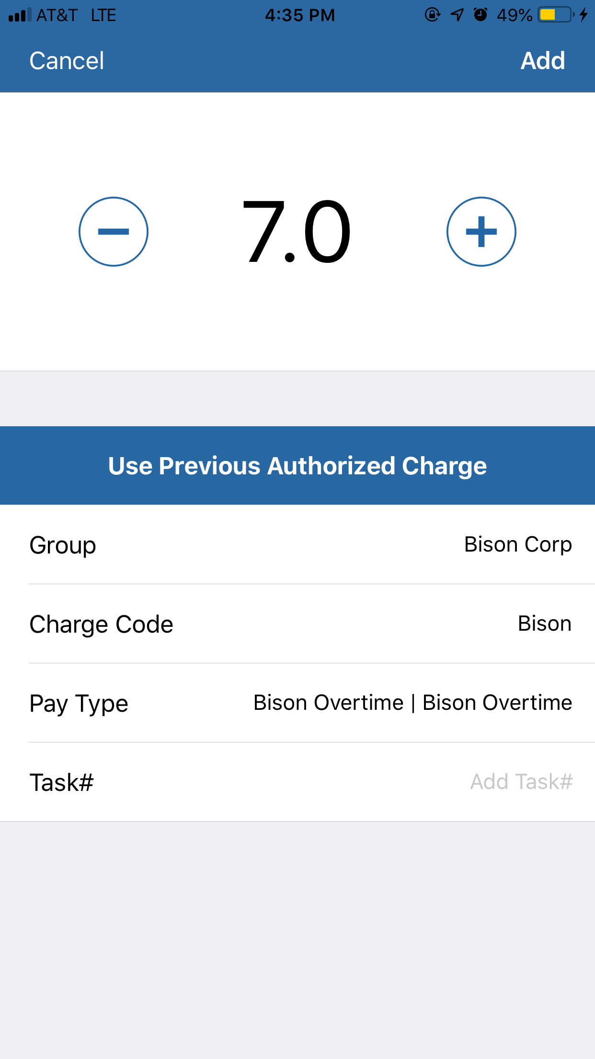
After you have made the changes, you will be brought out to the details for the day that you made changes for, with the corrected information showing. Be sure to tap Back and then Save on the Timesheet page to ensure the changes are saved. | 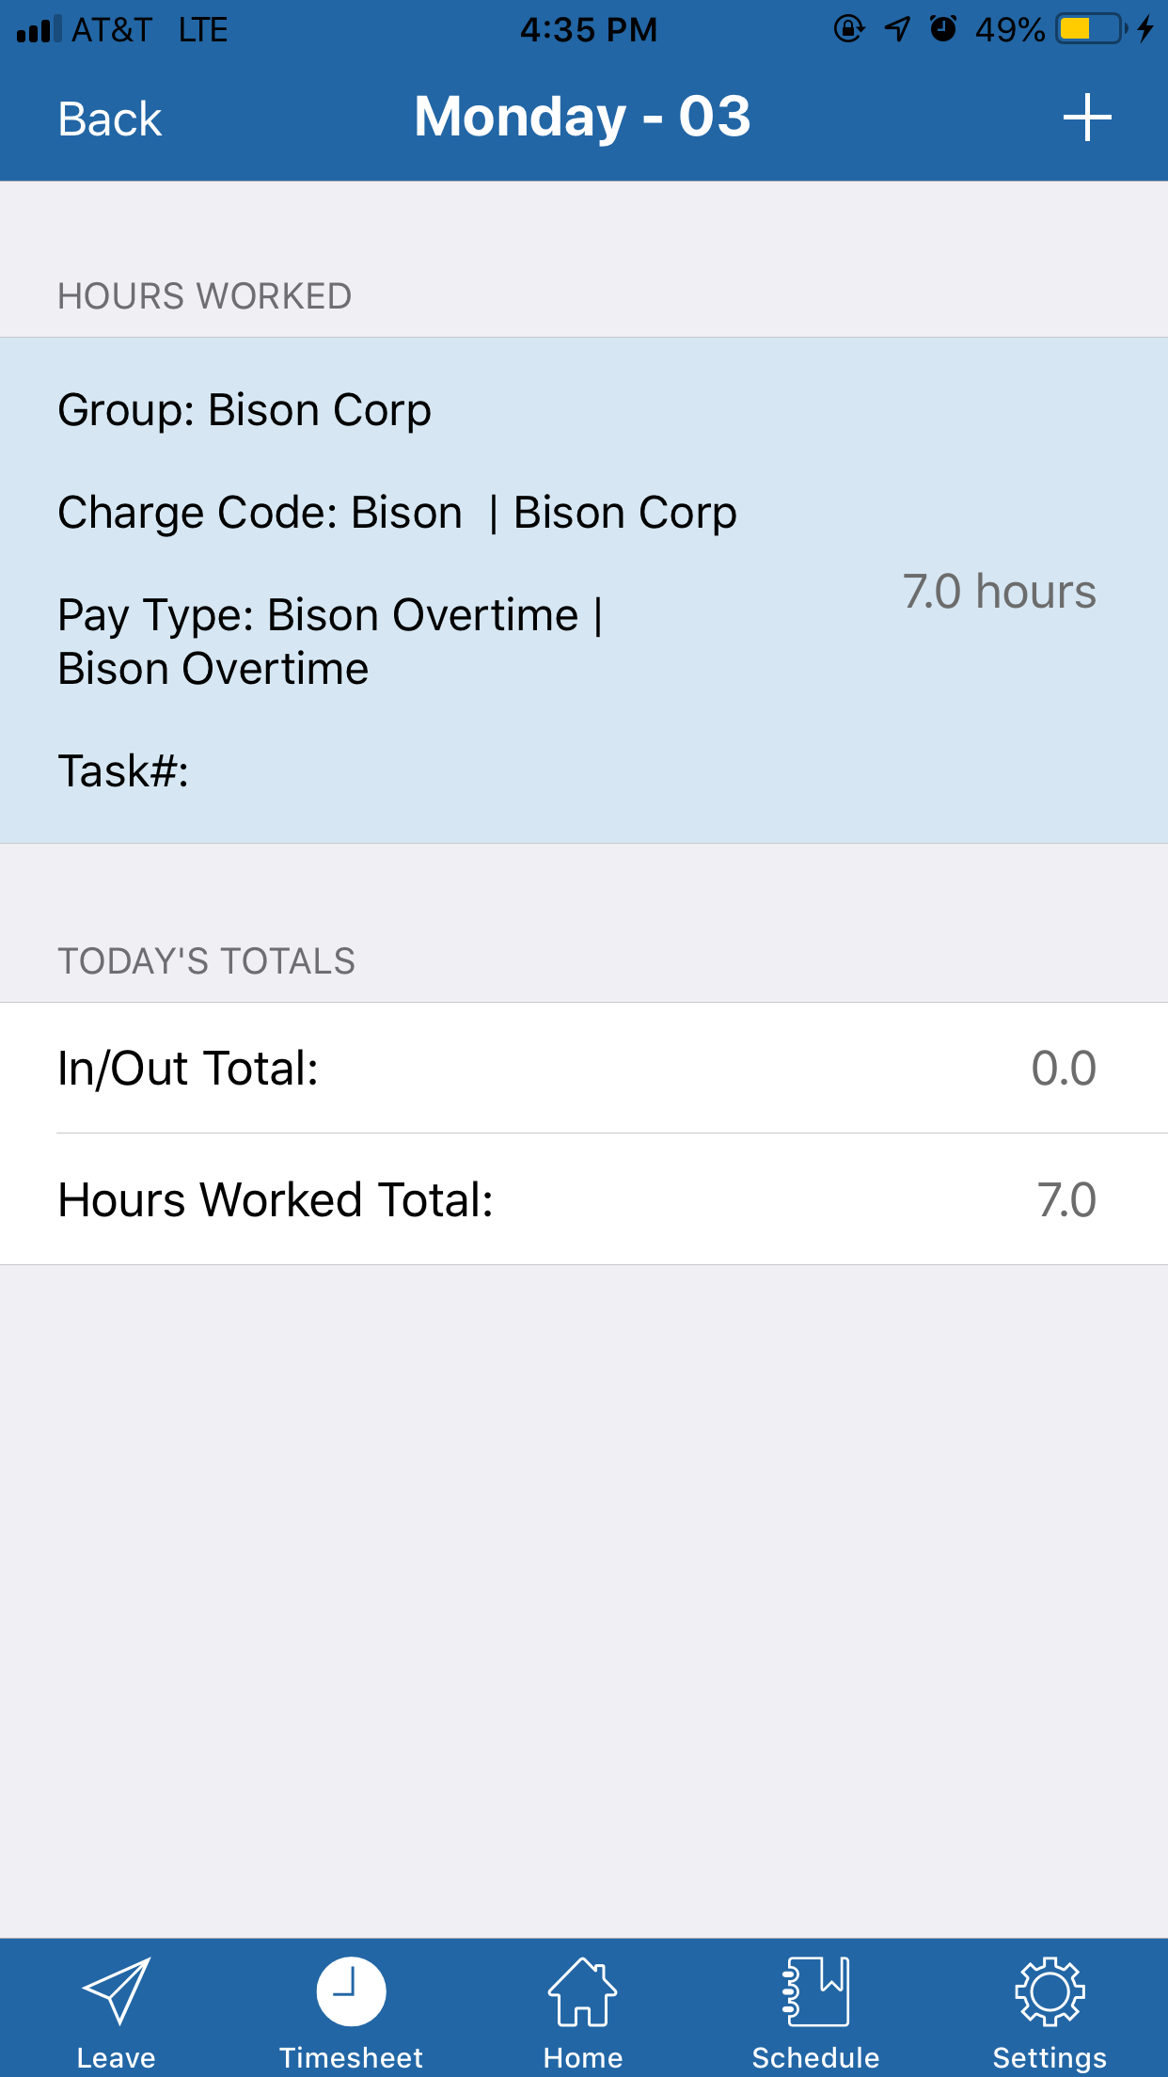
Process Complete

Removing Hours Worked
In order to delete hours, swipe the hours you wish to delete. | 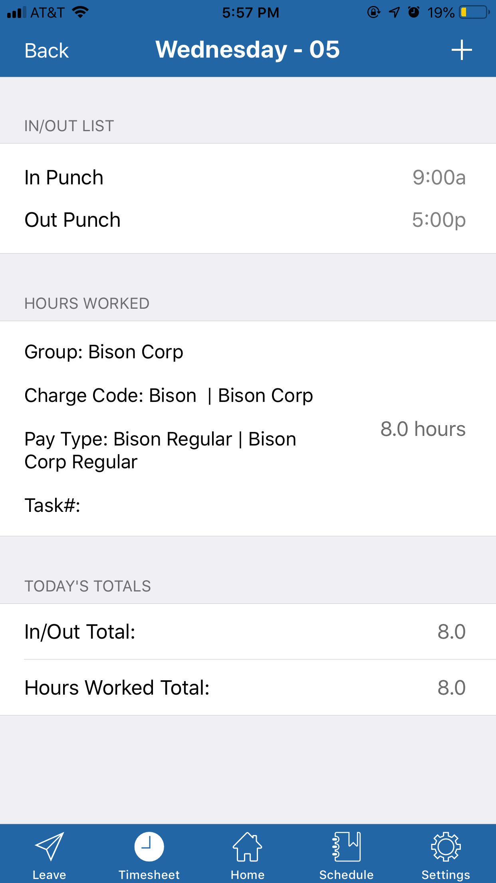
After you have swiped the hours, Tap the delete button that appears. | 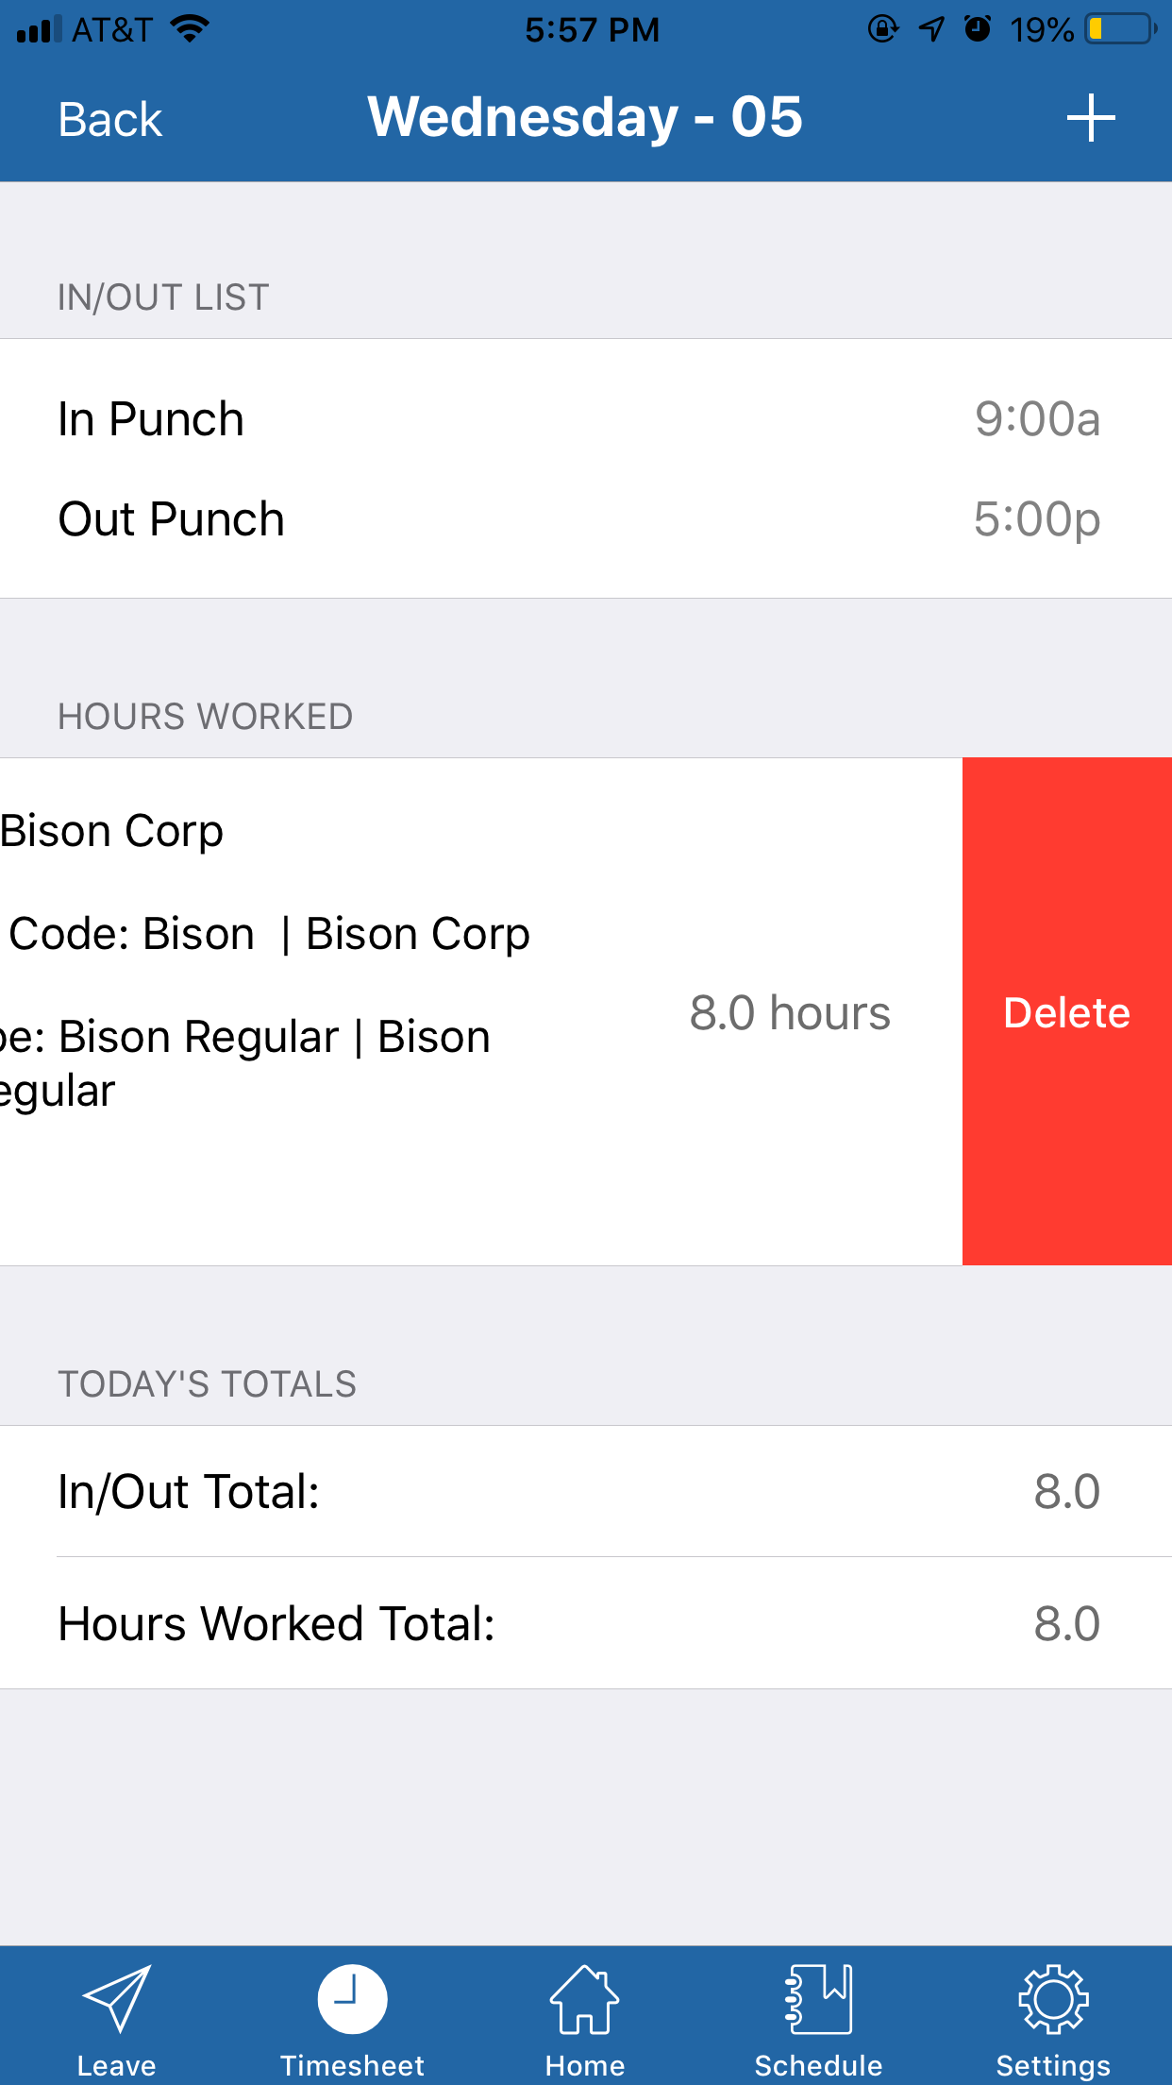
Once you have deleted the hours, you will disappear from the screen.
Process Complete

Timesheet Submission

Submitting Timesheets
Once you are ready to submit your timesheet, you can tap the three dots in the top left corner from the Timesheet page. | 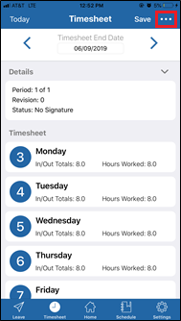
A menu will pop up with four options. Tap the Submit option. | 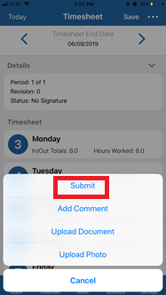
After tapping Submit a message will pop up asking “Are you sure you want to submit your timesheet?” Select Yes, | 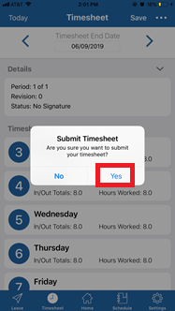
After confirming, a message with a checkbox saying “Timesheet Submitted” will pop up briefly. | 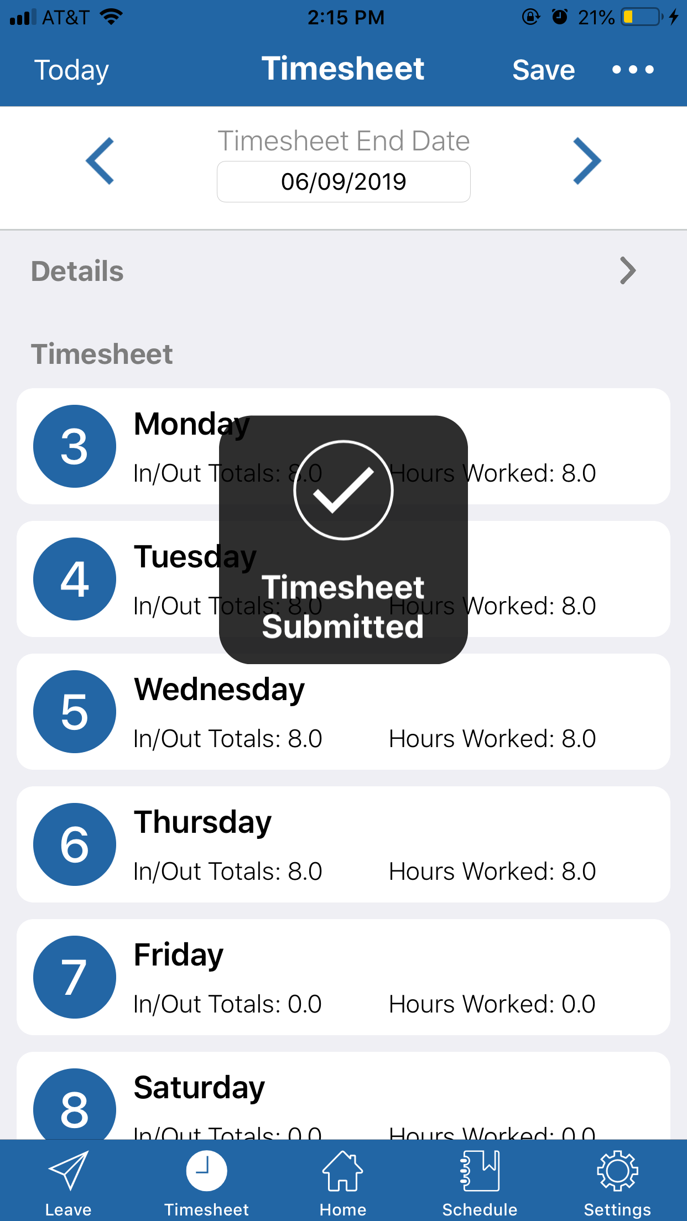
Once the timesheet is submitted, no changes can be made to it. If you attempt to make any changes after submission, you will get an error message stating “It looks like your timesheet is submitted. To add hours, you will need to unsubmit it.” | 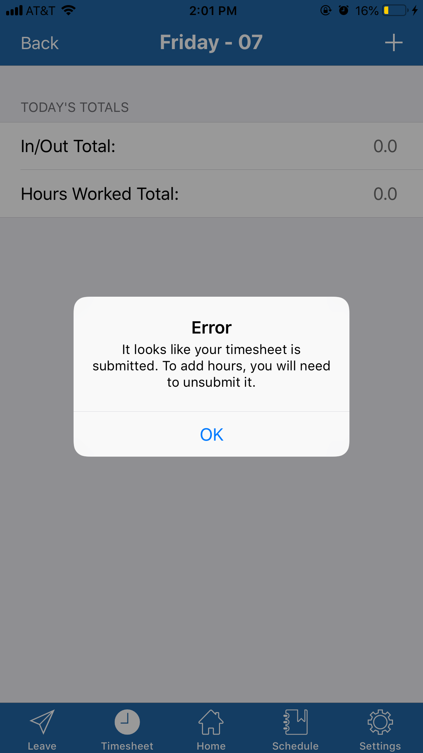

Unsubmitting Timesheets
To unsubmit a timesheet, you will need to tap the three dots in the top corner again, and the only options will be Unsubmit and Cancel. Select Unsubmit to unsubmit the timesheet. | 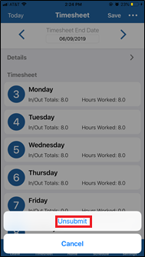
After unsubmitting, a message with a checkbox saying “Timesheet unsubmitted” will pop up briefly. At this point, the employee will be able to make any needed changes to their timesheet. | 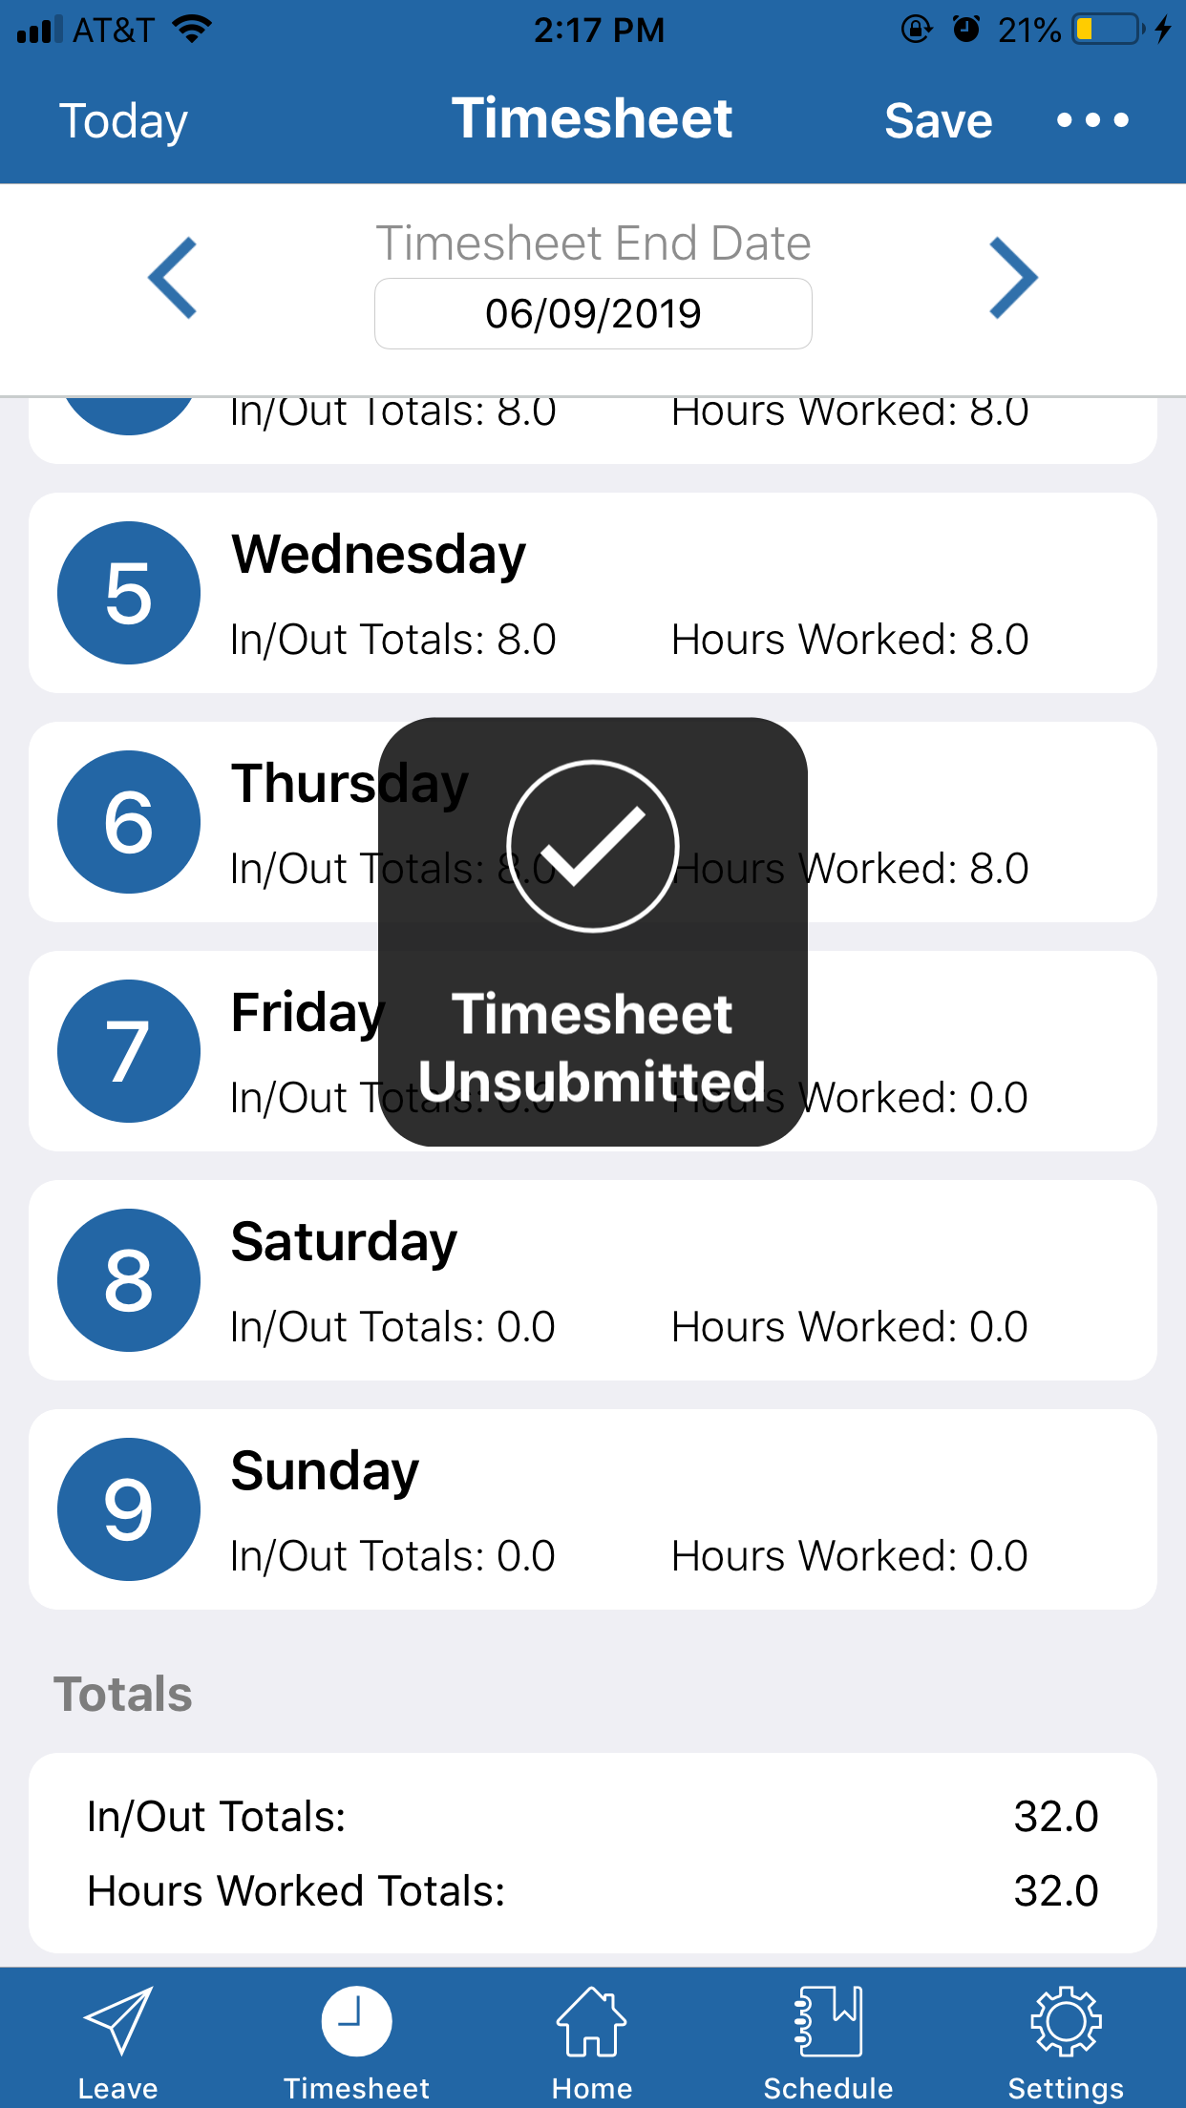
Process Complete

Timesheet Comments

Adding Comments
In order to leave a comment on the Timesheet, you will need to tap the three dots in the top right corner of the Timesheet page. Then, tap the Add Comment button to bring up the Comment box. | 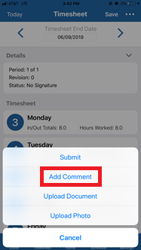
Once the comment box is up, type the comment, and tap the Add button. | 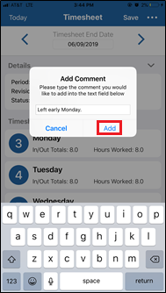
Once the comment is added, a black message with words “Comment Added” will appear over the timesheet. | 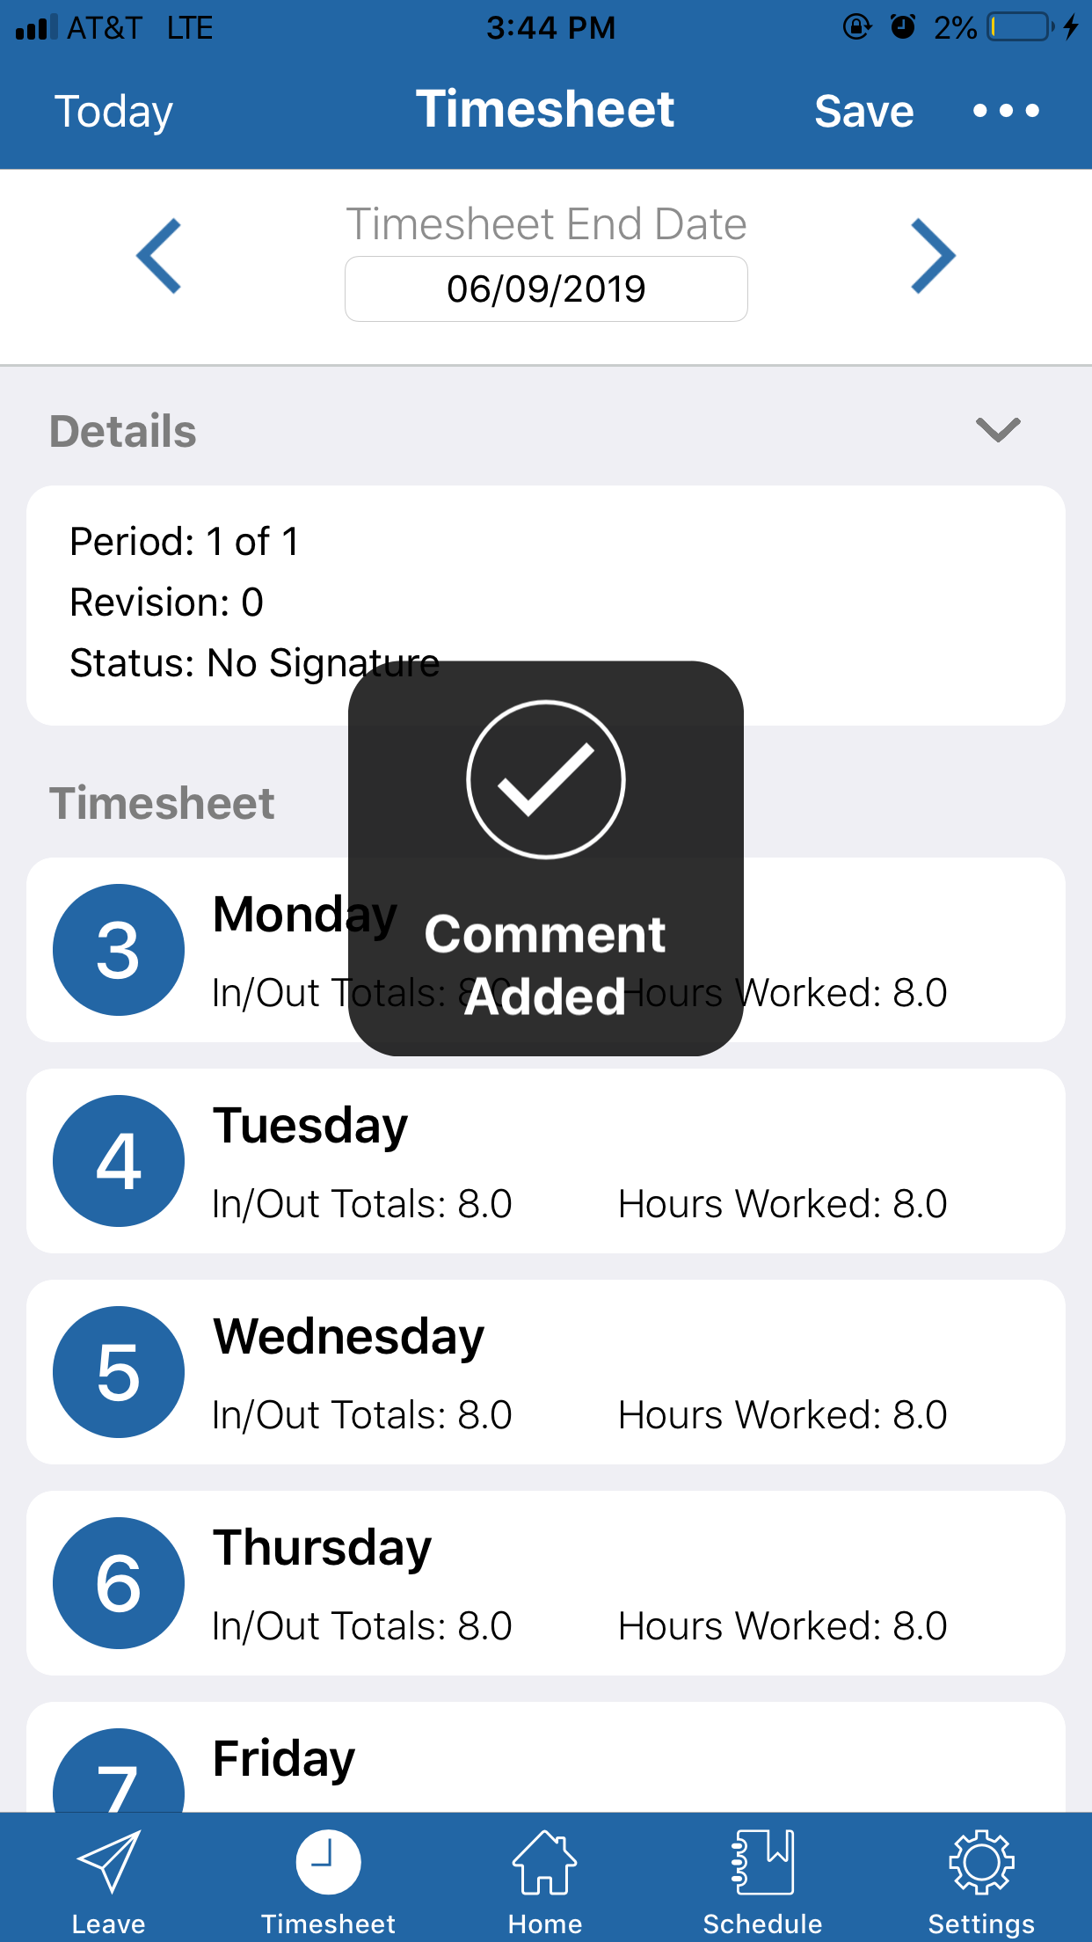
Process Complete

Editing Comments
In order to edit a comment that was already made, press the three dots in the top right corner, and tap “Update Comment.” | 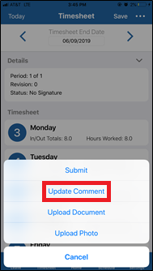
Once the Update Comment box shows up, make any changes needed to the existing comment, and tap Update. | 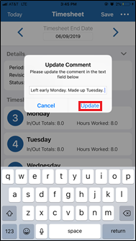
After the comment is updated, a black message with words “Comment Updated” will appear over the timesheet. | 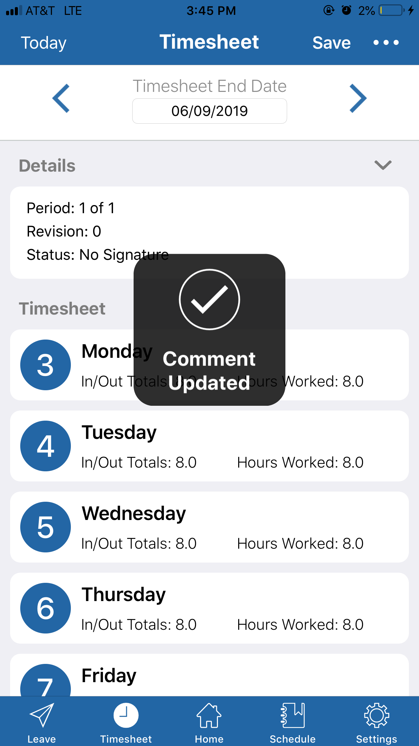
Process Complete

Removing Comments
To remove a comment, simply go through the same process as updating a comment, and delete all of the text in the box, then tap Update. No confirmation message will appear. | 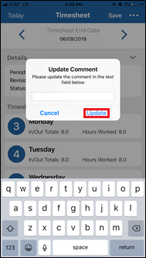
Process Complete

Documents

Adding Documents
To upload a document, the first step is to tap the three dots in the top corner of the Timesheet page, and tap Upload Document. | 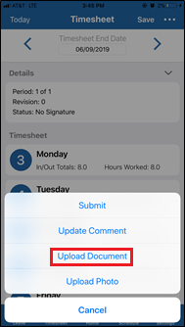
Once Upload Document is tapped, your device will pull up a list of all of the documents saved on your device. Tap the document you wish to upload. | 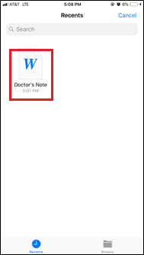
Once you have selected the document you wish to upload, a confirmation message will appear. Tap Upload to upload the document to the Timesheet. | 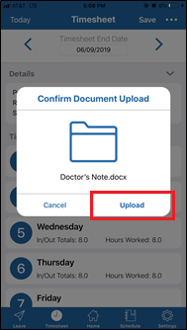
Once the document is uploaded, a black message with words “Upload Complete” will appear over the timesheet. | 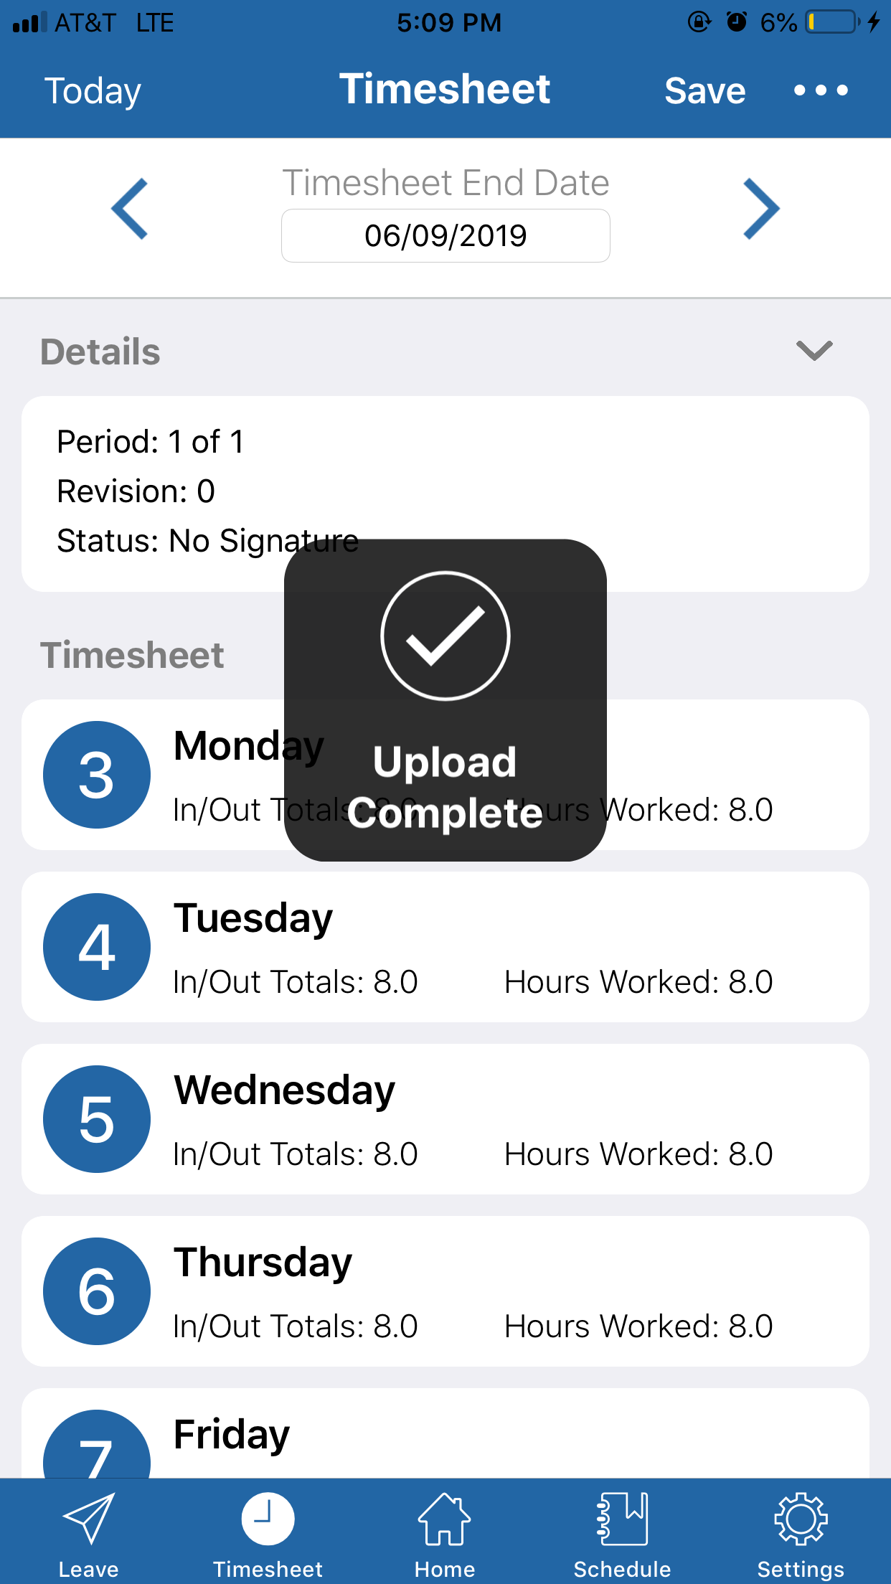

Removing Documents
In order to remove a document, tap the three dots, and then tap Document List. | 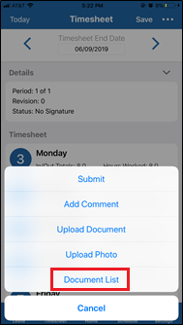
Once you tap Document List, a list of all of the documents you have uploaded to this particular timesheet will populate. Next to the document that you wish to remove, tap the minus (-) in the red circle. | 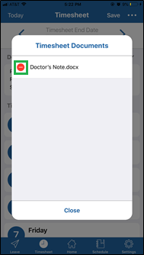
Once the (-) is tapped, tap the button that appears on the right side of the document name. | 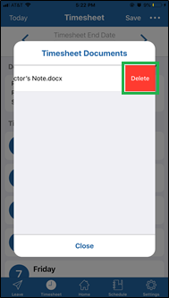
After the document is deleted, you will be brought back to the Timesheet Documents list, and the document will be gone from the list. | 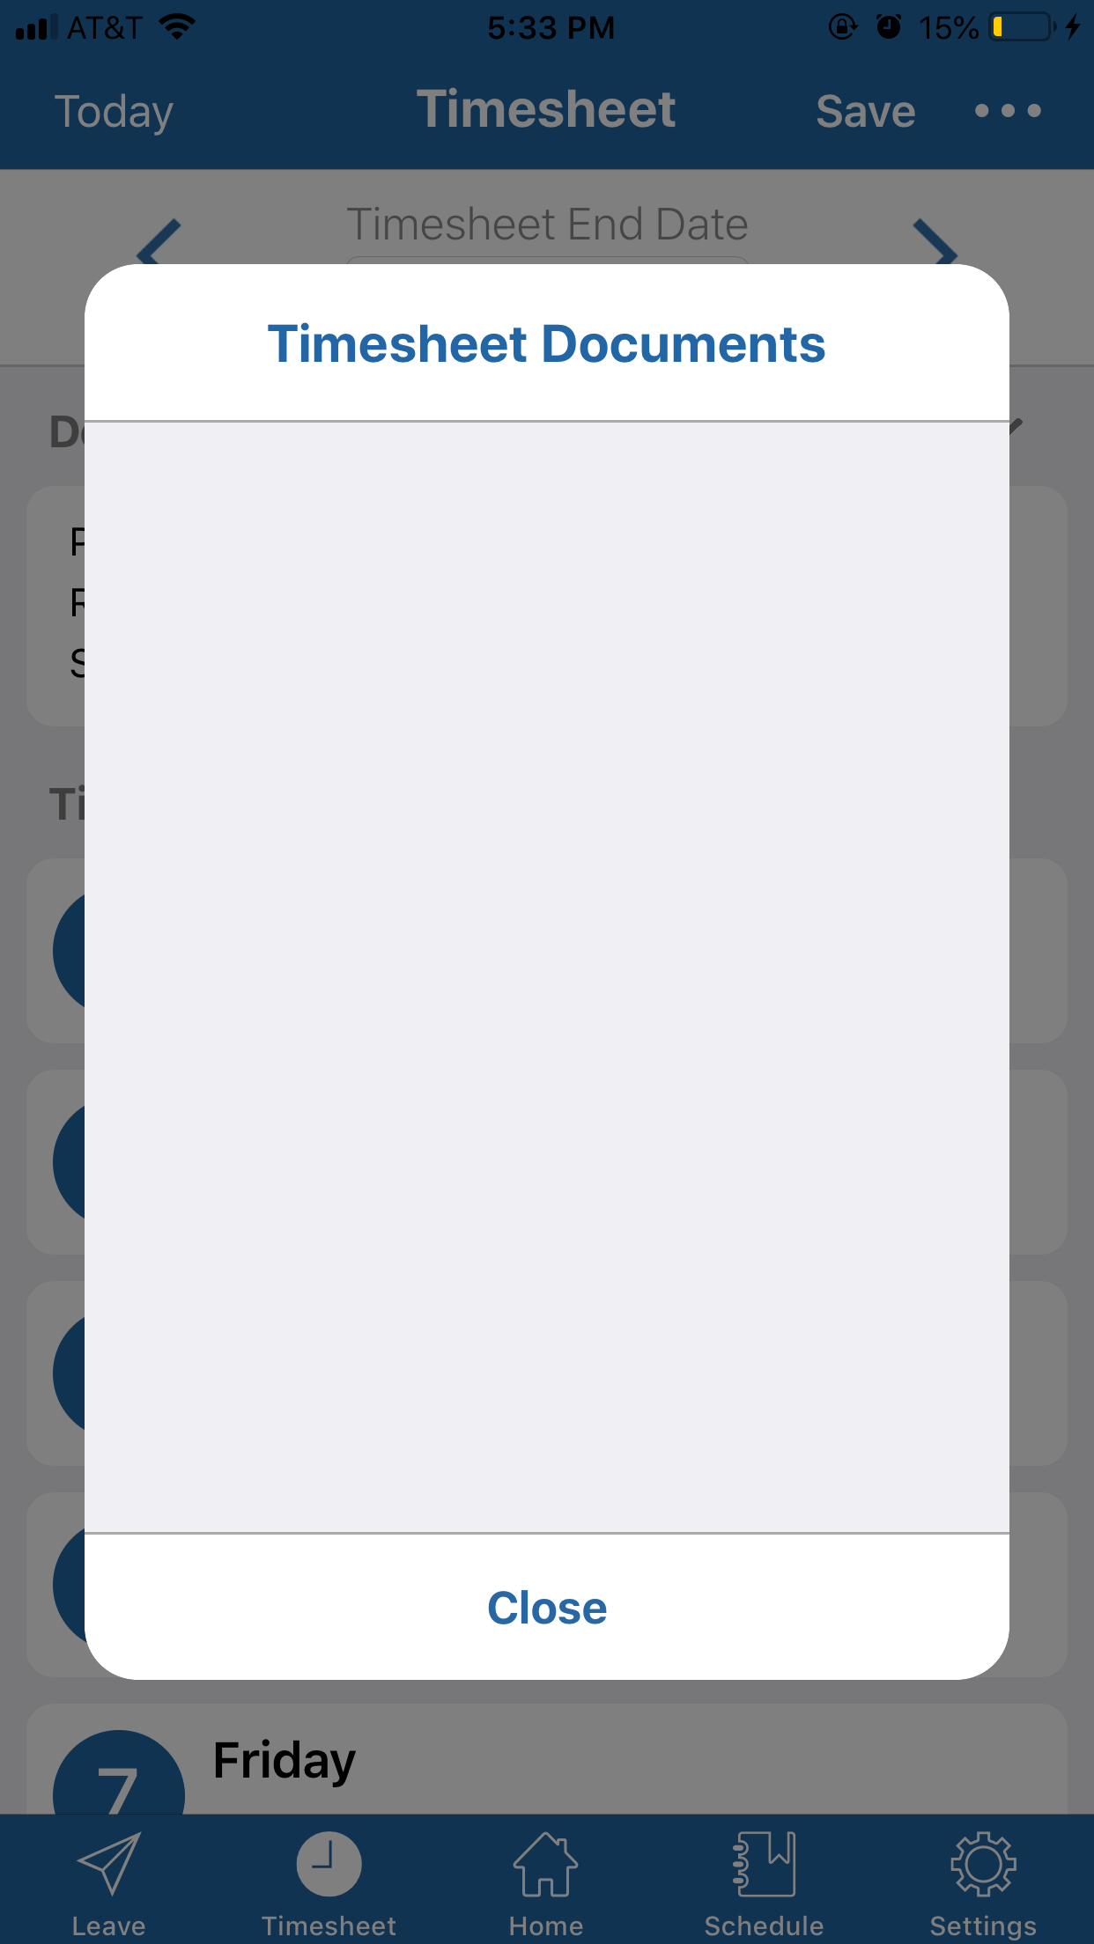
Process Complete

Photos

Adding Photos
To upload a photo, the first step is to tap the three dots in the top corner of the Timesheet page, and tap Upload Photo. | 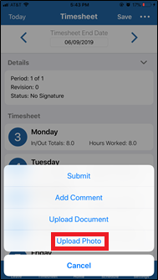
Once you’ve tapped Upload Photo, tap the photo you want to attach. | 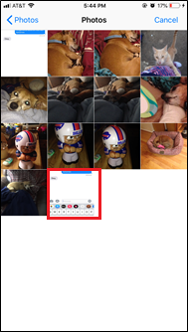
After the photo is uploaded, a black message with word “Success!” will appear over the timesheet. | 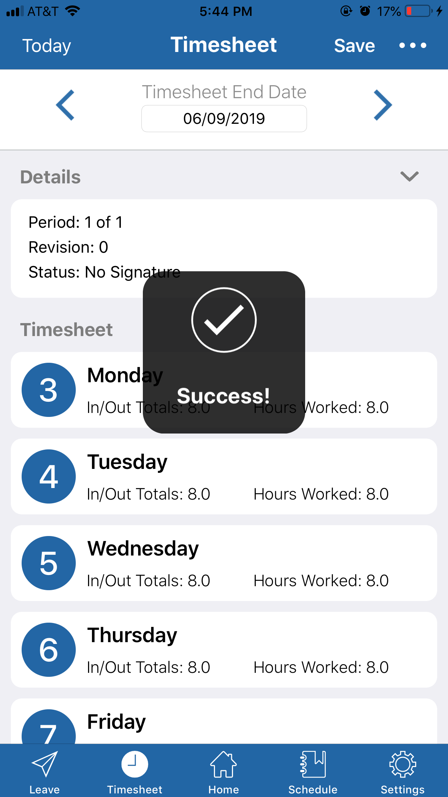
Process Complete

Removing Photos
In order to remove a photo, tap the three dots, and then tap Document List. | 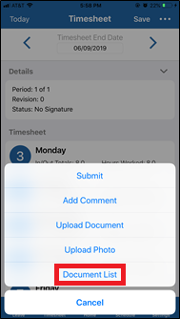
Once you tap Document List a list of all of the documents and photos you have uploaded to this particular timesheet will populate. Next to the photo that you wish to remove, tap the minus (-) in the red circle. | 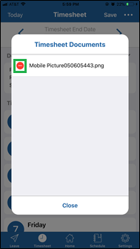
Once the (-) is tapped, tap the button that appears on the right side of the photo name. | 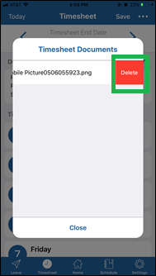
Once the photo is deleted, you will be brought back to the Timesheet Documents list, and the photo will be gone from the list.
Process Complete

Schedule Tab
When you first tap the Schedule tab, it will show you information for the current week, as how many hours you’re scheduled to be working each day. You can use the left and right arrows to look at past and future schedules. Tapping Today in the top left corner will bring you back to the current schedule. | 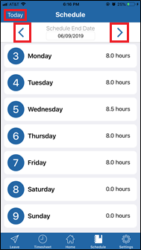
In order to view a certain day with more details, tap on the day you want to view. | 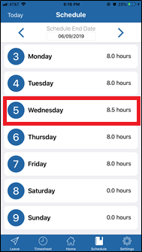
Once you have selected the day you wish to view, you will be brought to the screen for the specific day. The top box will show you your scheduled in/out times. The bottom box will show your Total Hours, amount of Break time, and any comments. | 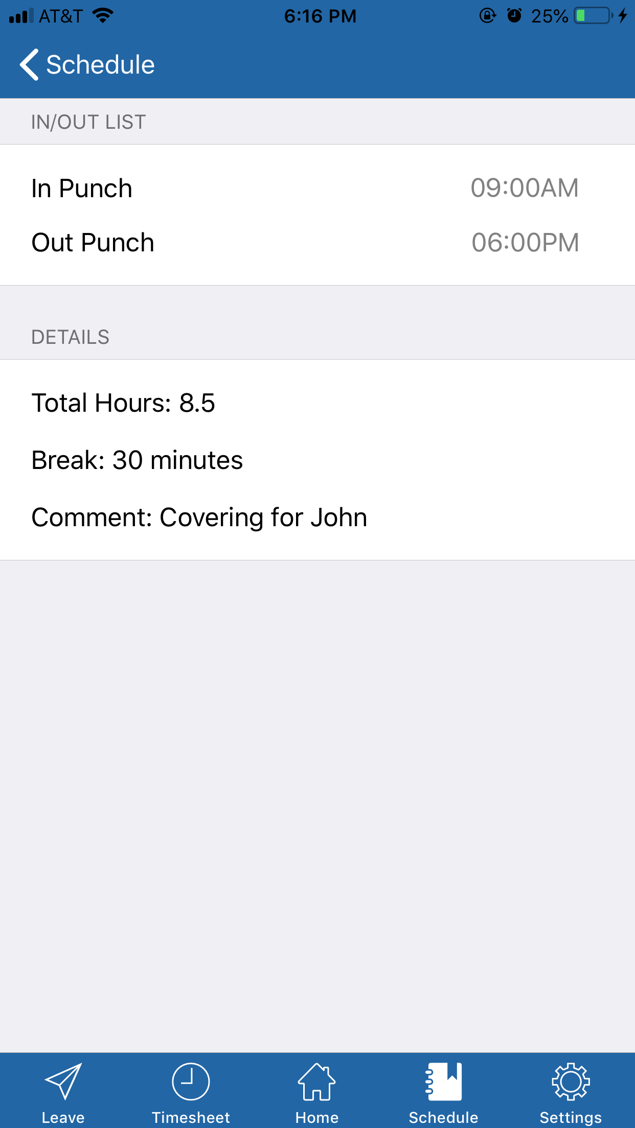
Process Complete

Leave Tab
Once you tap the Leave tab in the bottom left corner, the first thing that is displayed is the list of all leaves available to you, and your current balance for all of these leaves. | 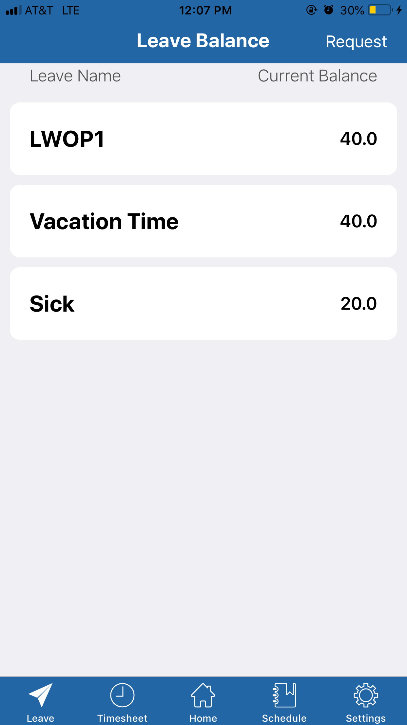
To request leave, the first step is to tap Request in the top left-hand corner, which will bring you to the Leave Request page. | 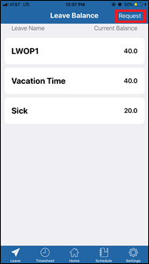
Once on the Leave Request page, you will need to enter the Start Date, End Date, Leave Type, and Hours per day. Today’s date will be the default Start and End Date. | 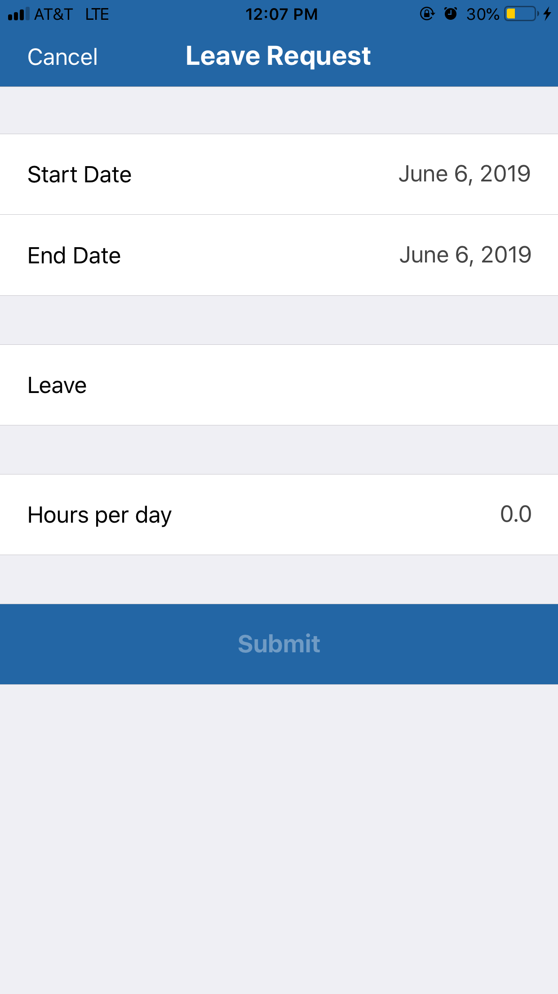
Next, Tap the Start Date, and use the date picker to scroll for the date you wish to start the leave. Once your start date is picked, go through the same process with the End Date. | 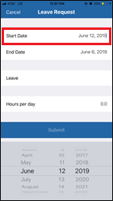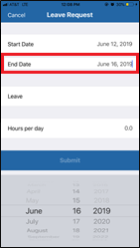
Next, tap Leave, and select the type of leave you wish to request. | 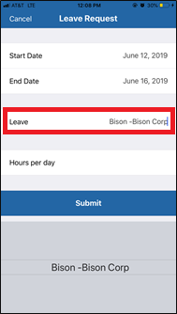
The next step is to tap the Hours per day box, and type the number of hours of the leave that you are requesting to take per day, for that time period. | 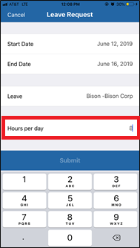
Finally, tap the Submit button to submit your request. | 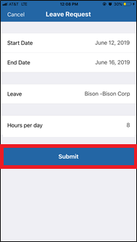
Once your request is submitted, a message will pop up stating “Success Your request for [XX.X] hours of leave has been submitted” | 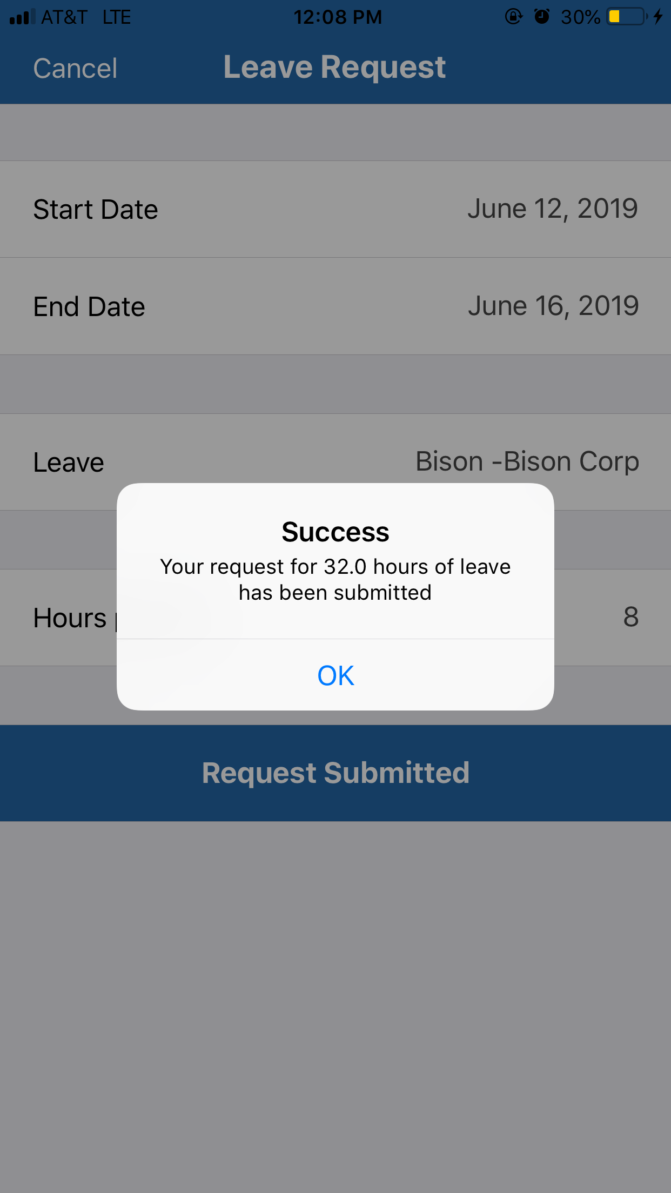
After you tap OK on the confirmation message, it will automatically bring you back to the Leave Balance page.  NOTE: The Leave balances will still be the same after the request, and will not change until the leave is actually taken. | 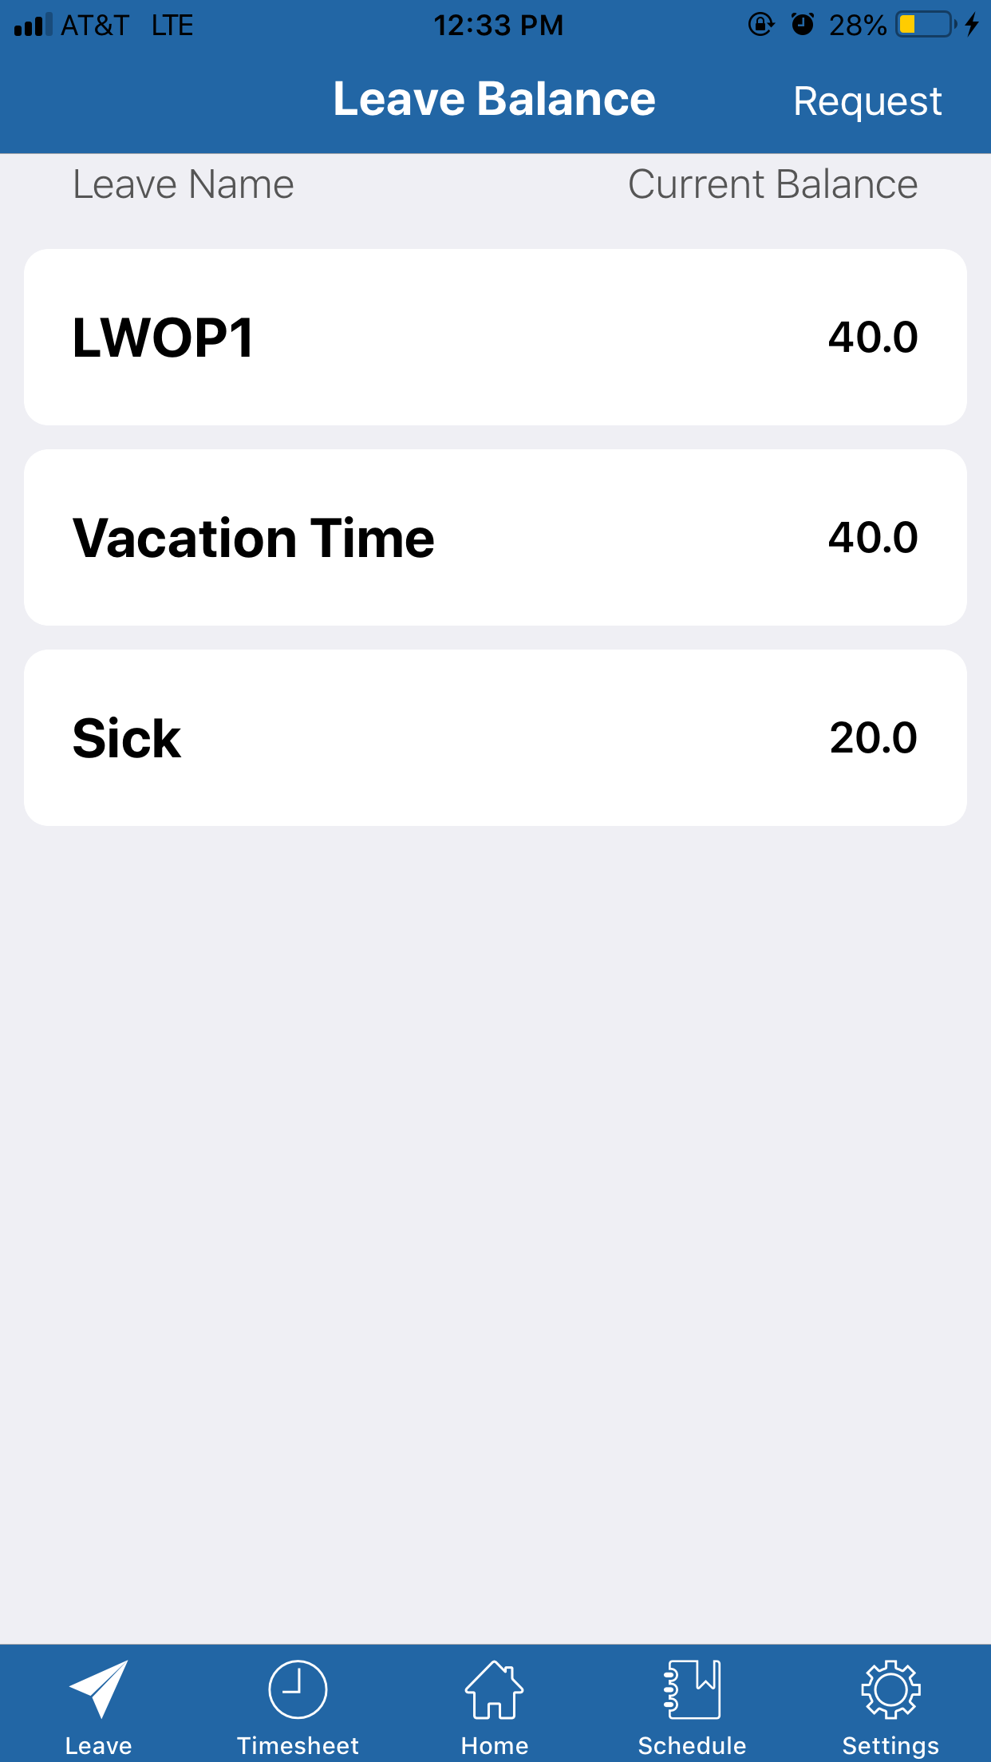
Process Complete

Settings Tab
The Settings tab allows you show or hide code descriptions, enable and disable Touch ID, and allow the app permission to use your location. It will also show you a complete history of transactions made on the app, and show you the license information. | 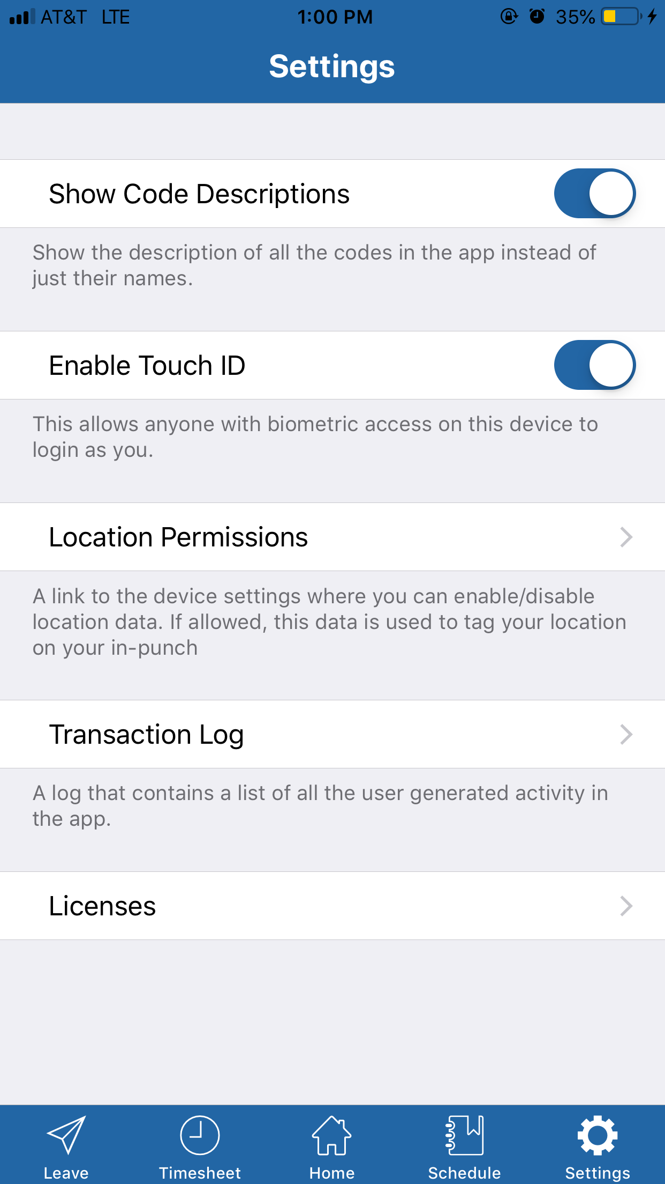
For the Show Code Descriptions option, toggle the switch on if you want to show the descriptions in all of the codes in the app. Toggle it off if to show just the names. | 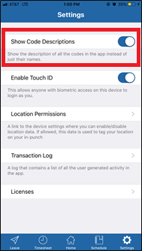
The Enable Touch ID option allows you toggle the switch on if you would like to use Touch ID to login. Toggle it off if you only want to be able to use your password to login. | 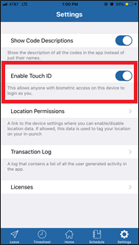
Location Permissions allows you to enable or disable location services for the app. | 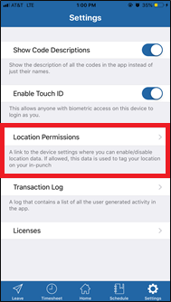
Once you tap Location Services it will bring you outside the app, and to the Clockwise app settings page on your phone. To toggle this, tap Location.  This page will also let you choose whether to allow the app to use cellular data. If toggled off, the app will only transfer data over a Wi-Fi connection. | 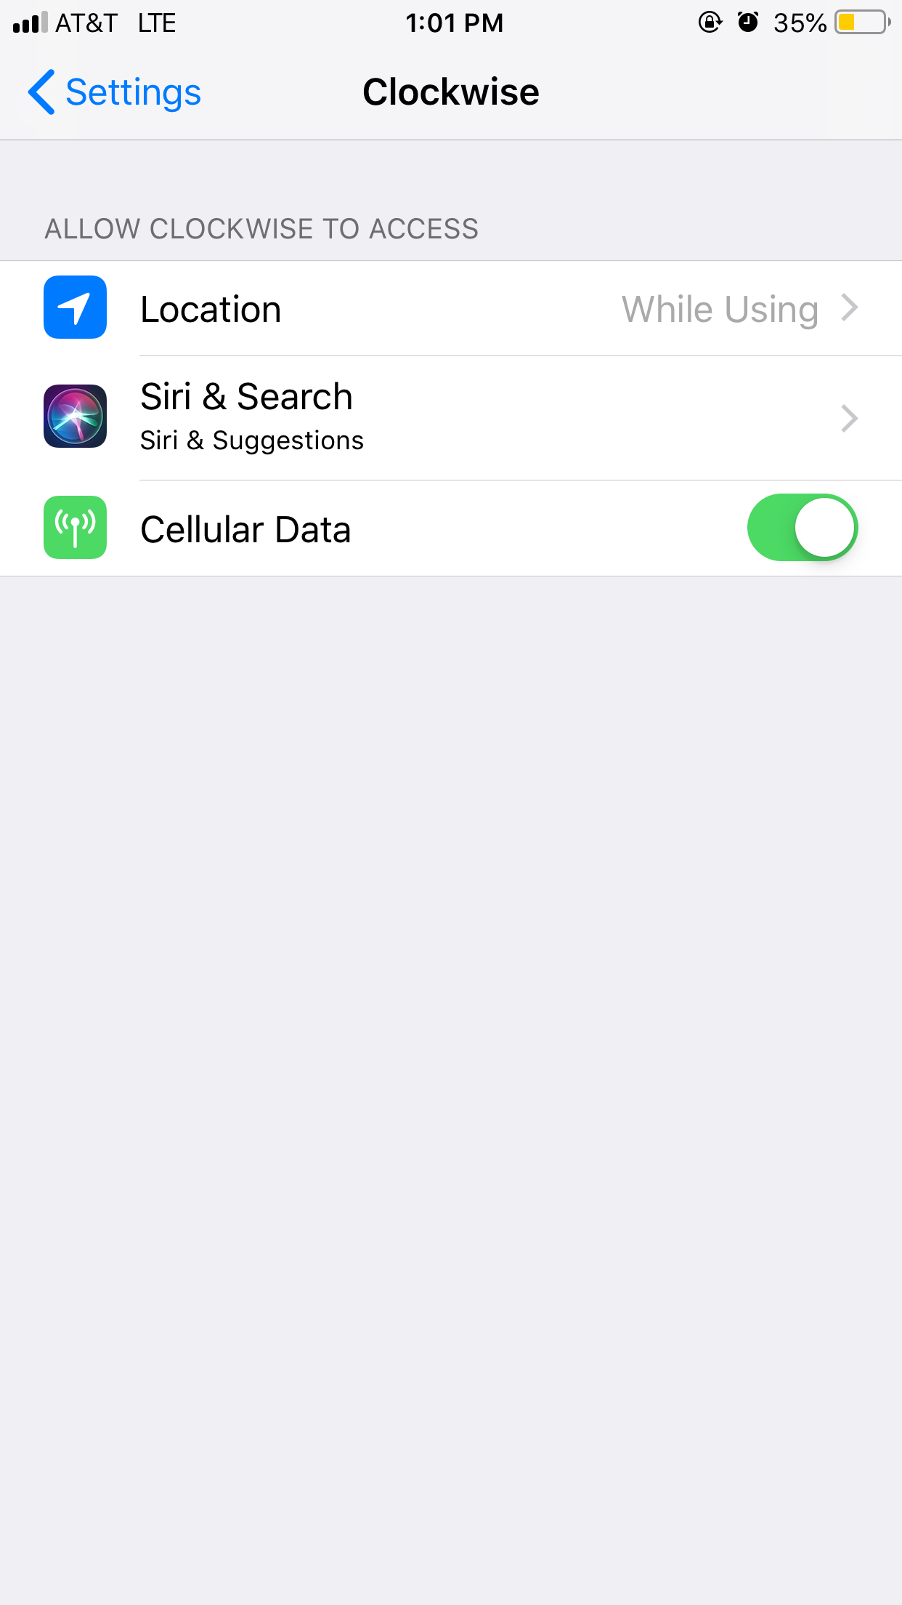
Once you tap Location, it will bring you two options. Never, which completely restricts the app from using your location. The other option While Using the App allows the app to use your location only while in the app. Specifically, tagging your location from where you make a punch. | 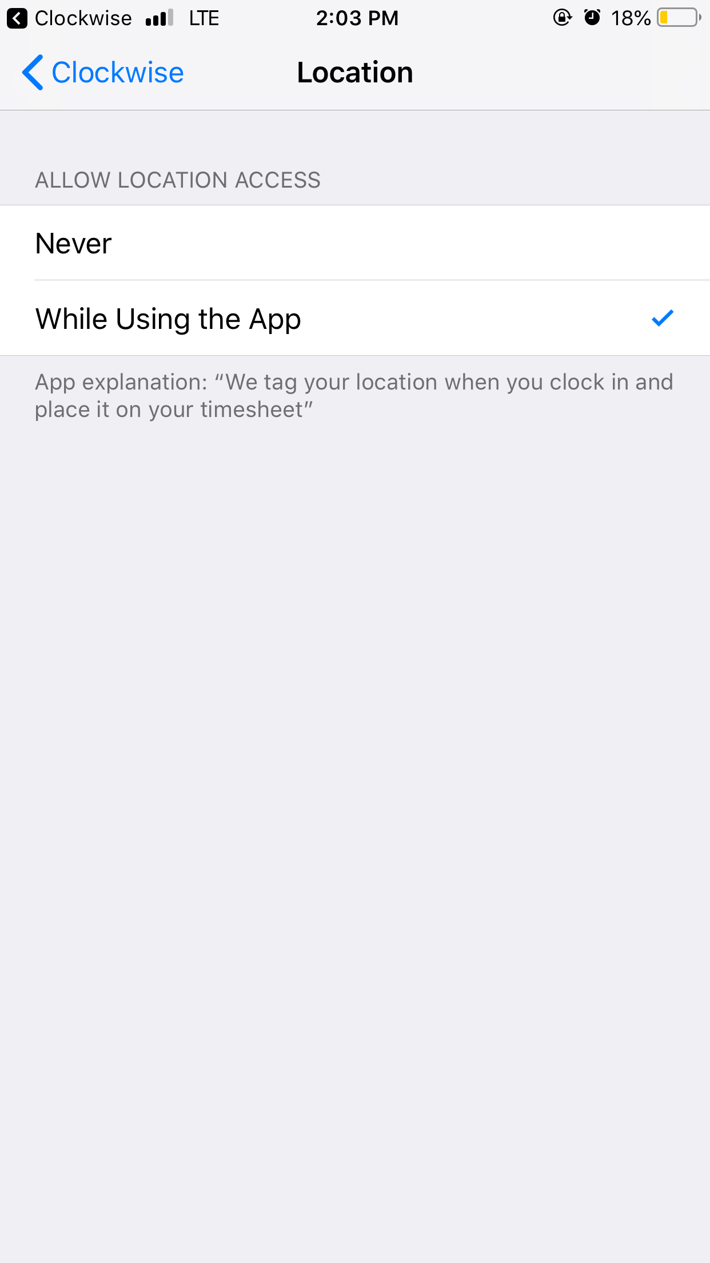
The Transaction Log shows a complete list of all the user generated activity in the app. | 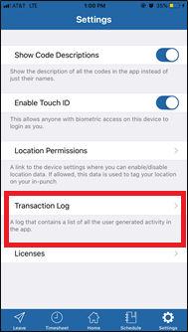
Once in the transaction log, it will show a full list of all transactions made from the app.  NOTE: This will show ALL activities performed by ALL uses that have made transactions from this device. | 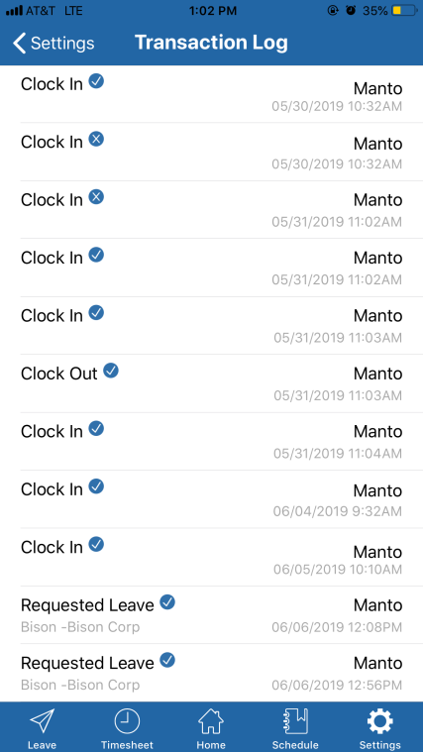
The Licenses tab will show you all of the different licensing used in the app. | 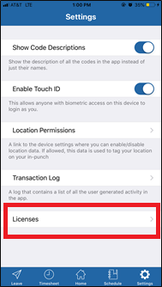
Once on the Licenses page, it will show a list of all of the companies we have licensed to use the app. Tap the name of a specific company for more details. | 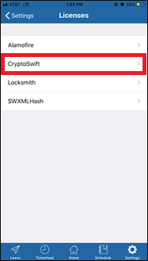
Once you tap a company name, a box with all of the information for the licensing will pop up. | 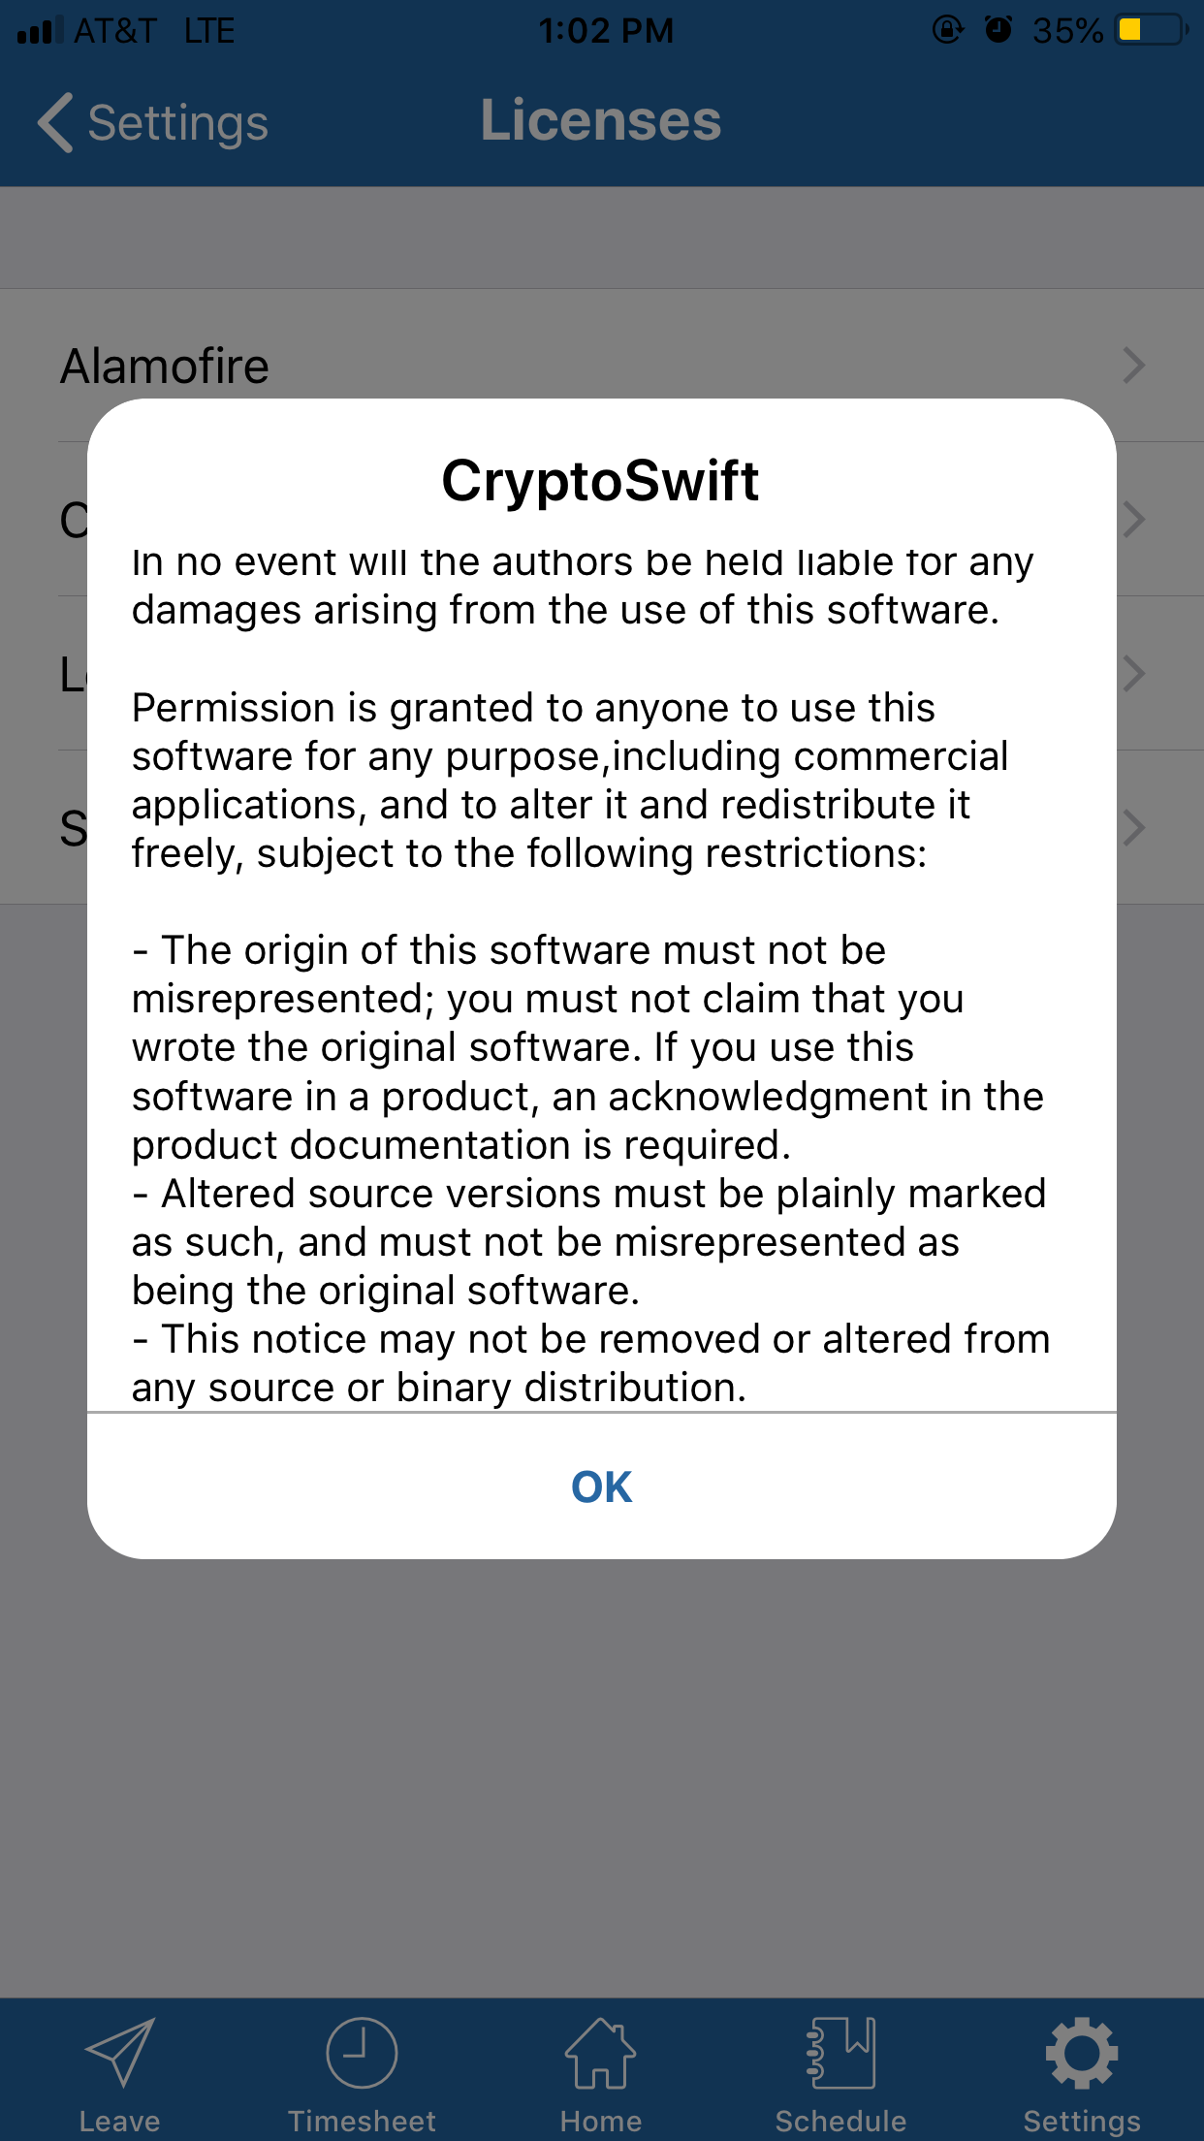

FAQ

Does the Clockwise Mobile app work on iPads?
Although our product is designed to work for the iPhone, it may work on the iPad, but with some known issues. We don’t guarantee that it will work, but if you have issues with our app on the iPad, call our support team, and they will do everything they can to get it to work.
Why has my leave balance not changed after I requested leave?
The Leave balances will still be the same after the request, and will not change until the leave is actually taken.
Why does my phone not show the Touch ID option?
This feature is only available on iPhone 5S and later.
Will this user guide help with using the Android version of the app?
This guide will walk users through the main processes and features of the iOS app. While similar, there are a few minor differences between the iOS and Android apps, and we do have a guide specifically for Android users as well.
Why do exempt employees still have the options to clock in and out?
The In/Out are a built-in feature of the mobile app, but should not be used by any user who does not have In/Outs visible on their timesheet. The remaining features are still accessible.

