Mobile App User Guide for Android

Webster, Texas 77598 Published: June 2019  www.goclockwise.com | Clockwise by GHG Corporation  960 Clear Lake City Blvd Document By: Joe Driscoll
Version 1.0

Table of Contents
Introduction 3
Requirements 3
Login Process 4
Timesheet 8
In/Out Punches 9
Adding Punches 9
Editing Punches 12
Removing Punches 15
Hours Worked 17
Adding Hours Worked 17
Editing Hours Worked 23
Removing Hours Worked 25
Timesheet Submission 27
Submitting Timesheets 27
Unsubmitting Timesheets 29
Timesheet Comments 30
Adding Comments 30
Removing Comments 34
Timesheet Documents 35
Adding Documents 35
Removing Documents 37
Schedule Tab 39
Leave Tab 41
Settings Tab 45
FAQ 50

Introduction
Clockwise strives to provide the easiest to use time and attendance system for both management and employees. This user guide will explore our mobile app on Android products. This new app will allow employees to use many of the features of the Clockwise website, from the convenience of their Android phone or tablet. They will be able to clock in, clock out, add hours, and submit their timesheet. They will also be able to request leave, and view their schedule.

Requirements
The following is required to use the Clockwise Android app:
- Site version 7.5.3.12 or higher
- Android Software version API 19 or higher
- Device ID assigned to the user
- Internet Access
- Must allow outside access (for self-hosted only)
- 3MB Size

Login Process
When you first open the app, the first thing you will see is the login screen. | 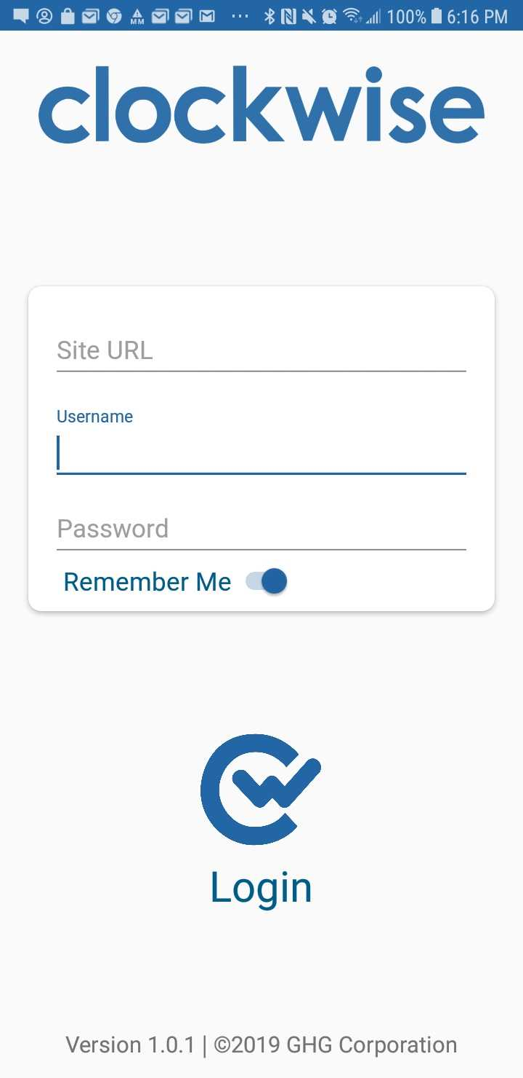
The first item to type in will be the URL for your company’s Clockwise site. | 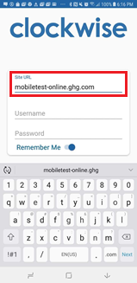
Once you’ve typed in the URL, you will need to enter your username. | 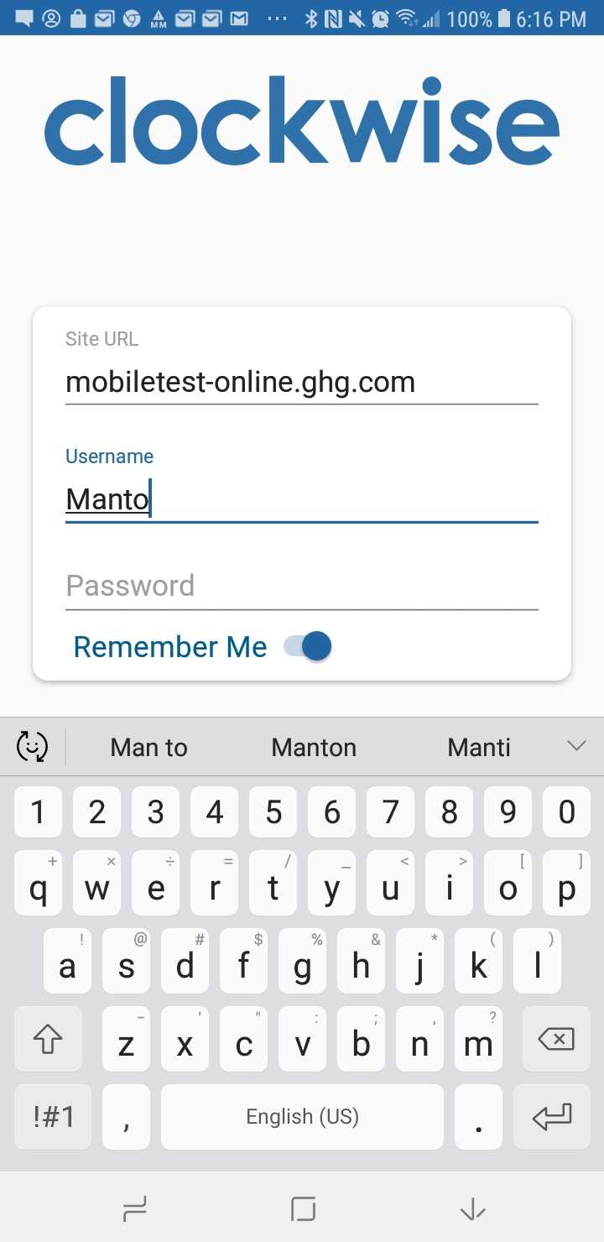
Once your username is entered, type your password. | 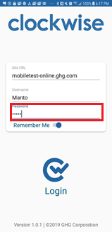
Selecting “Remember Me” will save the URL and the username. You would still need to enter your password every time you log into the app. | 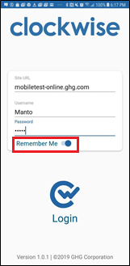
Once all of the information is entered, select the Clockwise Logo at the bottom to log in. | 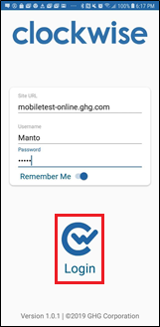
Once logged into the app, you will see the home screen. It will show your name, as well as your most recent punch. From here, you can tap ‘Clock In’ or ‘Clock Out’ to record an in or out punch respectively. To navigate anywhere in the app, open the hamburger menu in the top right-hand corner.
From the menu, you can choose Home, Timesheet, Leave, Schedule, and Settings. You can also log out from here. | 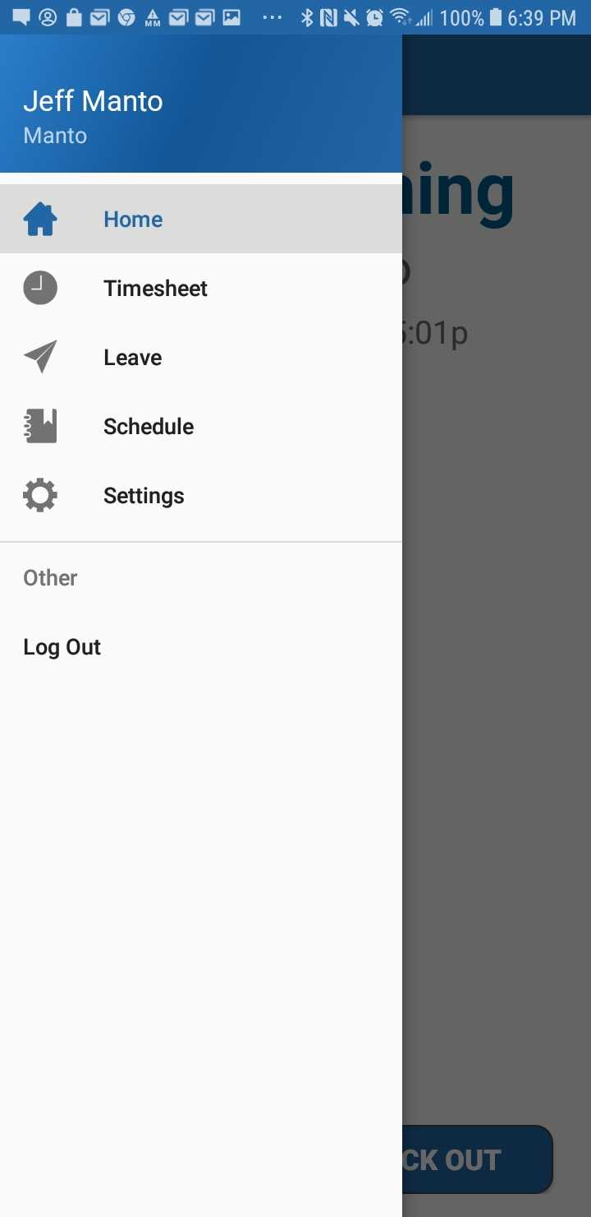
Process Complete

Timesheet
When you first open the Timesheet page, you will see the current timesheet. You can use the arrows to the left and right of where it says Timesheet End Date to scroll through past or future timesheets. It also shows the In/Out Totals and Hours Worked for each day during that timesheet. Tapping on that date will bring you to a more detailed breakdown of the selected day. | 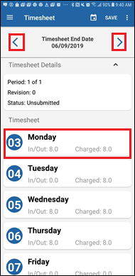
Once you tap the day, you can see the specific details for that day. This includes all In and Out punches, and which groups, pay types, charge codes, and tasks have been assigned.  This page also shows the In/Out and Hours Worked Totals. Tapping the Plus Sign (+) in the top left corner will allow the employee to Add In/Out punches, or hours worked. | 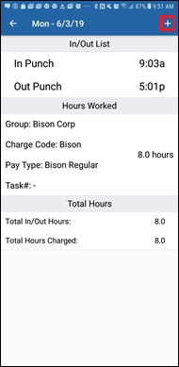

In/Out Punches

Adding Punches
To manually add an In or Out punch, first go to the details for the day you want to add punches on. Once there, tap the plus sign in the top right corner of the screen, then tap In/Out. | 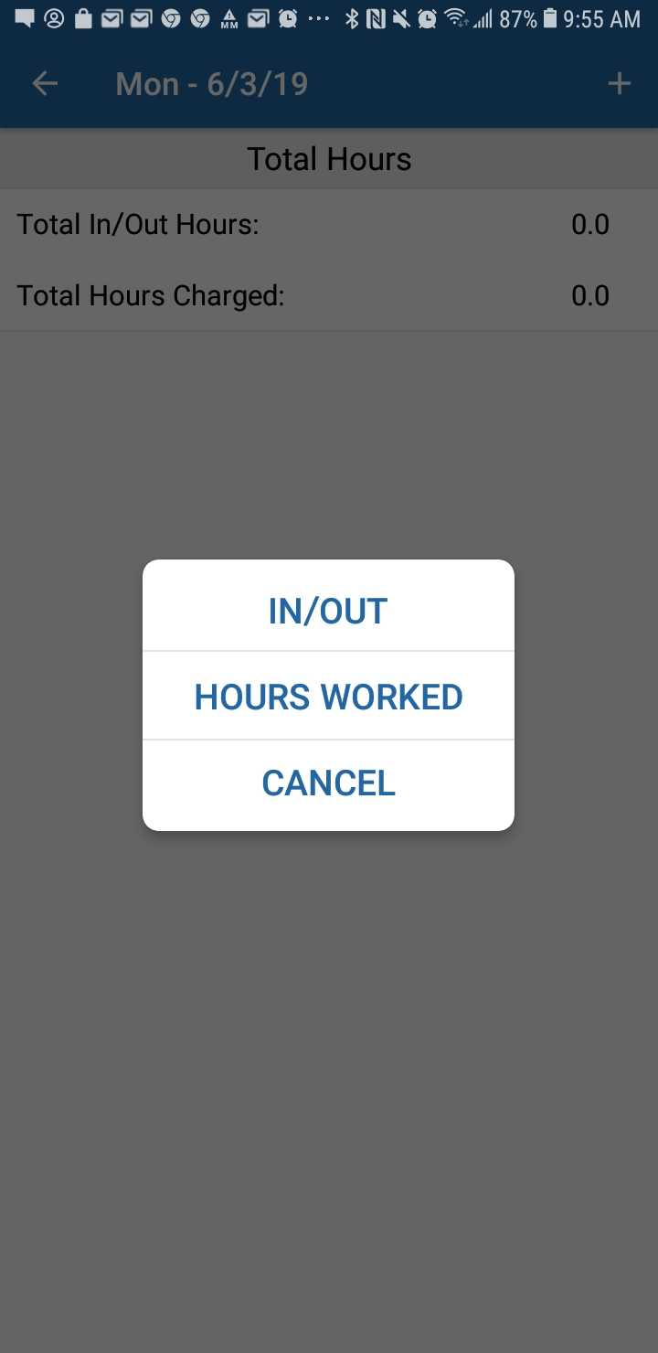
The Add In/Out page is where you manually enter any in and out punches. This is also where you would enter any Charge Codes or Tasks associated with the punches. To add a new punch, tap ADD in the top right-hand corner. | 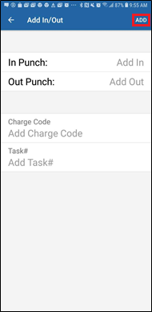
Next, tap the In Punch or Out Punch field, use the time picker to enter the time. Once the times have been entered, select OK when finished. | 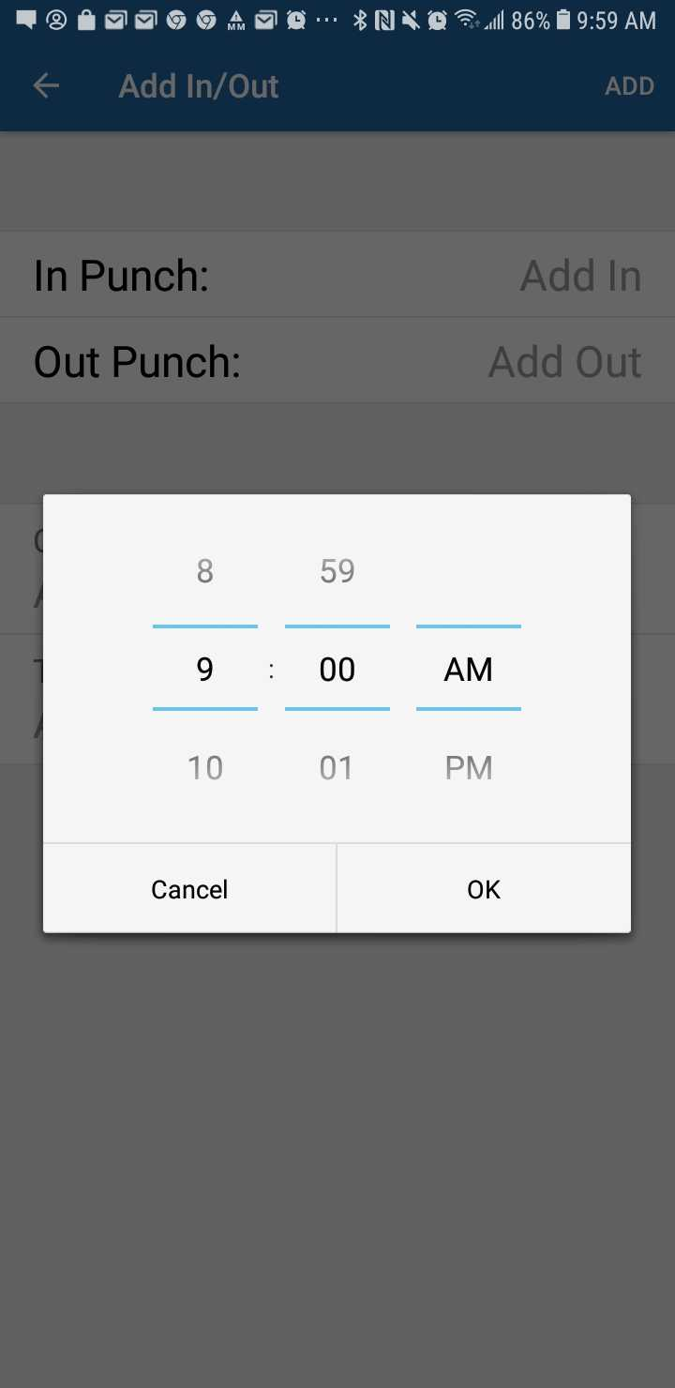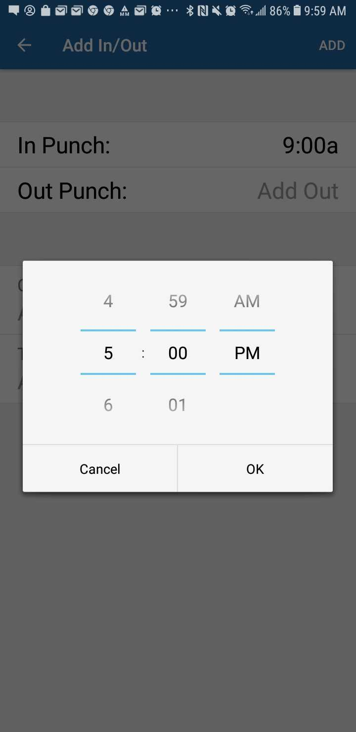
Once the times for the punches have been entered, the employee will also have the option to add a Charge Code and/or Task to this specific set of punches. | 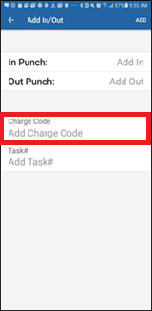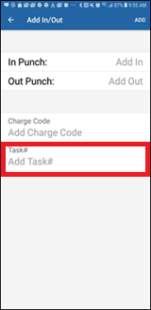
Once finished entering your punches, tap Add in the top right corner. | 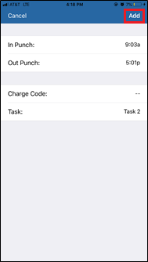
After adding the punches, you will be brought back to the details for that day. If you need to edit the punches after adding them, tap on the IN/OUT LIST box. | 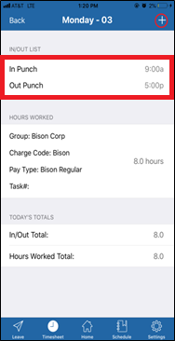
Process Complete

Editing Punches
To edit a punch, first, tap the set of punches you wish to edit from the detail page for that day. | 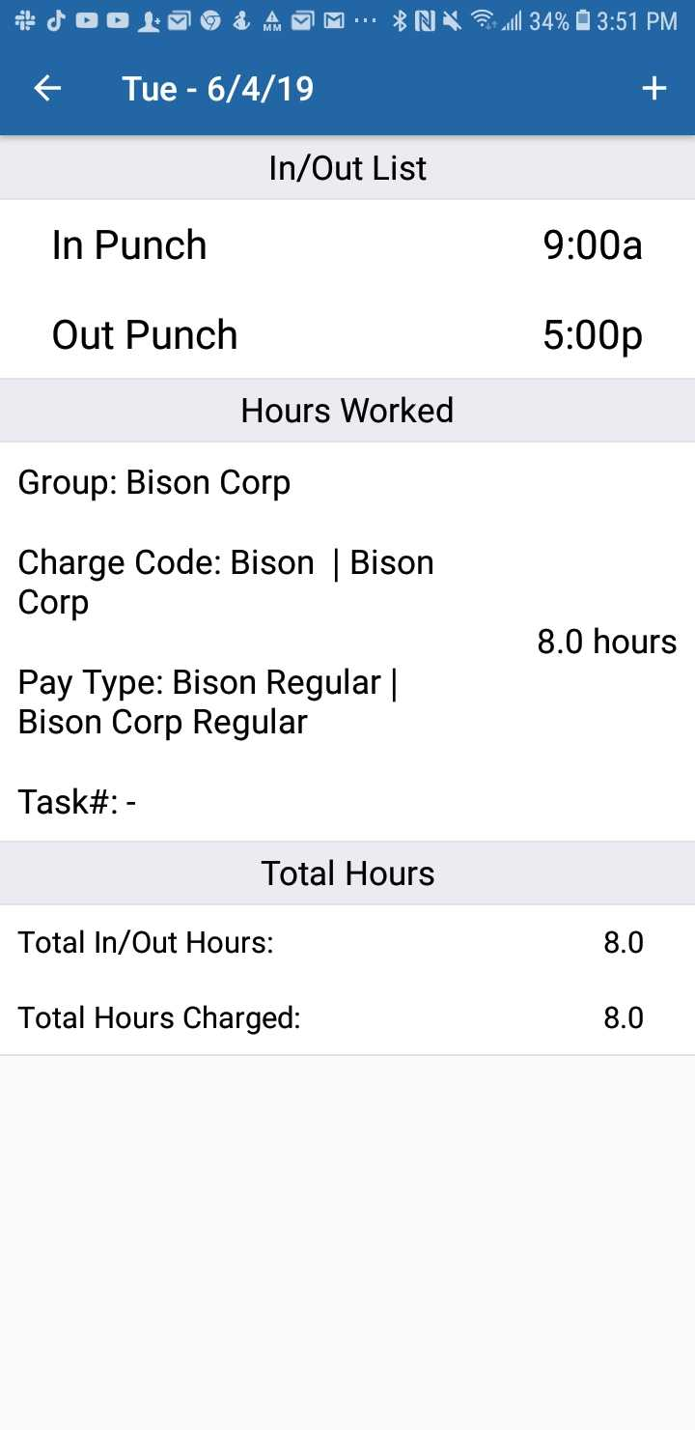
Once you have tapped the set of punches you need to edit, tap the specific punch that you are editing. | 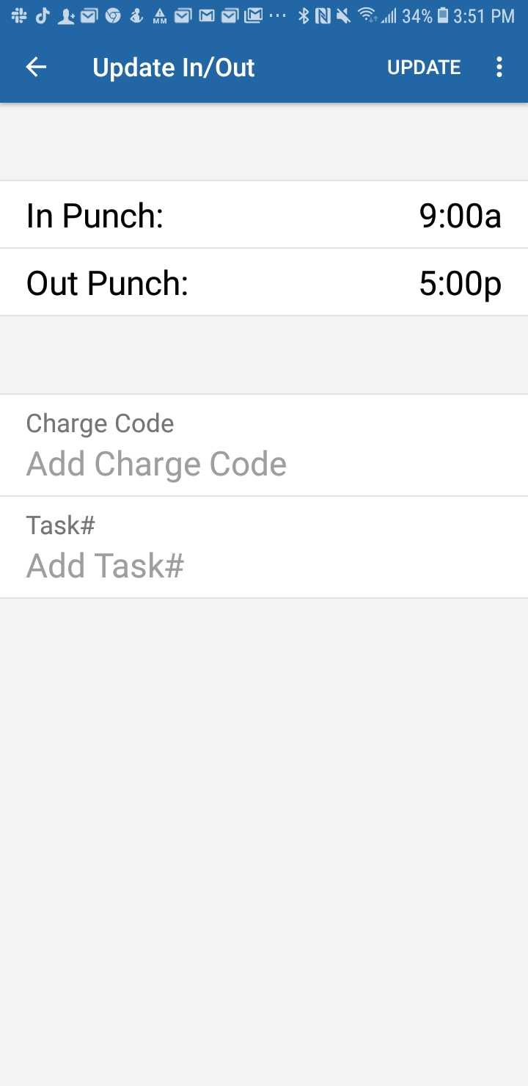
Next, use the time picker to change the punch to the appropriate time. Once done, tap OK. | 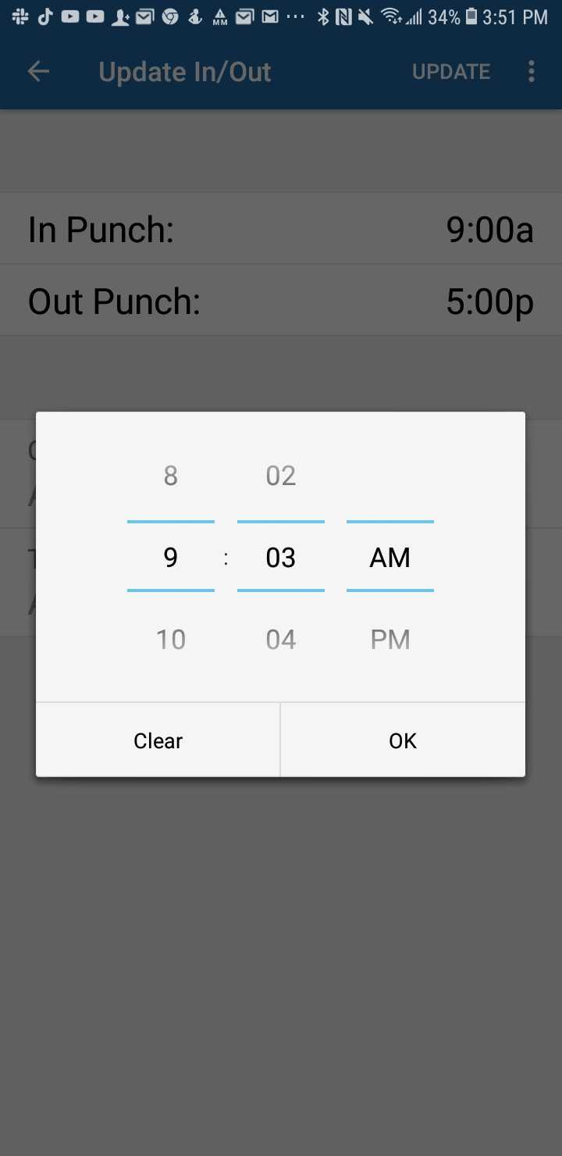
Finally, once you have made the needed changes, tap UPDATE in the top right corner. | 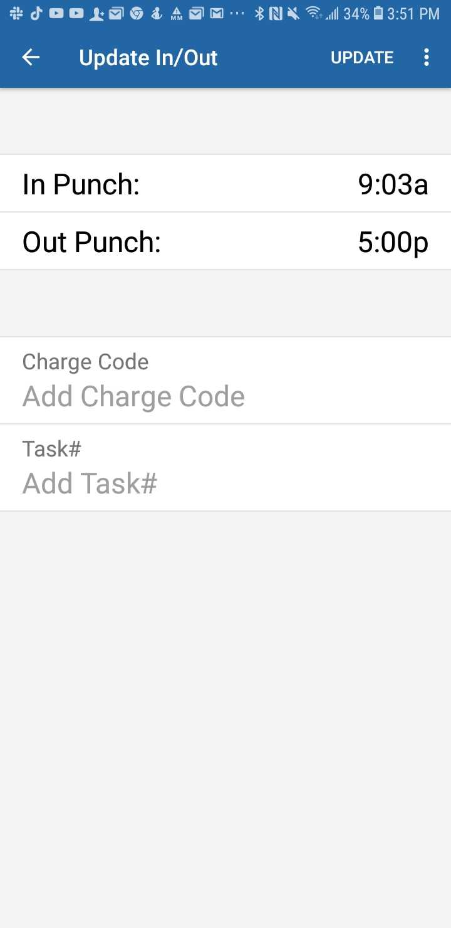
After tapping UPDATE you will be brought back to the details for the day, with the punches correct. Be sure to tap the back arrow and then SAVE to ensure that the changes are saved. | 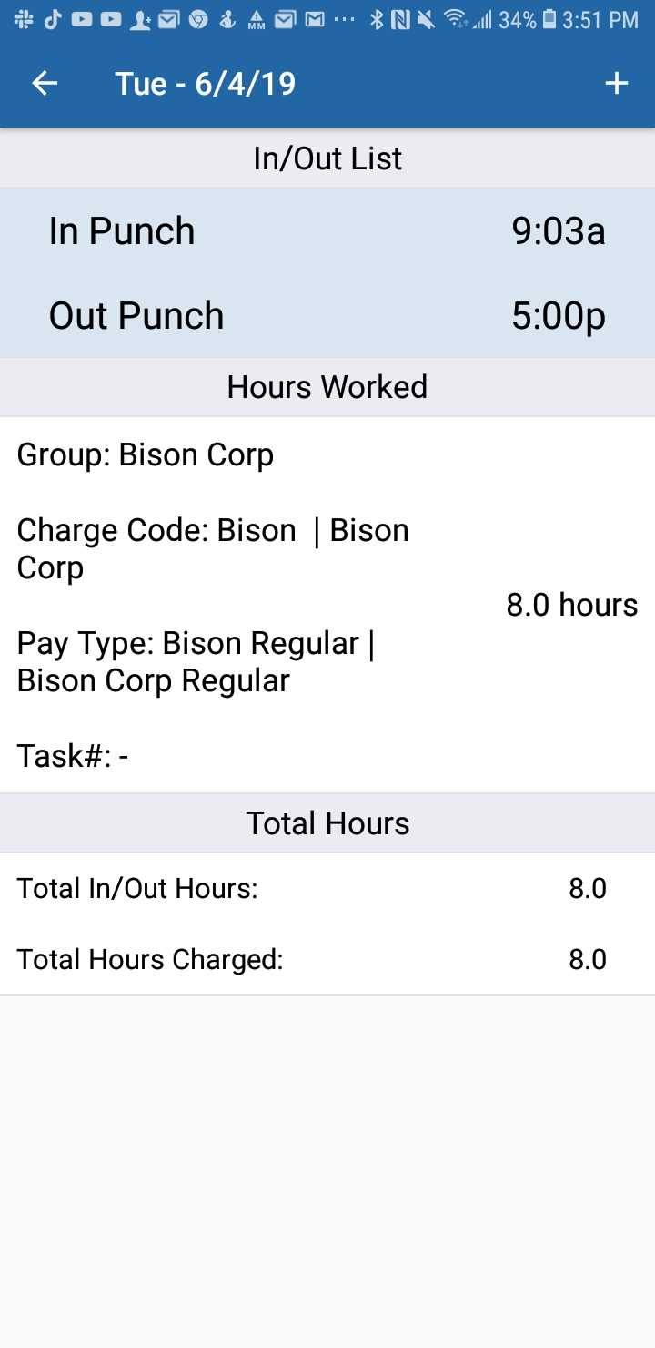
Process Complete

Removing Punches
In order to delete a set of punches, you would need to go to the details page for that specific day, and tap on the set of punches you wish to remove. | 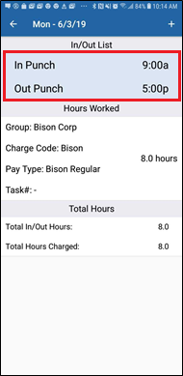
After you have selected there will be three dots in the top right corner. Tap those, and tap the Delete button that appears. | 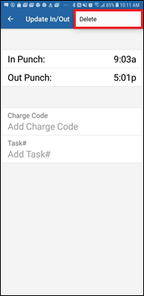

Once you have tapped the delete button, a confirmation message will appear asking “Are you sure you want to delete this in/out pair?” Tap yes. | 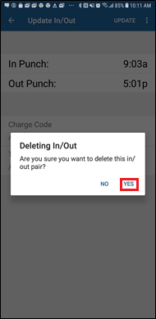
Once the punches are removed, you will be brought back to the day’s page, and the punches will be gone. | 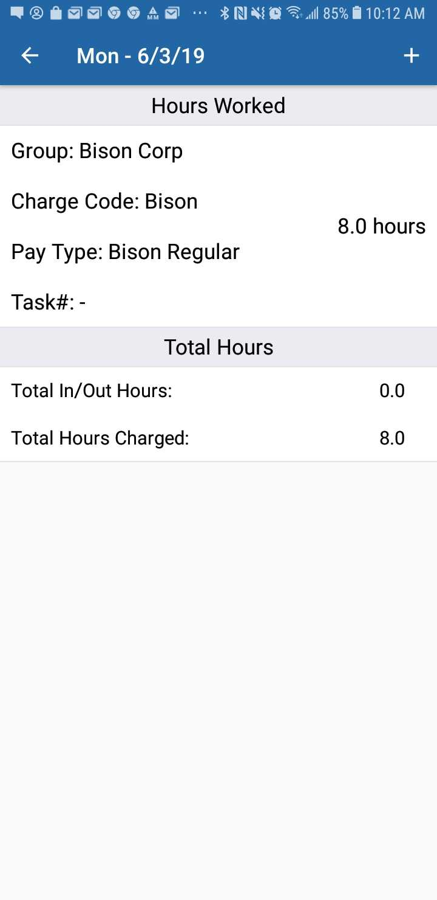
Process Complete

Hours Worked

Adding Hours Worked
To add Hours Worked, tap the plus sign in the top right corner of the screen, then tap Hours Worked. | 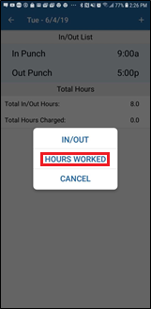
After tapping Hours Worked, the app will take you to the Add Hours Page. | 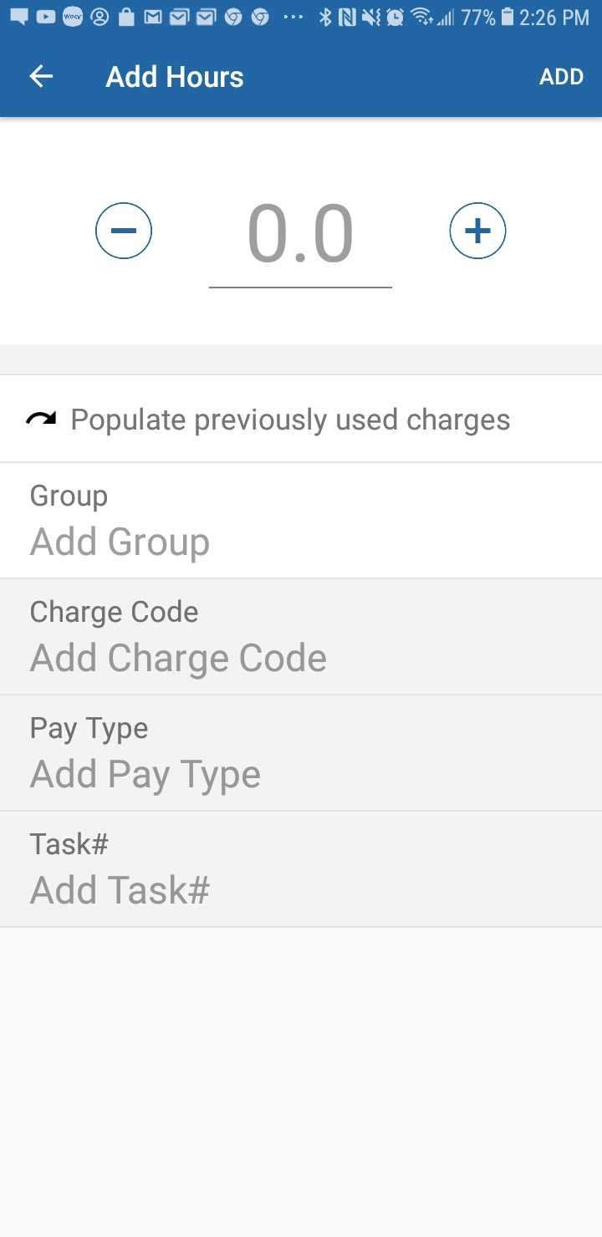
Process Complete
You can use the Plus (+) and Minus (-) buttons to add or subtract in one-hour increments. | 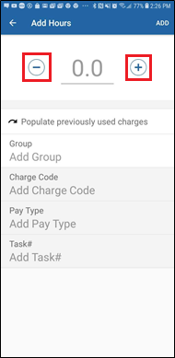
If you tap the number, you can type a specific number in tenths of an hour. | 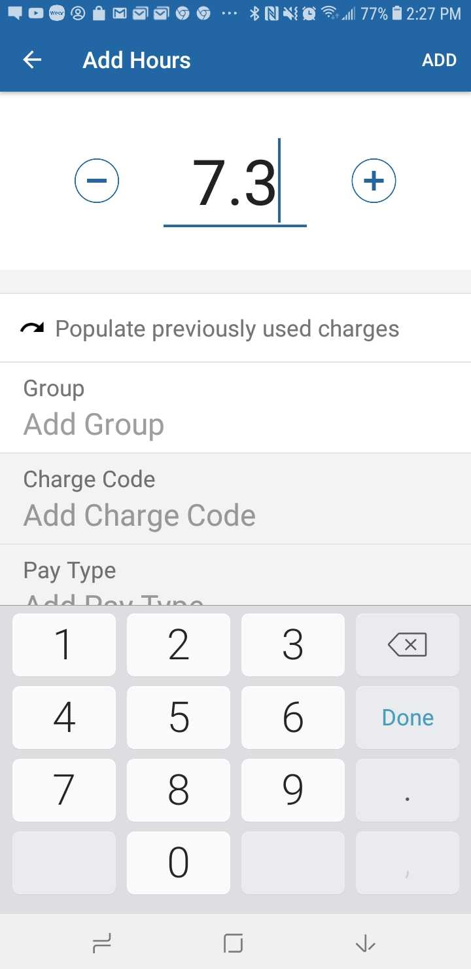
Once the hours are entered, tap the Group box to enter the Group associated with these hours. | 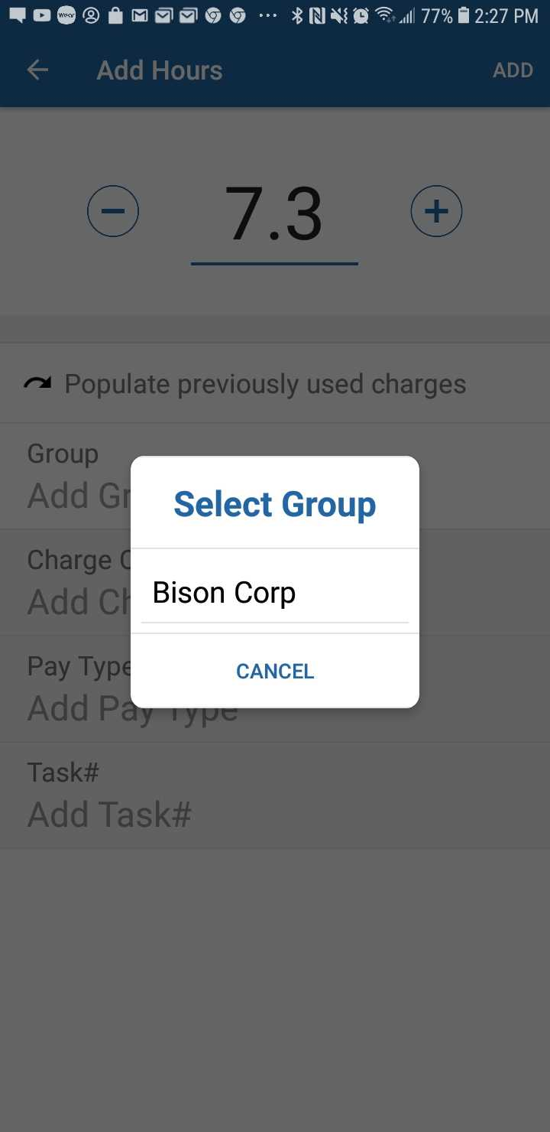
Once the Group is entered, tap the Charge Code box to enter the Charge Code associated with these hours. | 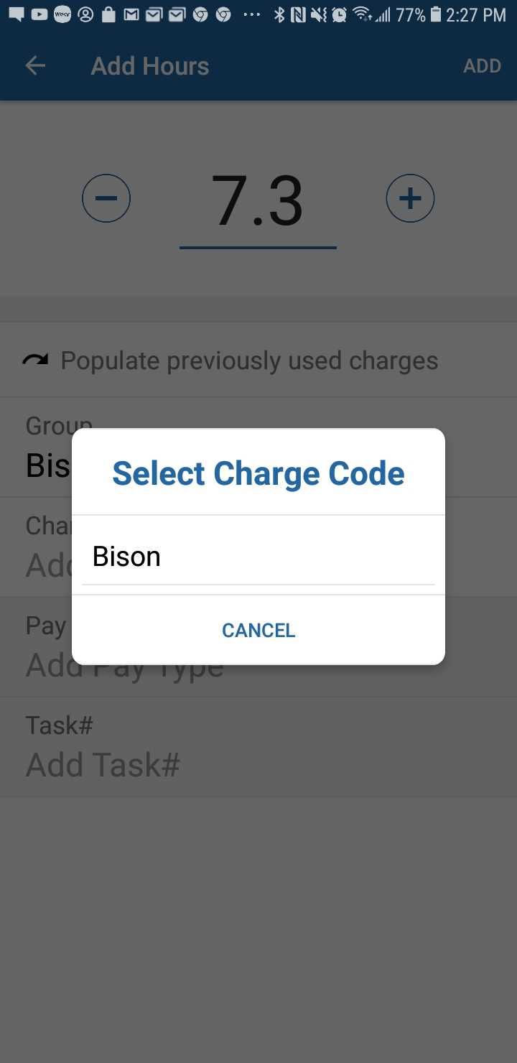
After choosing a Charge code, tap the Pay Type box and select the pay type needed. | 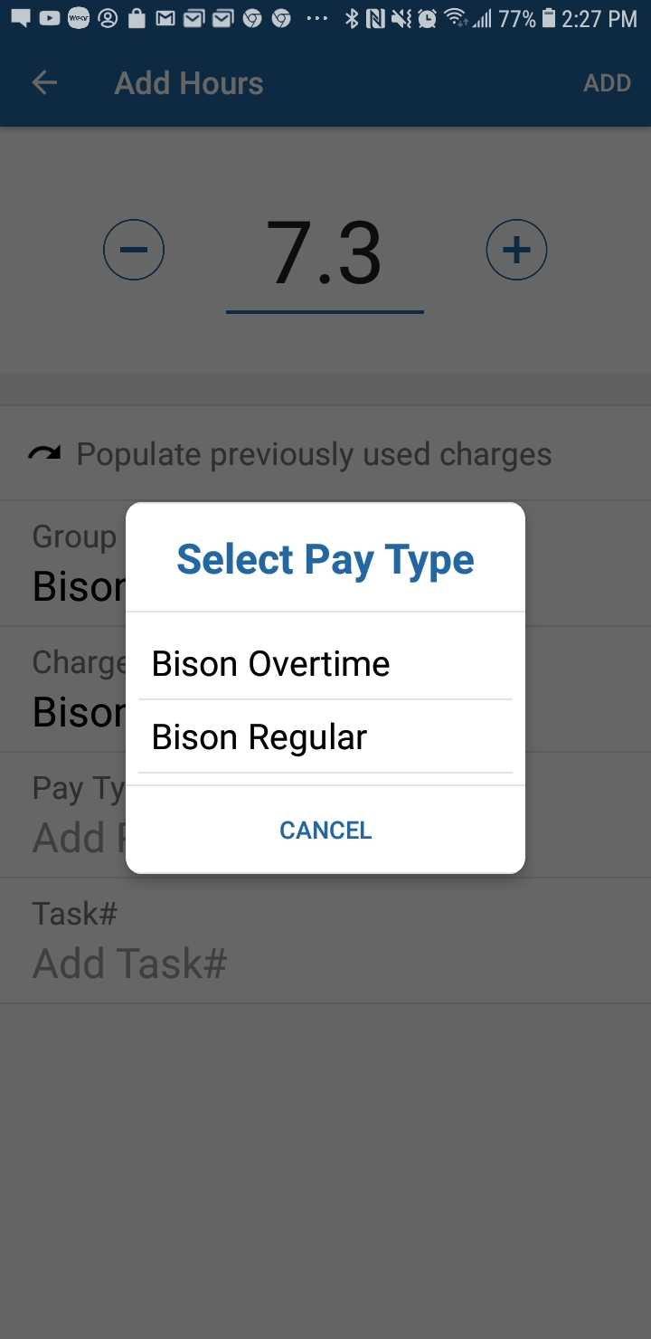
Finally, tap the Task # box, and select the appropriate task. | 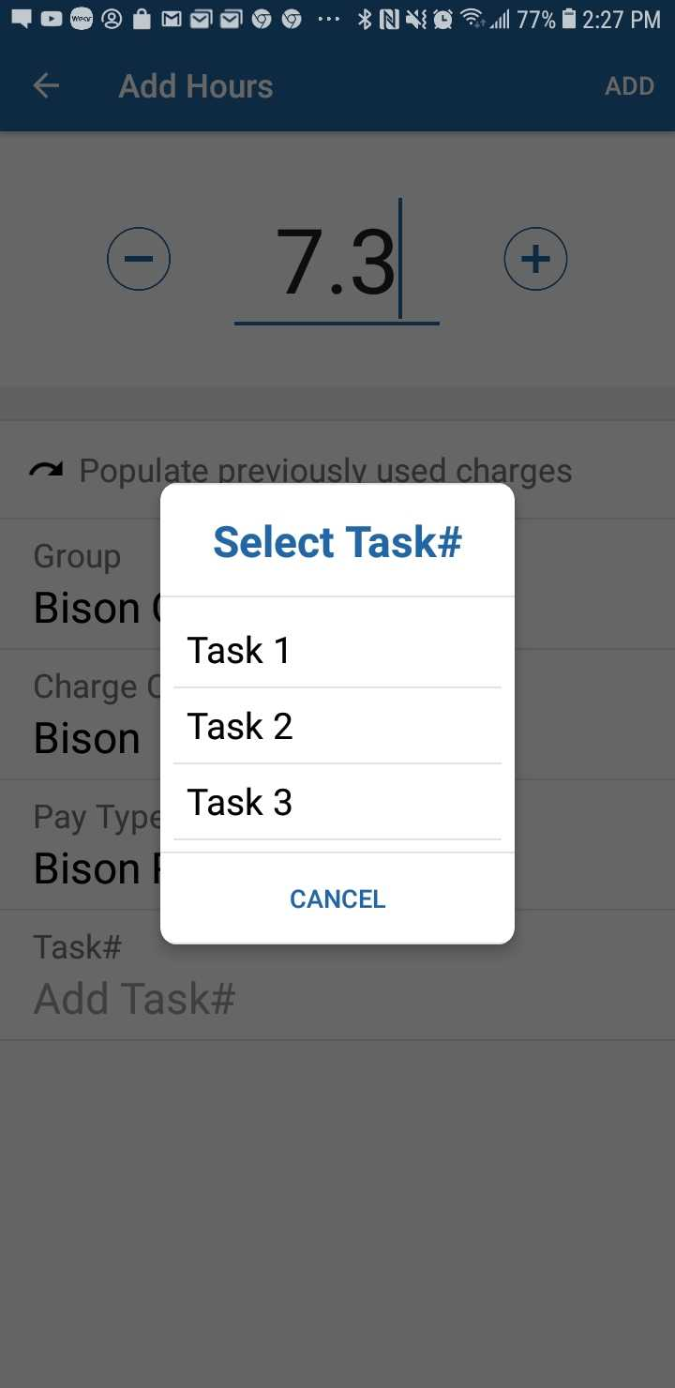
Another option is the Populate previously used charges button, which allows you to enter previously used charge codes. | 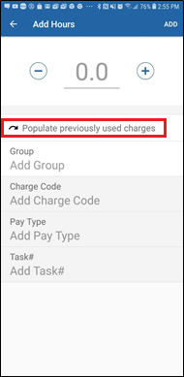
Once you tap Populate previously used charges, it will bring up a list of the all of the charge codes you have used this pay period. Select the charge code you wish to use. After, it will automatically fill in the Group, Charge Code, Pay Type, Organization, and Task #. | 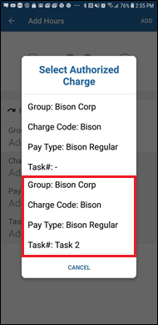
Once you have entered your hours worked, tap ADD in the top right corner. Confirm the information is correct, and tap the back arrow again, to bring you to the timesheet for the current period. | 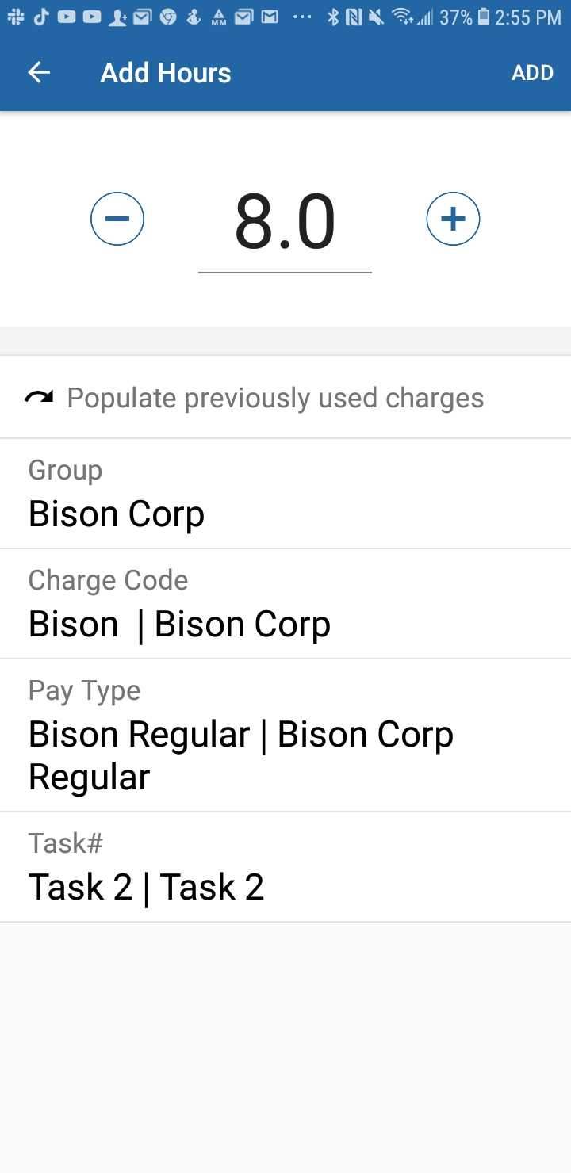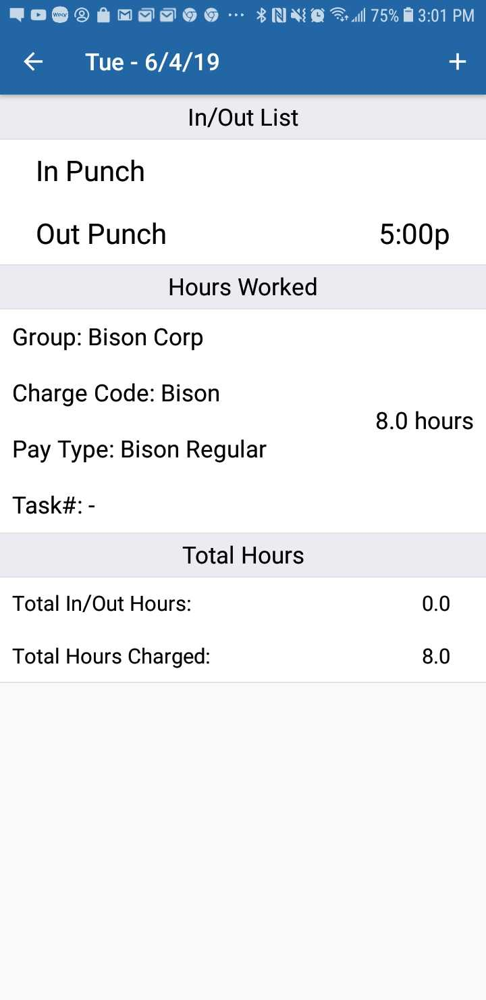
Once on the timesheet, tap Save in the top right-hand corner of the page. This will save any changes made to your timesheet during this session. | 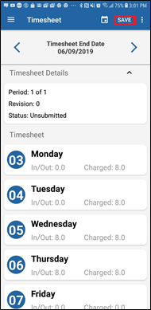

Editing Hours Worked
To edit Hours Worked, tap on the set of hours you would like to edit. | 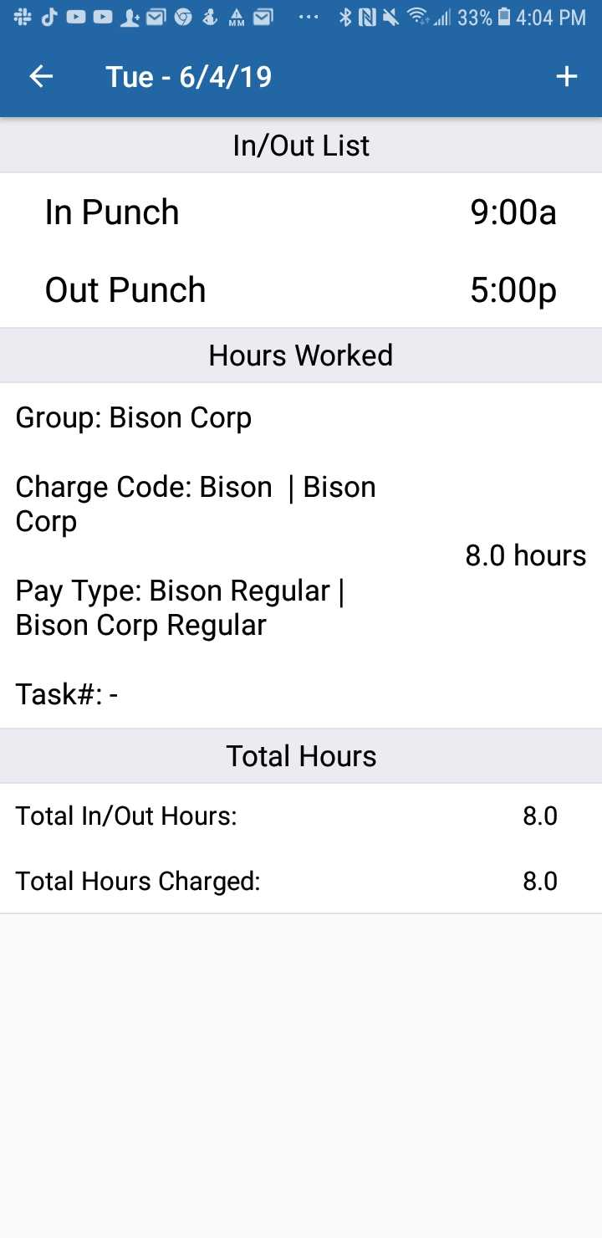
Once you tap the hours, you will be brought to the Update Hours screen. From here, tap on an item to make any changes needed, either to Group, Charge Code, etc, or to the number of hours worked. Once changes have been made, tap UPDATE in the top right hand corner. | 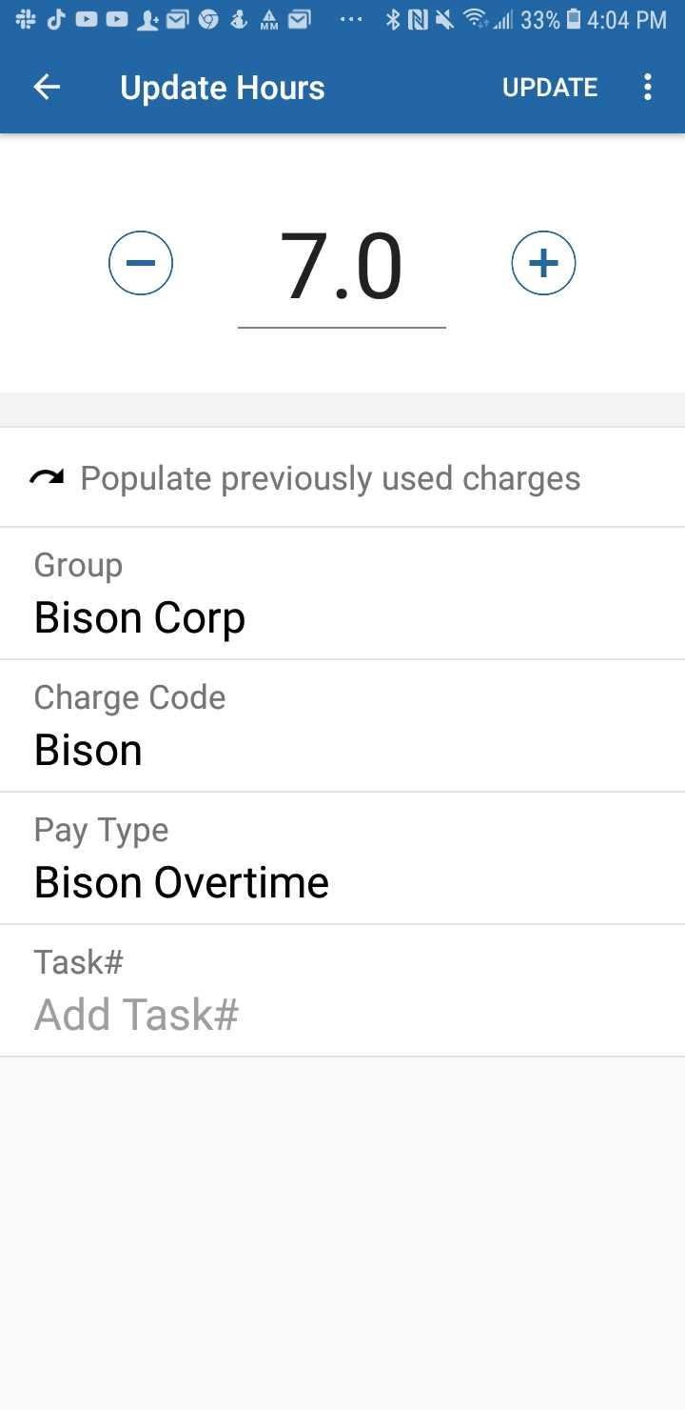
After tapping UPDATE you will be brought back to the details for the day, with the hours corrected. Be sure to tap the back arrow and then SAVE to ensure that the changes are saved. | 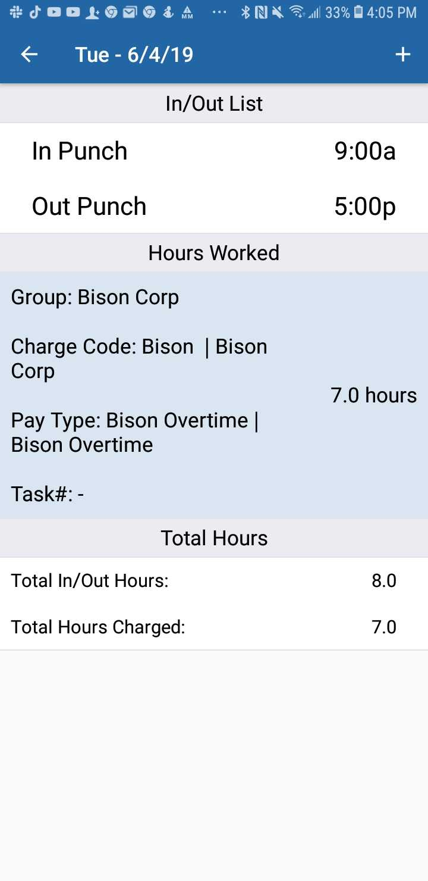
Process Complete

Removing Hours Worked
After you have selected there will be three dots in the top right corner. Tap those, and tap the Delete button that appears. | 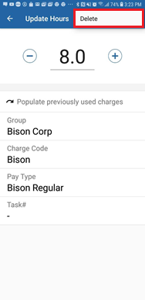
Once you have tapped the delete button, a confirmation message will appear asking “Are you sure you want to delete these hours worked?” Tap yes. | 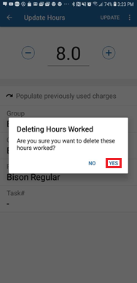
Once the Hours Worked are removed, you will be brought back to the day’s page, and the Hours Worked will be gone. | 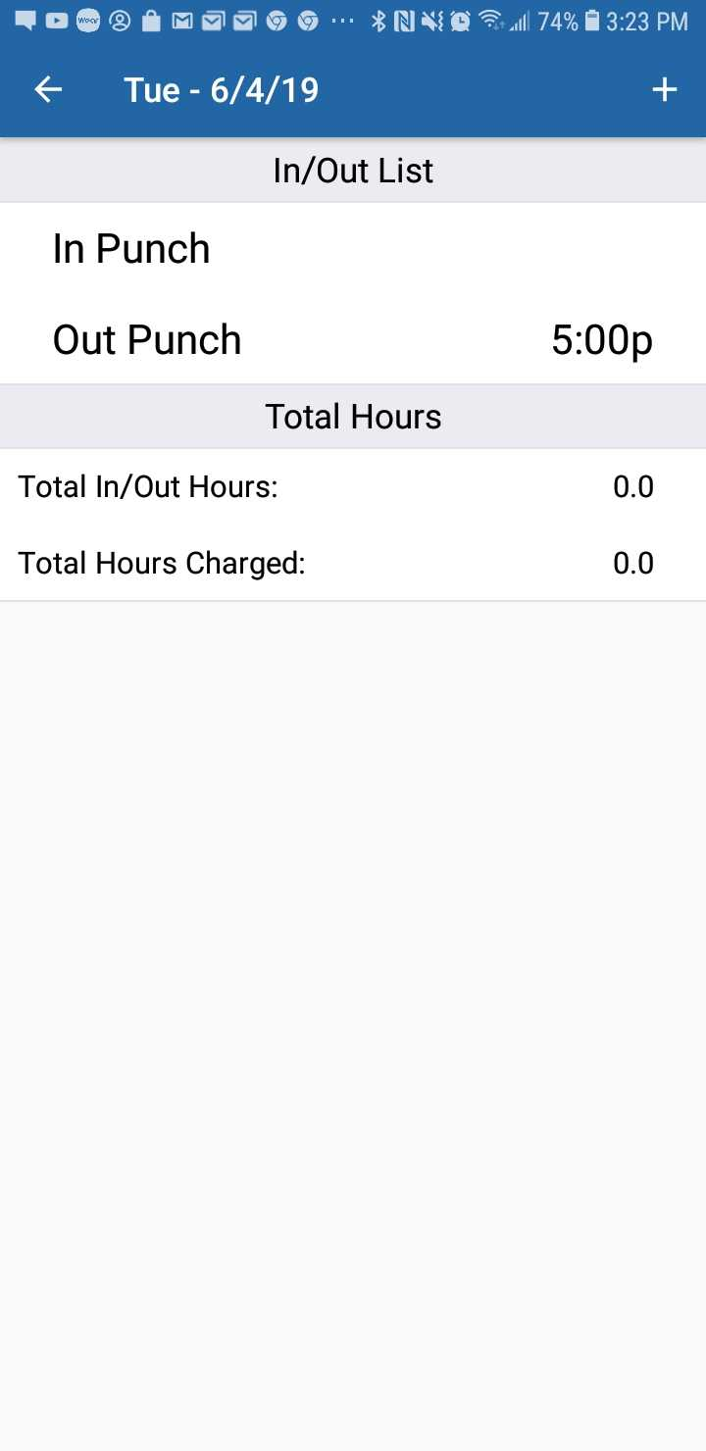
Process Complete

Timesheet Submission

Submitting Timesheets
Once you are ready to submit your timesheet, you can tap the three dots in the top left corner from the Timesheet page. | 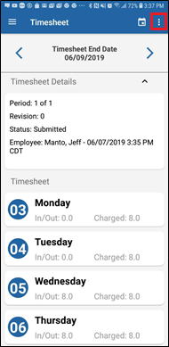
A menu will pop up with four options. Tap the Submit option. | 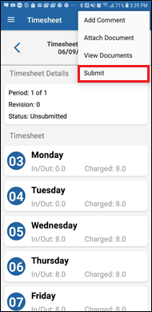
After tapping Submit a message will pop up asking “Are you sure you want to submit your timesheet?” Select Yes. | 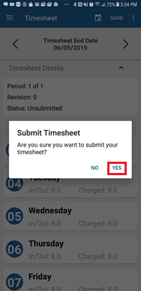
After confirming, a message saying “Timesheet Submitted” will pop up briefly. | 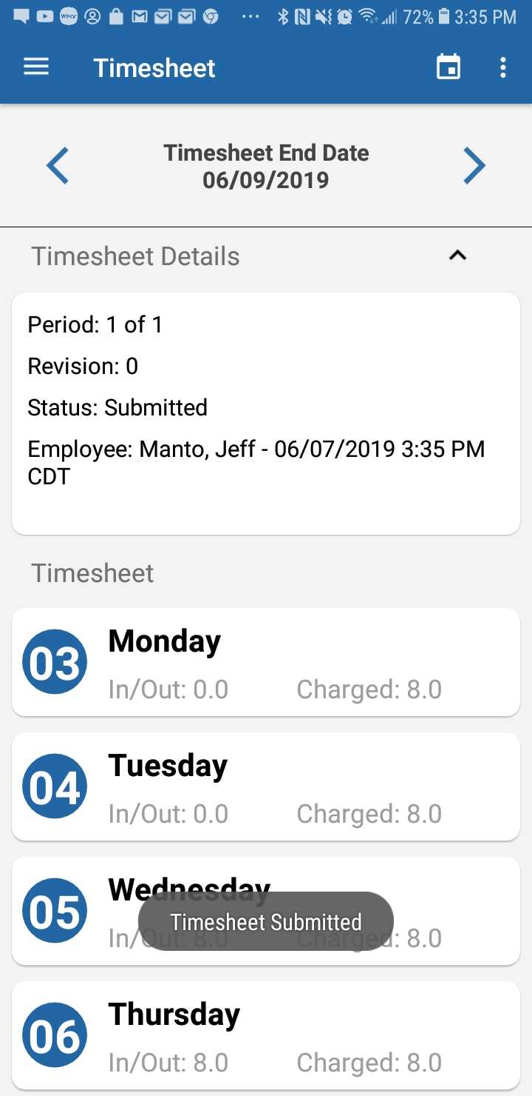
Process Complete

Unsubmitting Timesheets
Once the timesheet is submitted, no changes can be made to it. If you attempt to make any changes after submission, you will get an error message stating “It looks like your timesheet is submitted. To add hours, you will need to unsubmit it.”  To unsubmit a timesheet, you will need to tap the three dots in the top corner again, and the only options will be Unsubmit. Select Unsubmit to unsubmit the timesheet. | 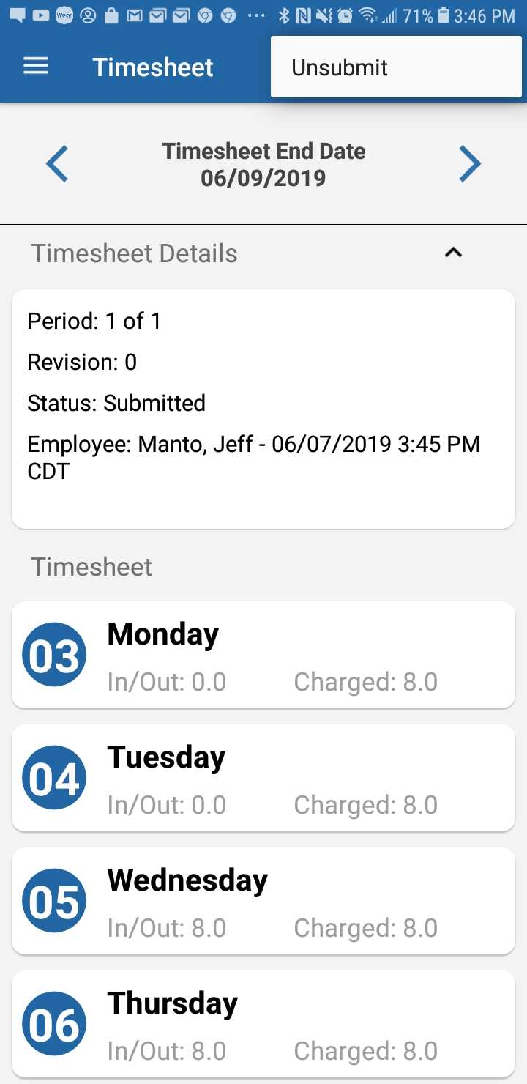
After unsubmitting, a message with a checkbox saying “Timesheet unsubmitted” will pop up briefly. At this point, you will be able to make any needed changes to their timesheet. | 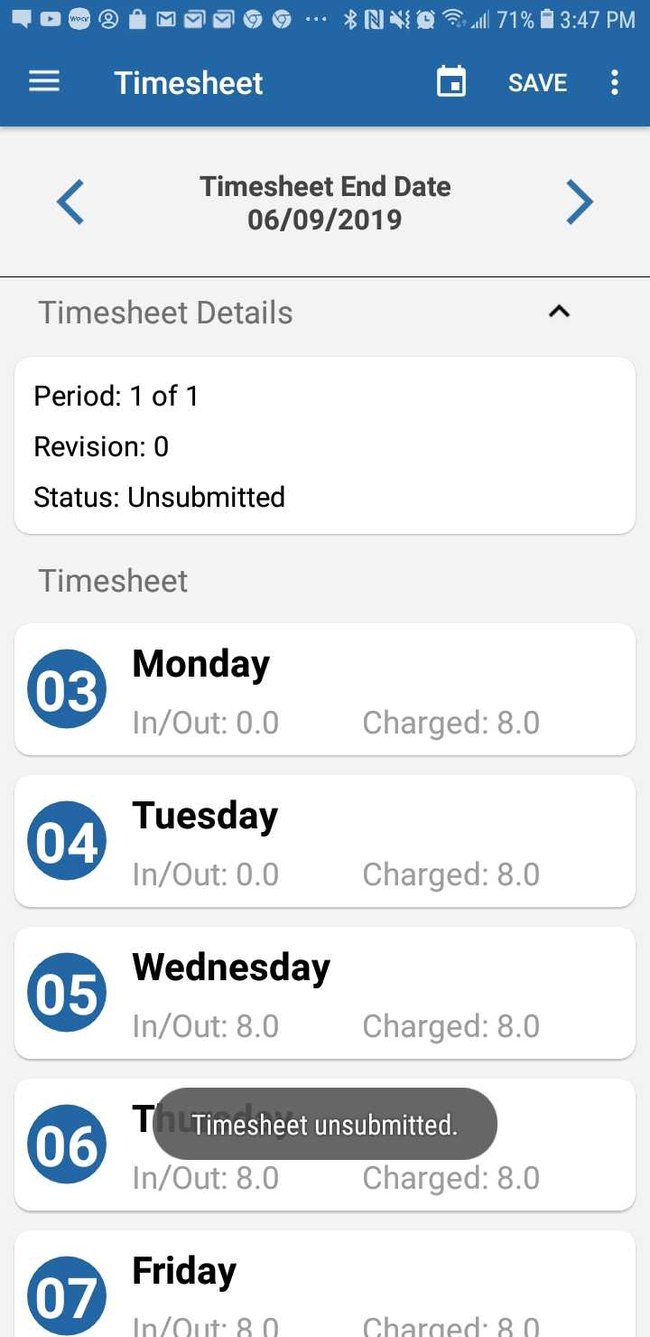
Process Complete

Timesheet Comments

Adding Comments
In order to leave a comment on the Timesheet, you will need to tap the three dots in the top right corner of the Timesheet page. Then, tap the Add Comment button to bring up the Comment box. | 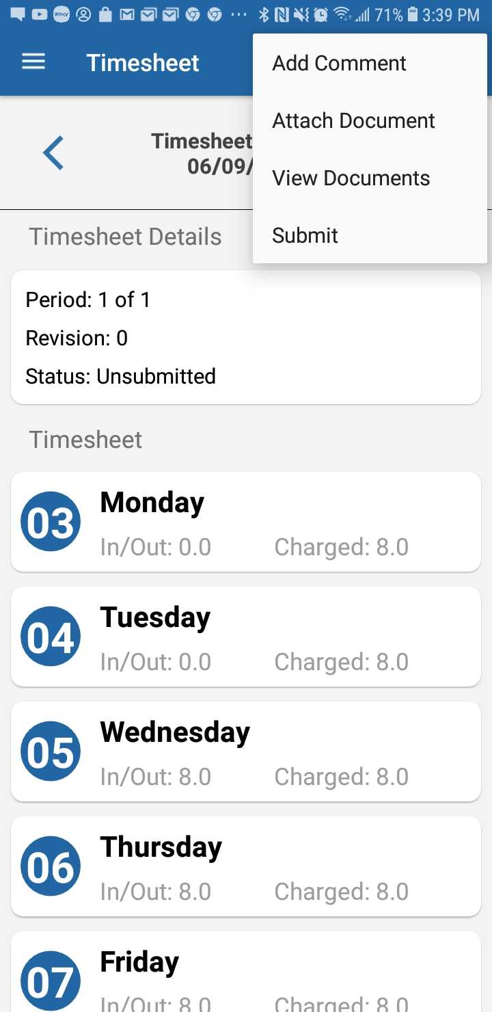
Once the comment box is up, type the comment, and tap the Add button. | 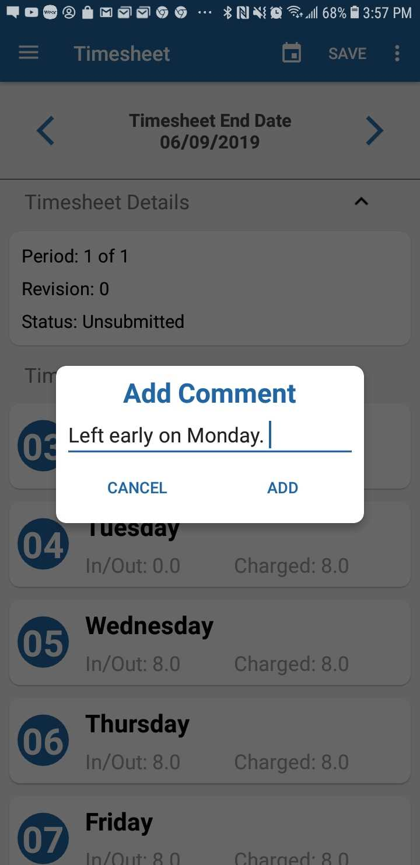
Process Complete
Once the comment is added, a black message with words “Comment Added” will appear over the timesheet. | 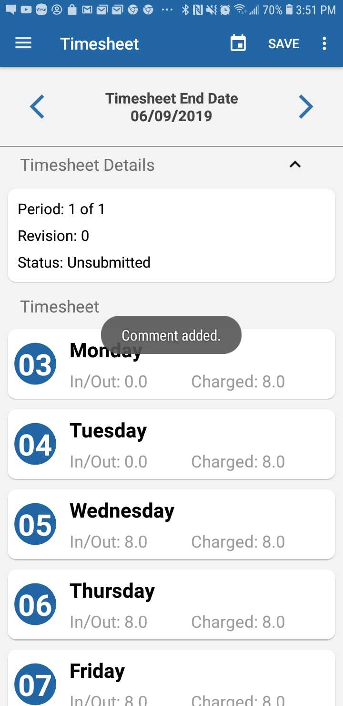
Once you have added the comment, be sure to tap SAVE in the top right corner to assure that the comments are saved to the timesheet. | 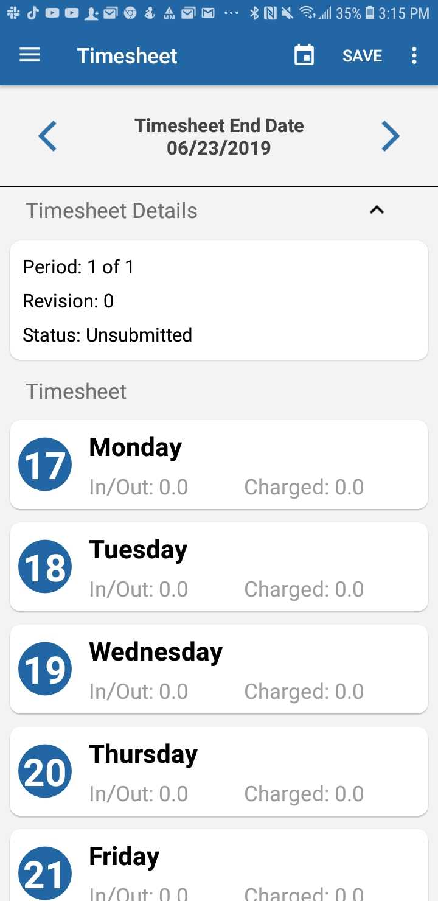
In order to edit a comment that was already made, press the three dots in the top right corner, and tap “Update Comment.” | 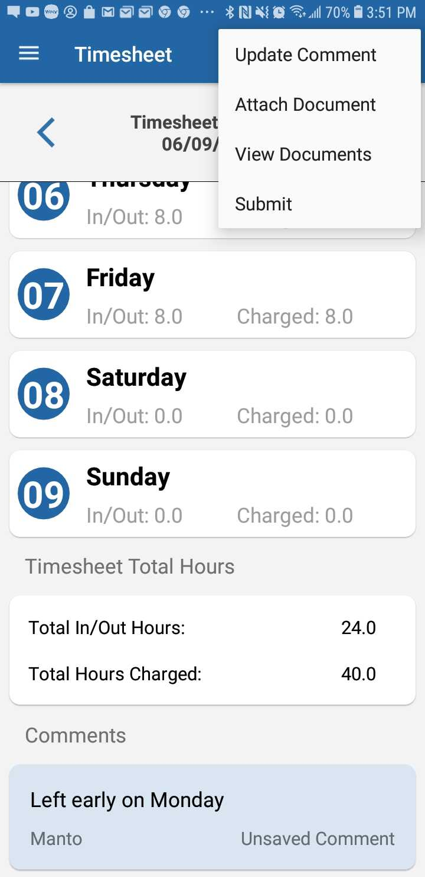
Once the Update Comment box shows up, make any changes needed to the existing comment, and tap Update. | 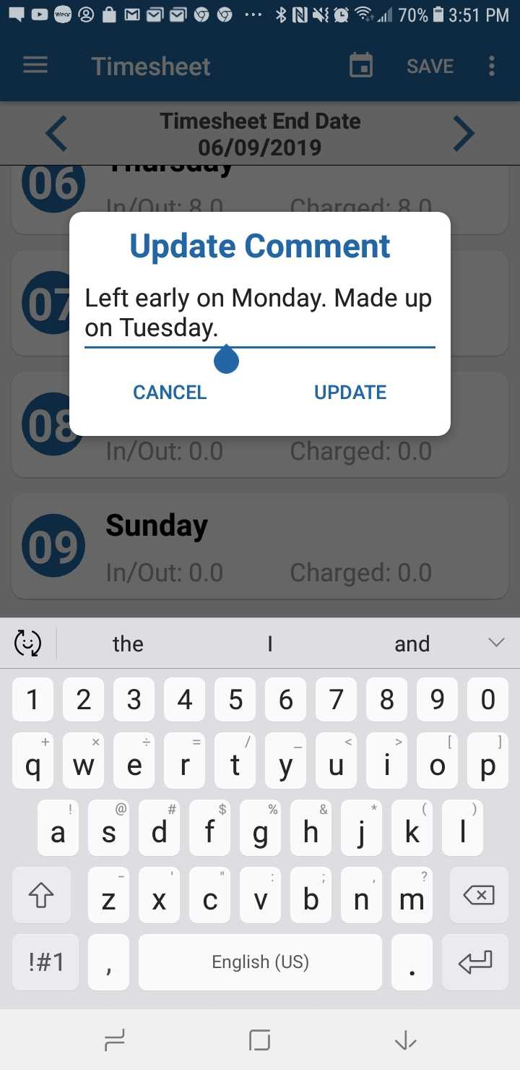
After the comment is updated, a black message with words “Comment Updated” will appear over the timesheet. | 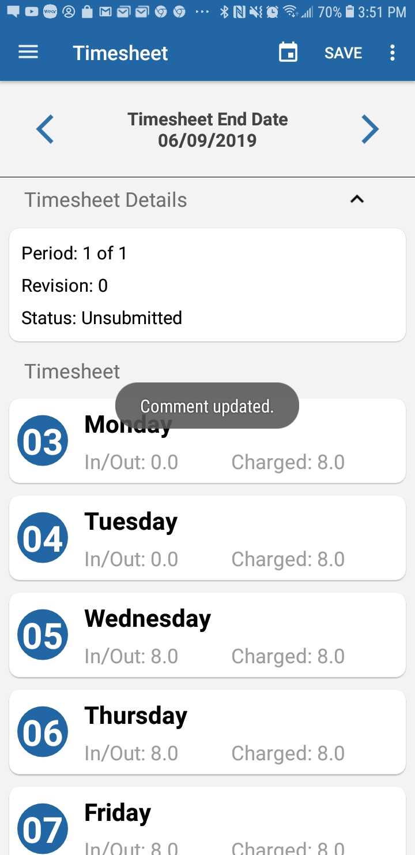

Removing Comments
To remove a comment, simply go through the same process as updating a comment, and delete all of the text in the box, then tap Update. No confirmation message will appear. | 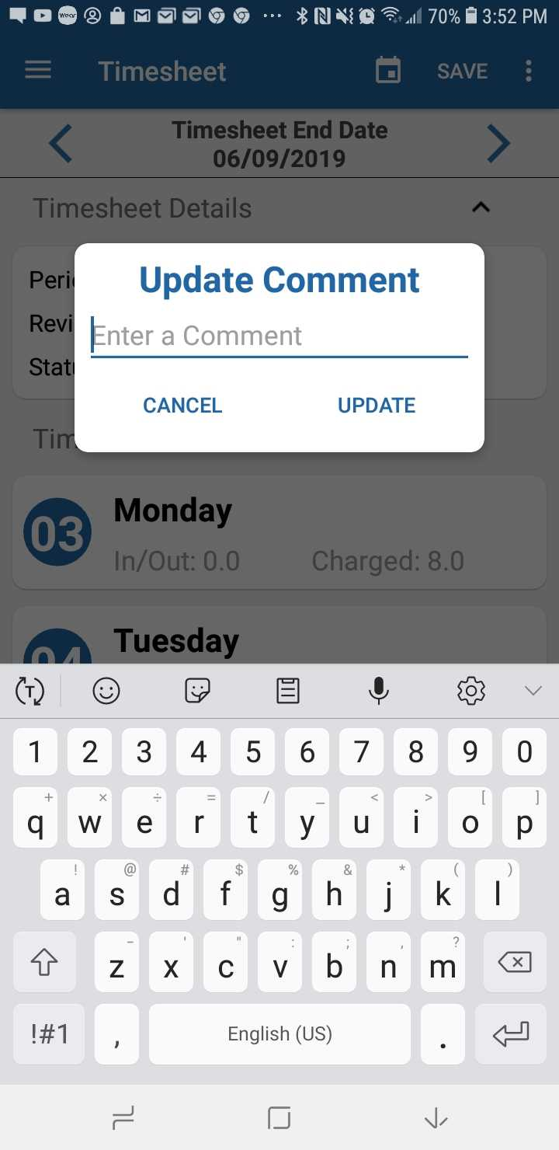
After you have deleted the comment, a message stating “Comment removed.” will appear. | 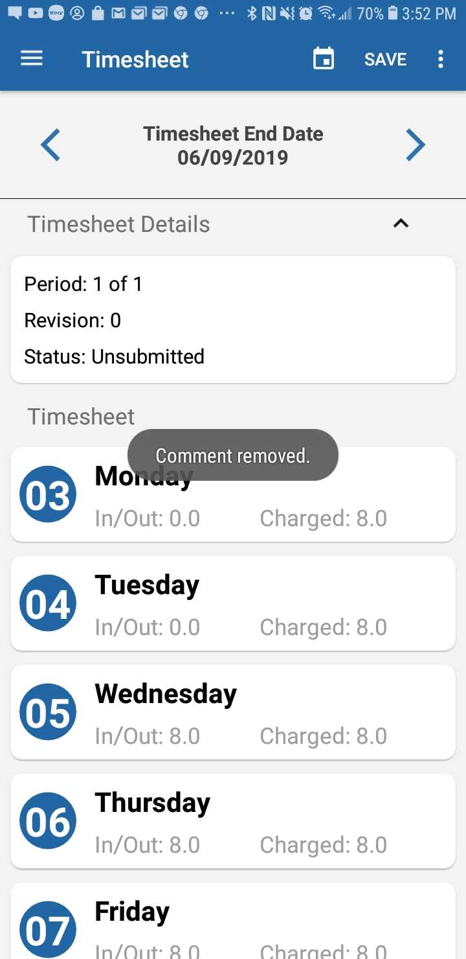
Process Complete

Timesheet Documents

Adding Documents
To upload a document, the first step is to tap the three dots in the top corner of the Timesheet page, and tap Attach Document. | 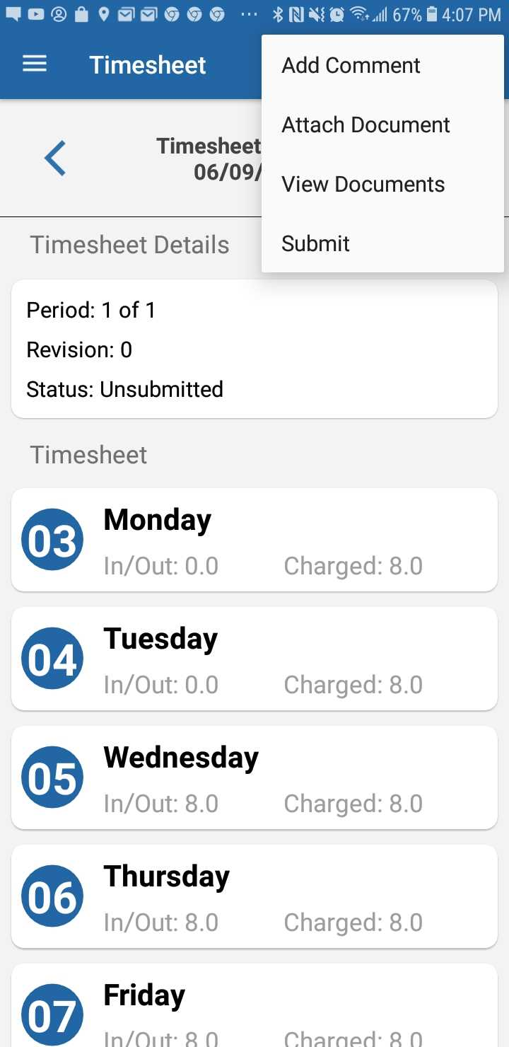
Tapping Attach Document will bring you to a menu where you can choose if you want to upload a document, or a photo. Tap Upload Document. | 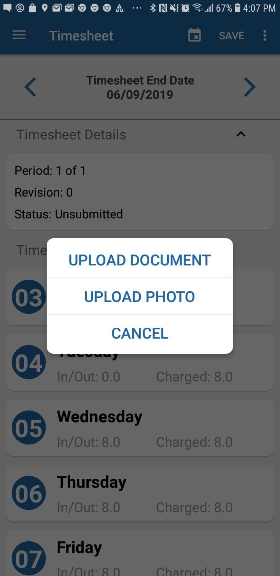
Once Upload Document is tapped, your device will pull up a list of all of the documents saved on your device. Tap the document you wish to upload. | 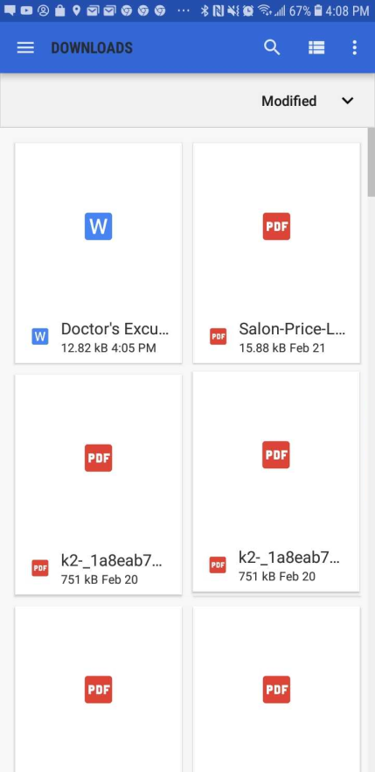
Once the document is uploaded, a black message with words “Upload of [DOCUMENT NAME] successful.” will appear over the timesheet.  NOTE: This process may take some time. There is no uploading indicator at this point, so it may seem frozen for up to ten seconds. | 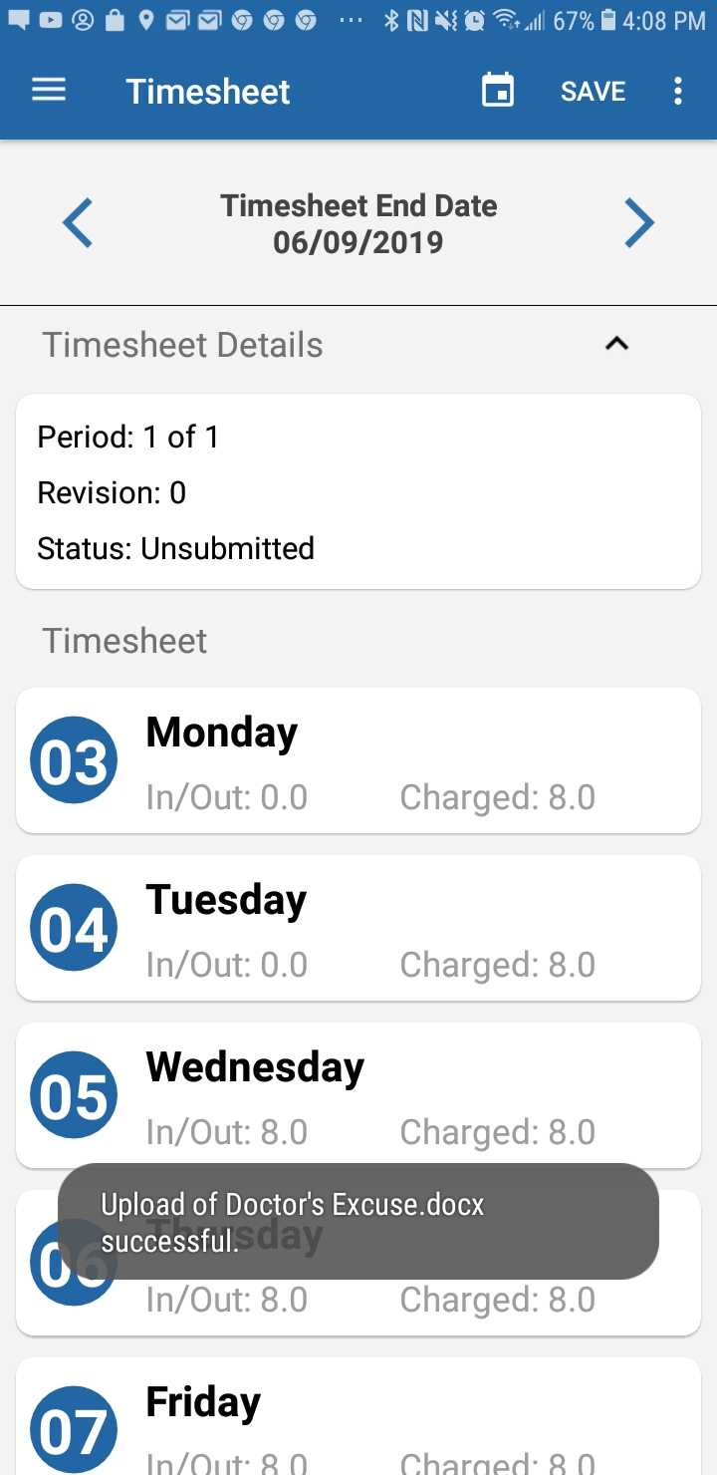
Process Complete

Removing Documents
In order to remove a document, tap the three dots, and then tap View Documents.
Once you tap Document List, a list of all of the documents you have uploaded to this particular timesheet will populate. Next to the document that you wish to remove, tap the trash can on the right side.
Once the trash can is tapped, a message will appear stating “Are you sure you would like to delete this document? This action cannot be undone.” Tap DELETE. | 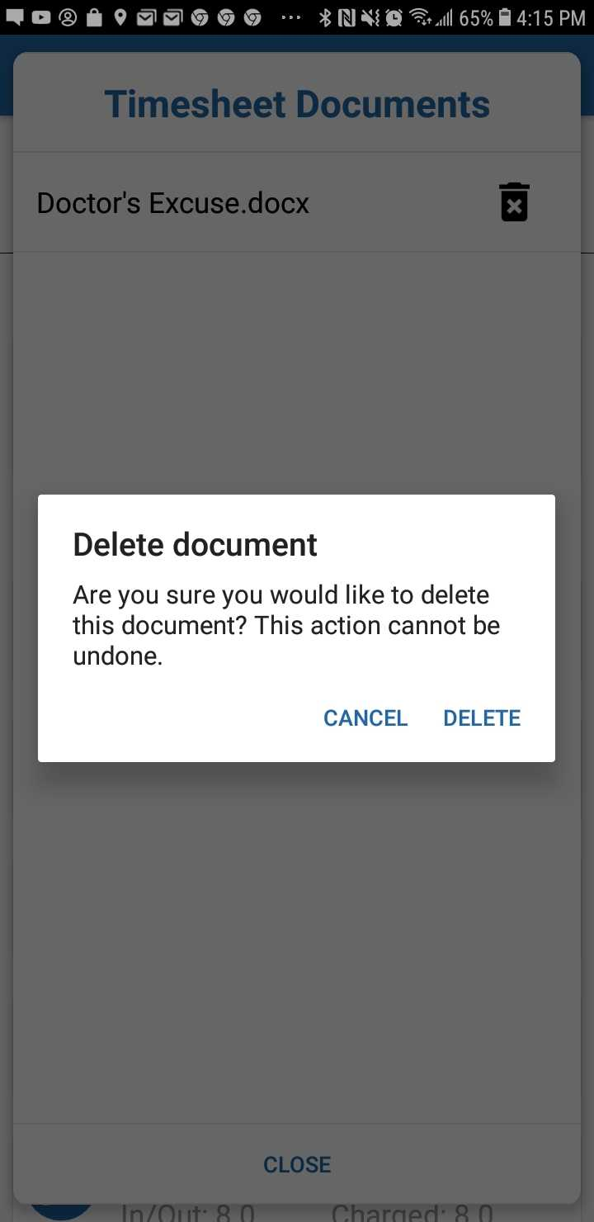
After the document is deleted, you will be brought back to the Timesheet Documents list, and the document will be gone from the list, along with a message stating “Document deleted successfully”.
Process Complete

Schedule Tab
When you first tap the Schedule tab, it will show you information for the current week, as how many hours you’re scheduled to be working each day. You can use the left and right arrows to look at past and future schedules. | 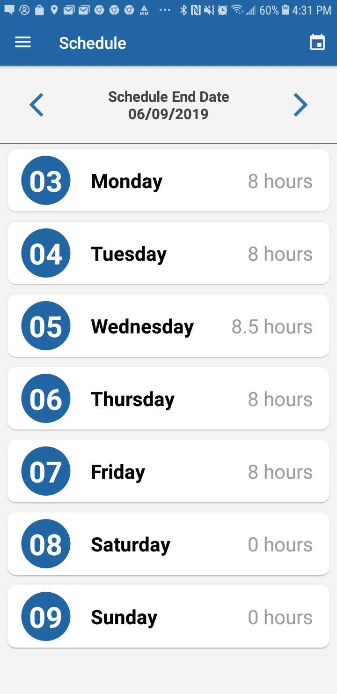
In order to view a certain day with more details, tap on the day you want to view.
Once you have selected the day you wish to view, you will be brought to the screen for the specific day. The top box will show your scheduled in/out times. The bottom box will show your Total Hours, amount of Break time, and any comments. | 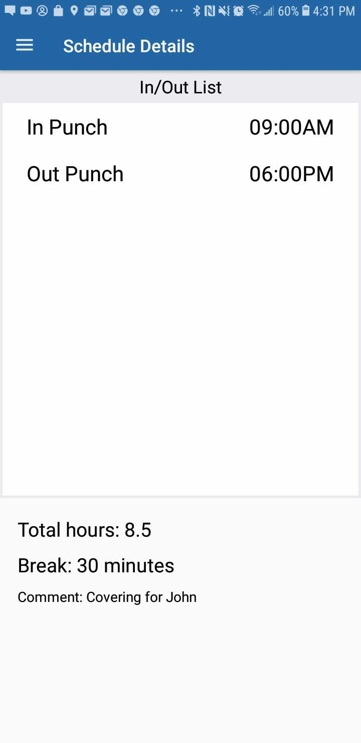
Process Complete

Leave Tab
Once you tap the Leave tab in the Navigation drawer in the top left hand corner, the first thing that is displayed is the list of all leaves available to you, and your current balance for all of these leaves. | 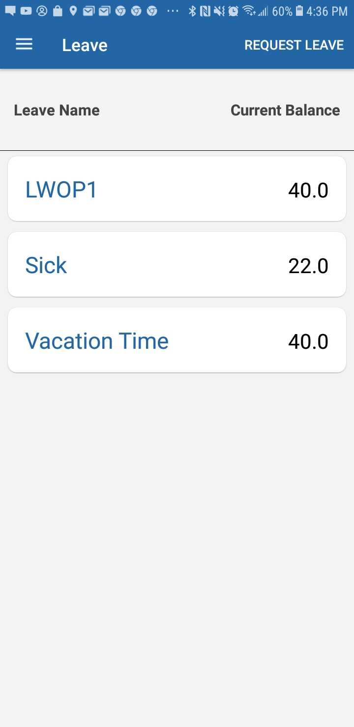
To request leave, the first step is to tap REQUEST LEAVE in the top right-hand corner, which will bring you to the Leave Request page.
Once on the Leave Request page, you will need to enter the Start Date, End Date, Leave Code, and Hours per day. Today’s date will be the default Start and End Date. | 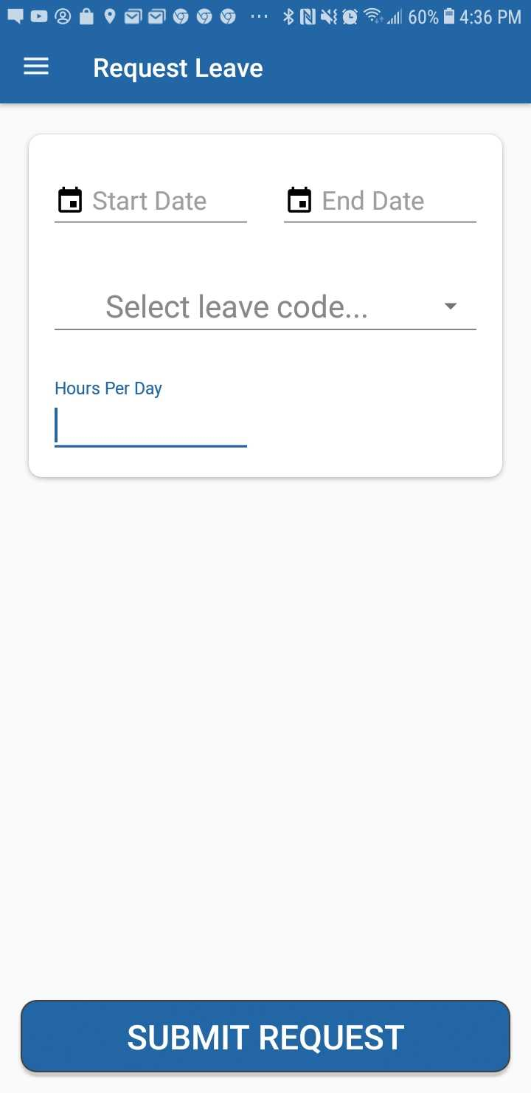
Next, Tap the Start Date, and use the calendar to scroll for the date you wish to start the leave. Once your start date is picked, go through the same process with the End Date. | 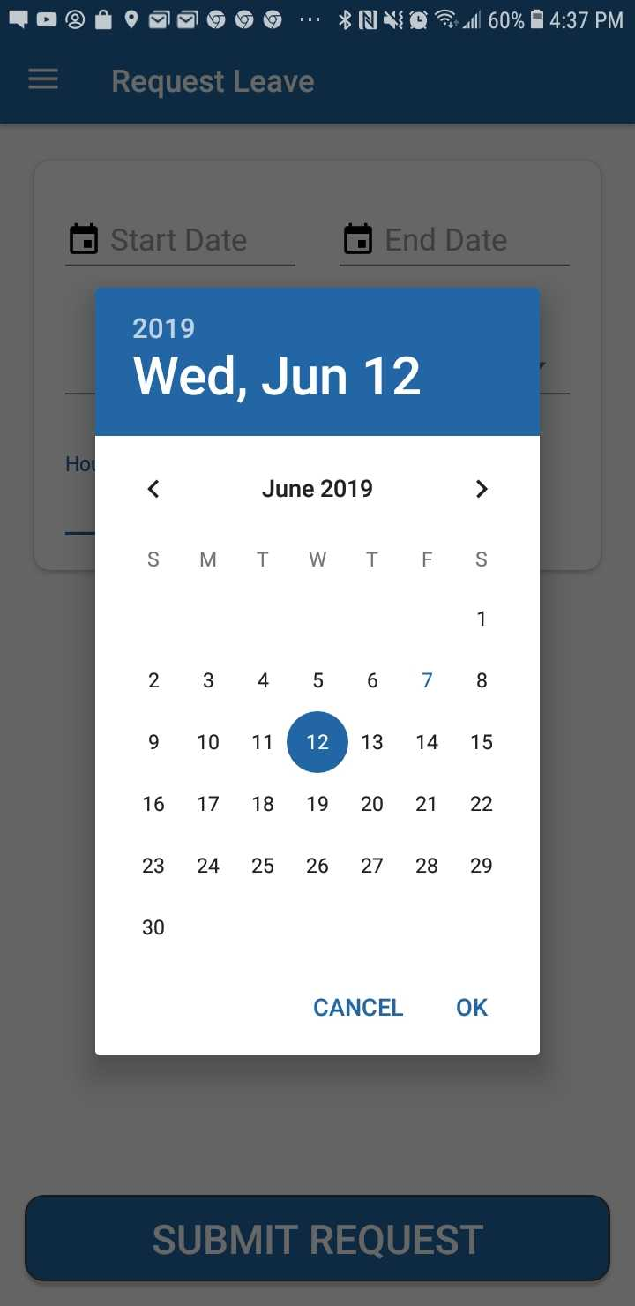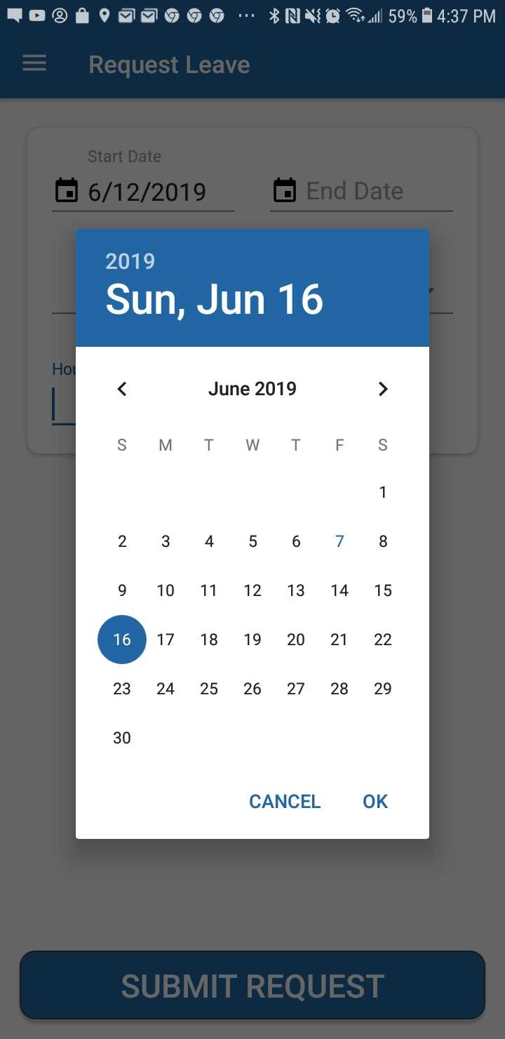
Next, tap Select leave code..., and select the type of leave you wish to request.
The next step is to tap the Hours per day box, and type the number of hours of the leave that you are requesting to take per day, for that time period. | 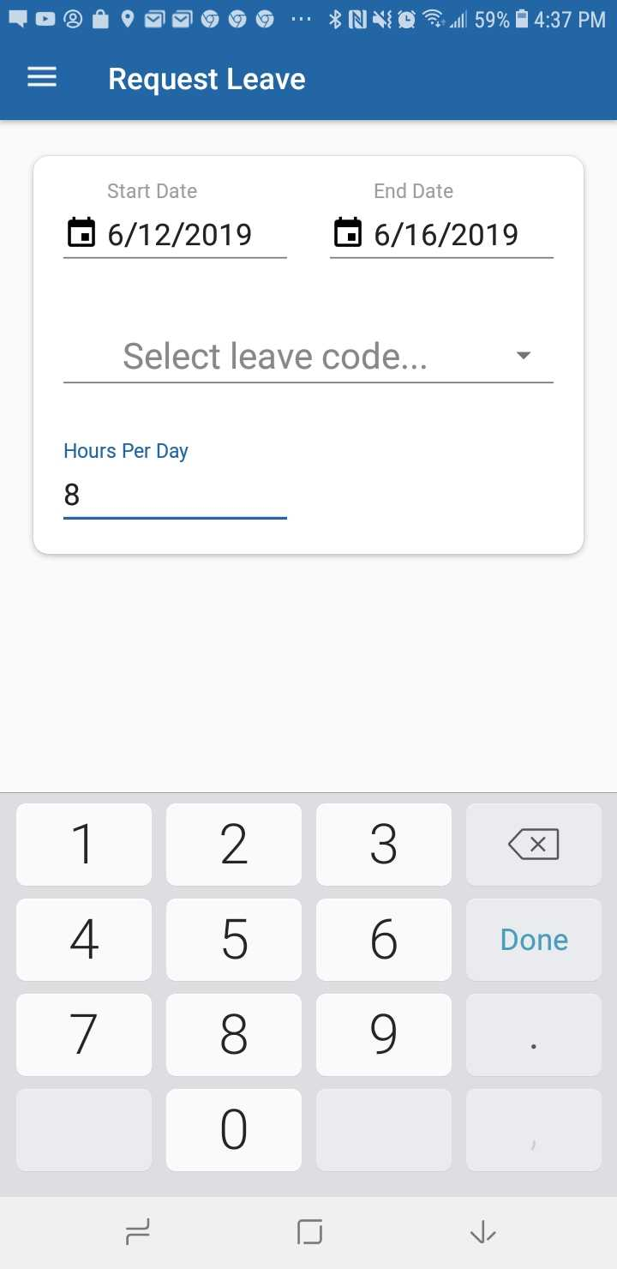
Finally, tap the SUBMIT REQUEST button to submit your request.
Once your request is submitted, a message will pop up stating “Success Your leave request has been successfully submitted” | 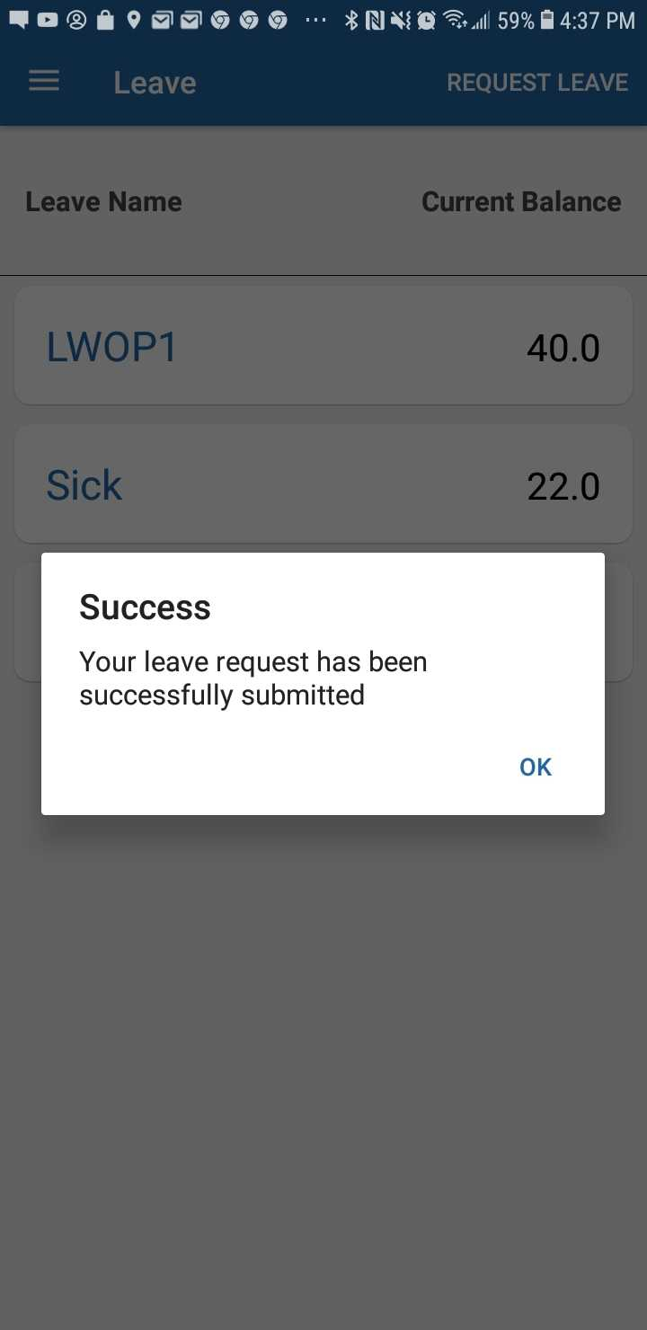
Process Complete

Settings Tab
The Settings tab allows you show or hide code descriptions, enable and disable Fingerprint use, and allow the app permission to use your location. It will also show you a complete history of transactions made on the app, and show you the license information. | 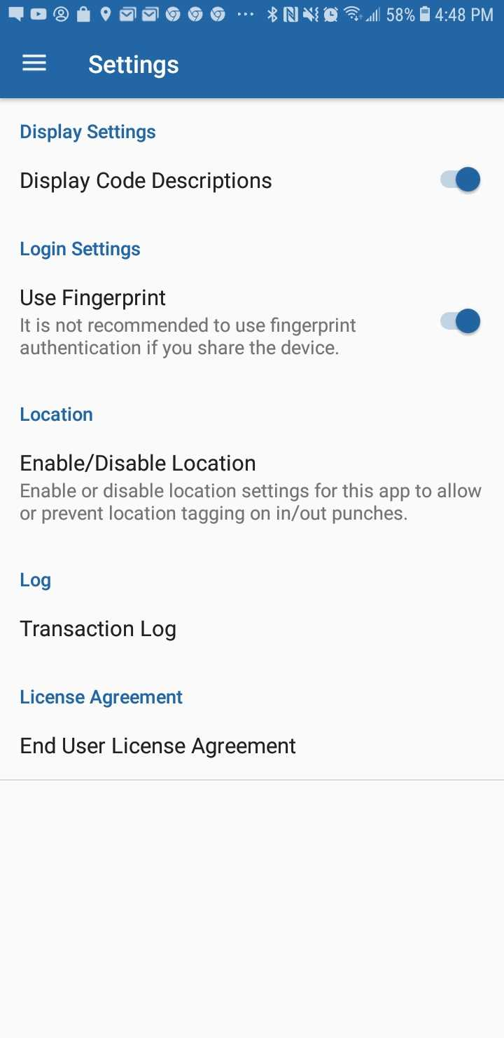
For the Display Code Descriptions option, toggle the switch on if you want to show the descriptions in all of the codes in the app. Toggle it off if to show just the names.
The Use Fingerprint option allows you toggle the switch on if you would like to use your fingerprint to login. Toggle it off if you only want to be able to use your password to login.
Location Permissions allows you to enable or disable location services for the app.
Once you tap Location, you will be brought to the APP INFO page. From here, tap Permissions. | 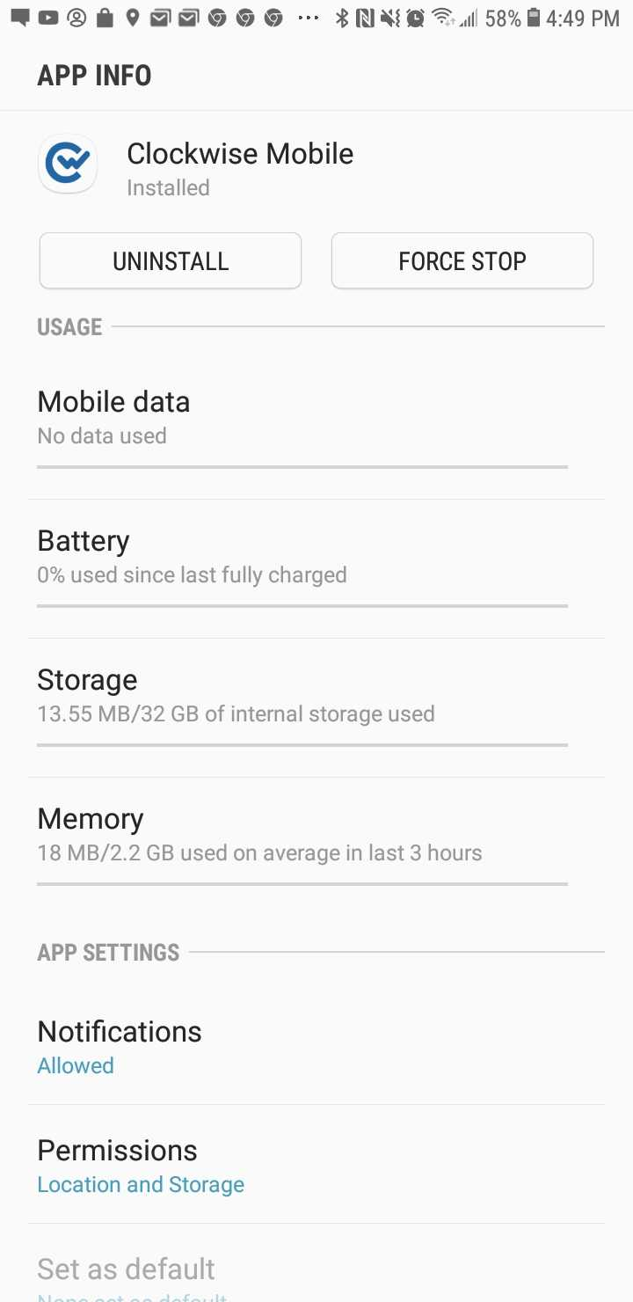
Once you tap APP PERMISSONS, it will allow you to toggle location on and off. Specifically, the app only uses location for tagging your location from where you make a punch.
Tapping Transaction Log shows a complete list of all the user generated activity in the app.
Once in the transaction log, it will show a full list of all transactions made from the app.  NOTE: This will show ALL activities performed by ALL uses that have made transactions from this device. | 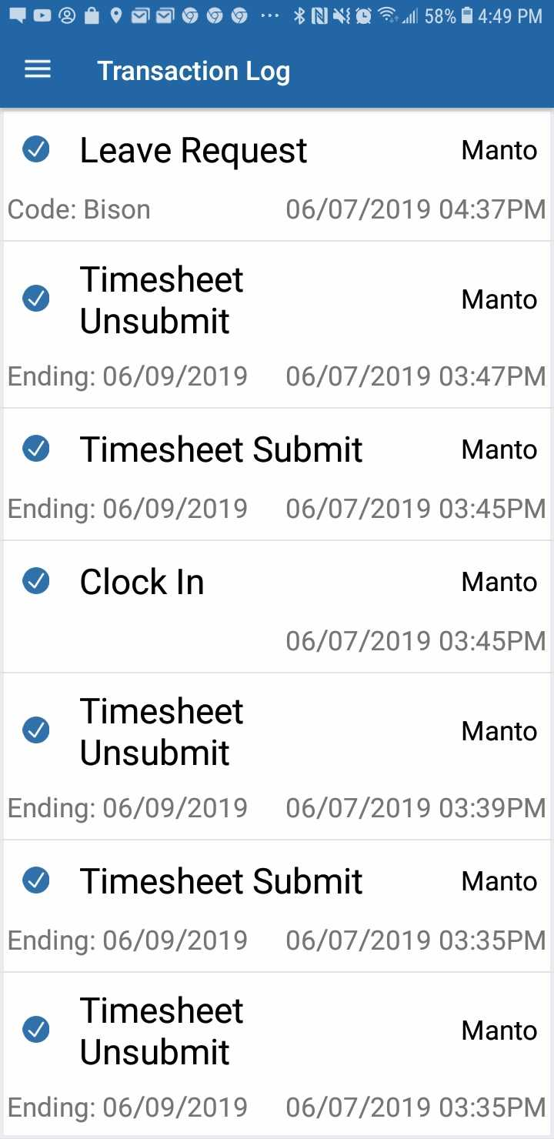
The License Agreement tab will show the End User License, which is legal documentation stating what you are able to do with our app.
Once you tap End User License Agreement, a box with all of the information for the licensing will pop up. | 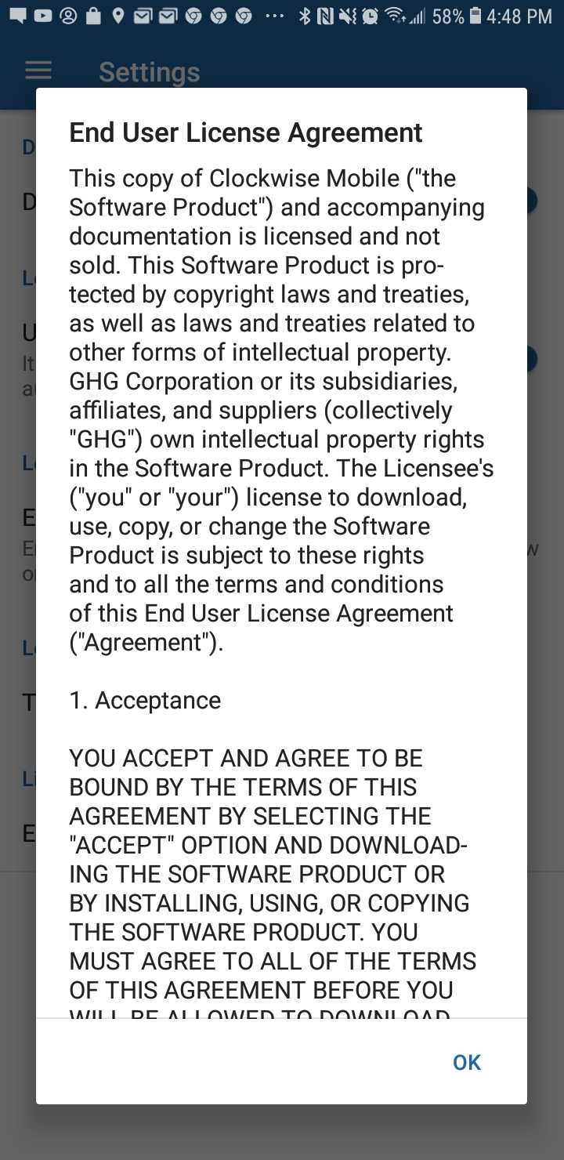

FAQ

Does the Clockwise Mobile app work on tablets?
Yes. This app will function on an Android tablet just as well as it does on an Android phone.
Why has my leave balance not changed after I requested leave?
The Leave balances will still be the same after the request, and will not change until the leave is actually taken.
Will this user guide help with using the Apple version of the app?
This guide will walk users through the main processes and features of the Android app. While similar, there are a few minor differences between the iOS and Android apps, and we do have a guide specifically for Apple users as well.
Why do exempt employees still have the options to clock in and out?
The In/Out are a built-in feature of the mobile app, but should not be used by any user who does not have In/Outs visible on their timesheet. The remaining features are still accessible.

